**CH2: Basic processes in visual perception**

Fare quiz chapter 1

**Gist of a scene**: first representation of a scene, is done very fast, to build a more detailed representation of a scene we need more time

**Reception/transduction/coding**: perception in general is the transformation of external energy in neural energy is done with receptors that perform the transformation that is called *transduction.* The neural signal is then coded in different representations and re elaborated in different parts of the brain. Already in the retina the signal is transformed.

**The representation is distributed**: like when you represent a number using bits. But different combinations of bits represent different numbers. Same thing in the brain, different neurons activated represent different concept

**How does the eye work/why is it like a camera**: an eye is like a camera because like a camera can adjust the light coming in. The corner is a fixed transparent lens. Under the corner there is a lens that can be changed.

The difference is that on the back of a camera there is a filter that records the light in that moment. On the retina instead there are 3 layers of neurons, the first one does detection and transduction, then the signal in the second and third is elaborated and changed

**Retinotopic representation**: the Light travels straight. Objects close outside are going to stimulate positions that are closed to the eye. The mapping is maintained the same. what is close in the word is close in the eye.

**Type or receptors, properties (convergence, sensibility, acuity)**: retina is a multyler structure. On the back there are photoreceptors and then 2 other layers.

We have 2 types of photoreceptors:

* cones: for colour, concentrated in the center of the retina. Code colours because we have 3 types of cones but 1 type of rode. To be activated the cones need more light work much better during the day.
* Rodes: much more sensitive. Work where there is low light. A photon activates it. During the day they are off. Start working when there is not much light.

Cones are used for colour vision and sharpness of vision

Rods specialised for vision in dim light. 125 million rods concentrated in the outer regions of the retina

Retina ganglion cell: receives input from only fre bond but from hundreds of rods

Each eye has its own optics nerve. The two optic nerves meet at the optic chiasm.

**Receptive field and lateral inhibition**: the receptors are packet all together. Each photoreceptor activates one ganglion cell in a 1-1 connection.

Lateral inhibition: help us to recognise shape and detect borders. The aim is to discriminate objects. It focus on borders. To do so increases the differences:

Lateral inhibition increases the constraints at the edges of objects, make easier to identity the one between two objects

**Pathways (retino-geniculate-striate)**: go to the centre of the brain (LGN: Lateral Geniculate Nucleus) and then to the back of the brain V1

Go to the LGN and then V1. The difference in the retina

Two pathways: Parvocelullar and Magnocellular. Goes to different parts of visual area V1

* Parvo: mostly codes for the cones. Go to the area that code colours and form
* Magno: goes to the area that code position

When we have two eyes we have 2 optic nerves. The information is maintained separately

Two (relatively) independent channels or pathways

* parvocellular (or P) pathway. Most sensitive to colour and to fine detail. Most input from cones
* Magnocellular (or M) pathway. Most sensitive to movement information. Most input from rods

**Optic chiasm and lateralisation of signal**: everything that is project on one side of the eye

On the left side of the brain there is the right part of the word. After the crossing there is the LGN, different layers (parvo and magno) are overlapped. aligning the information of the two eyes.

**Processing stream after V1**: is still separated. V1 on the left we have all the information coming from the left side of the word. Different layers of the cortex contain information of the parvo and of the magno.

**Parallel processing and recurrence**: this division in 2 pathways is very useful it help us a lot, increase elaboration of signal in vision.

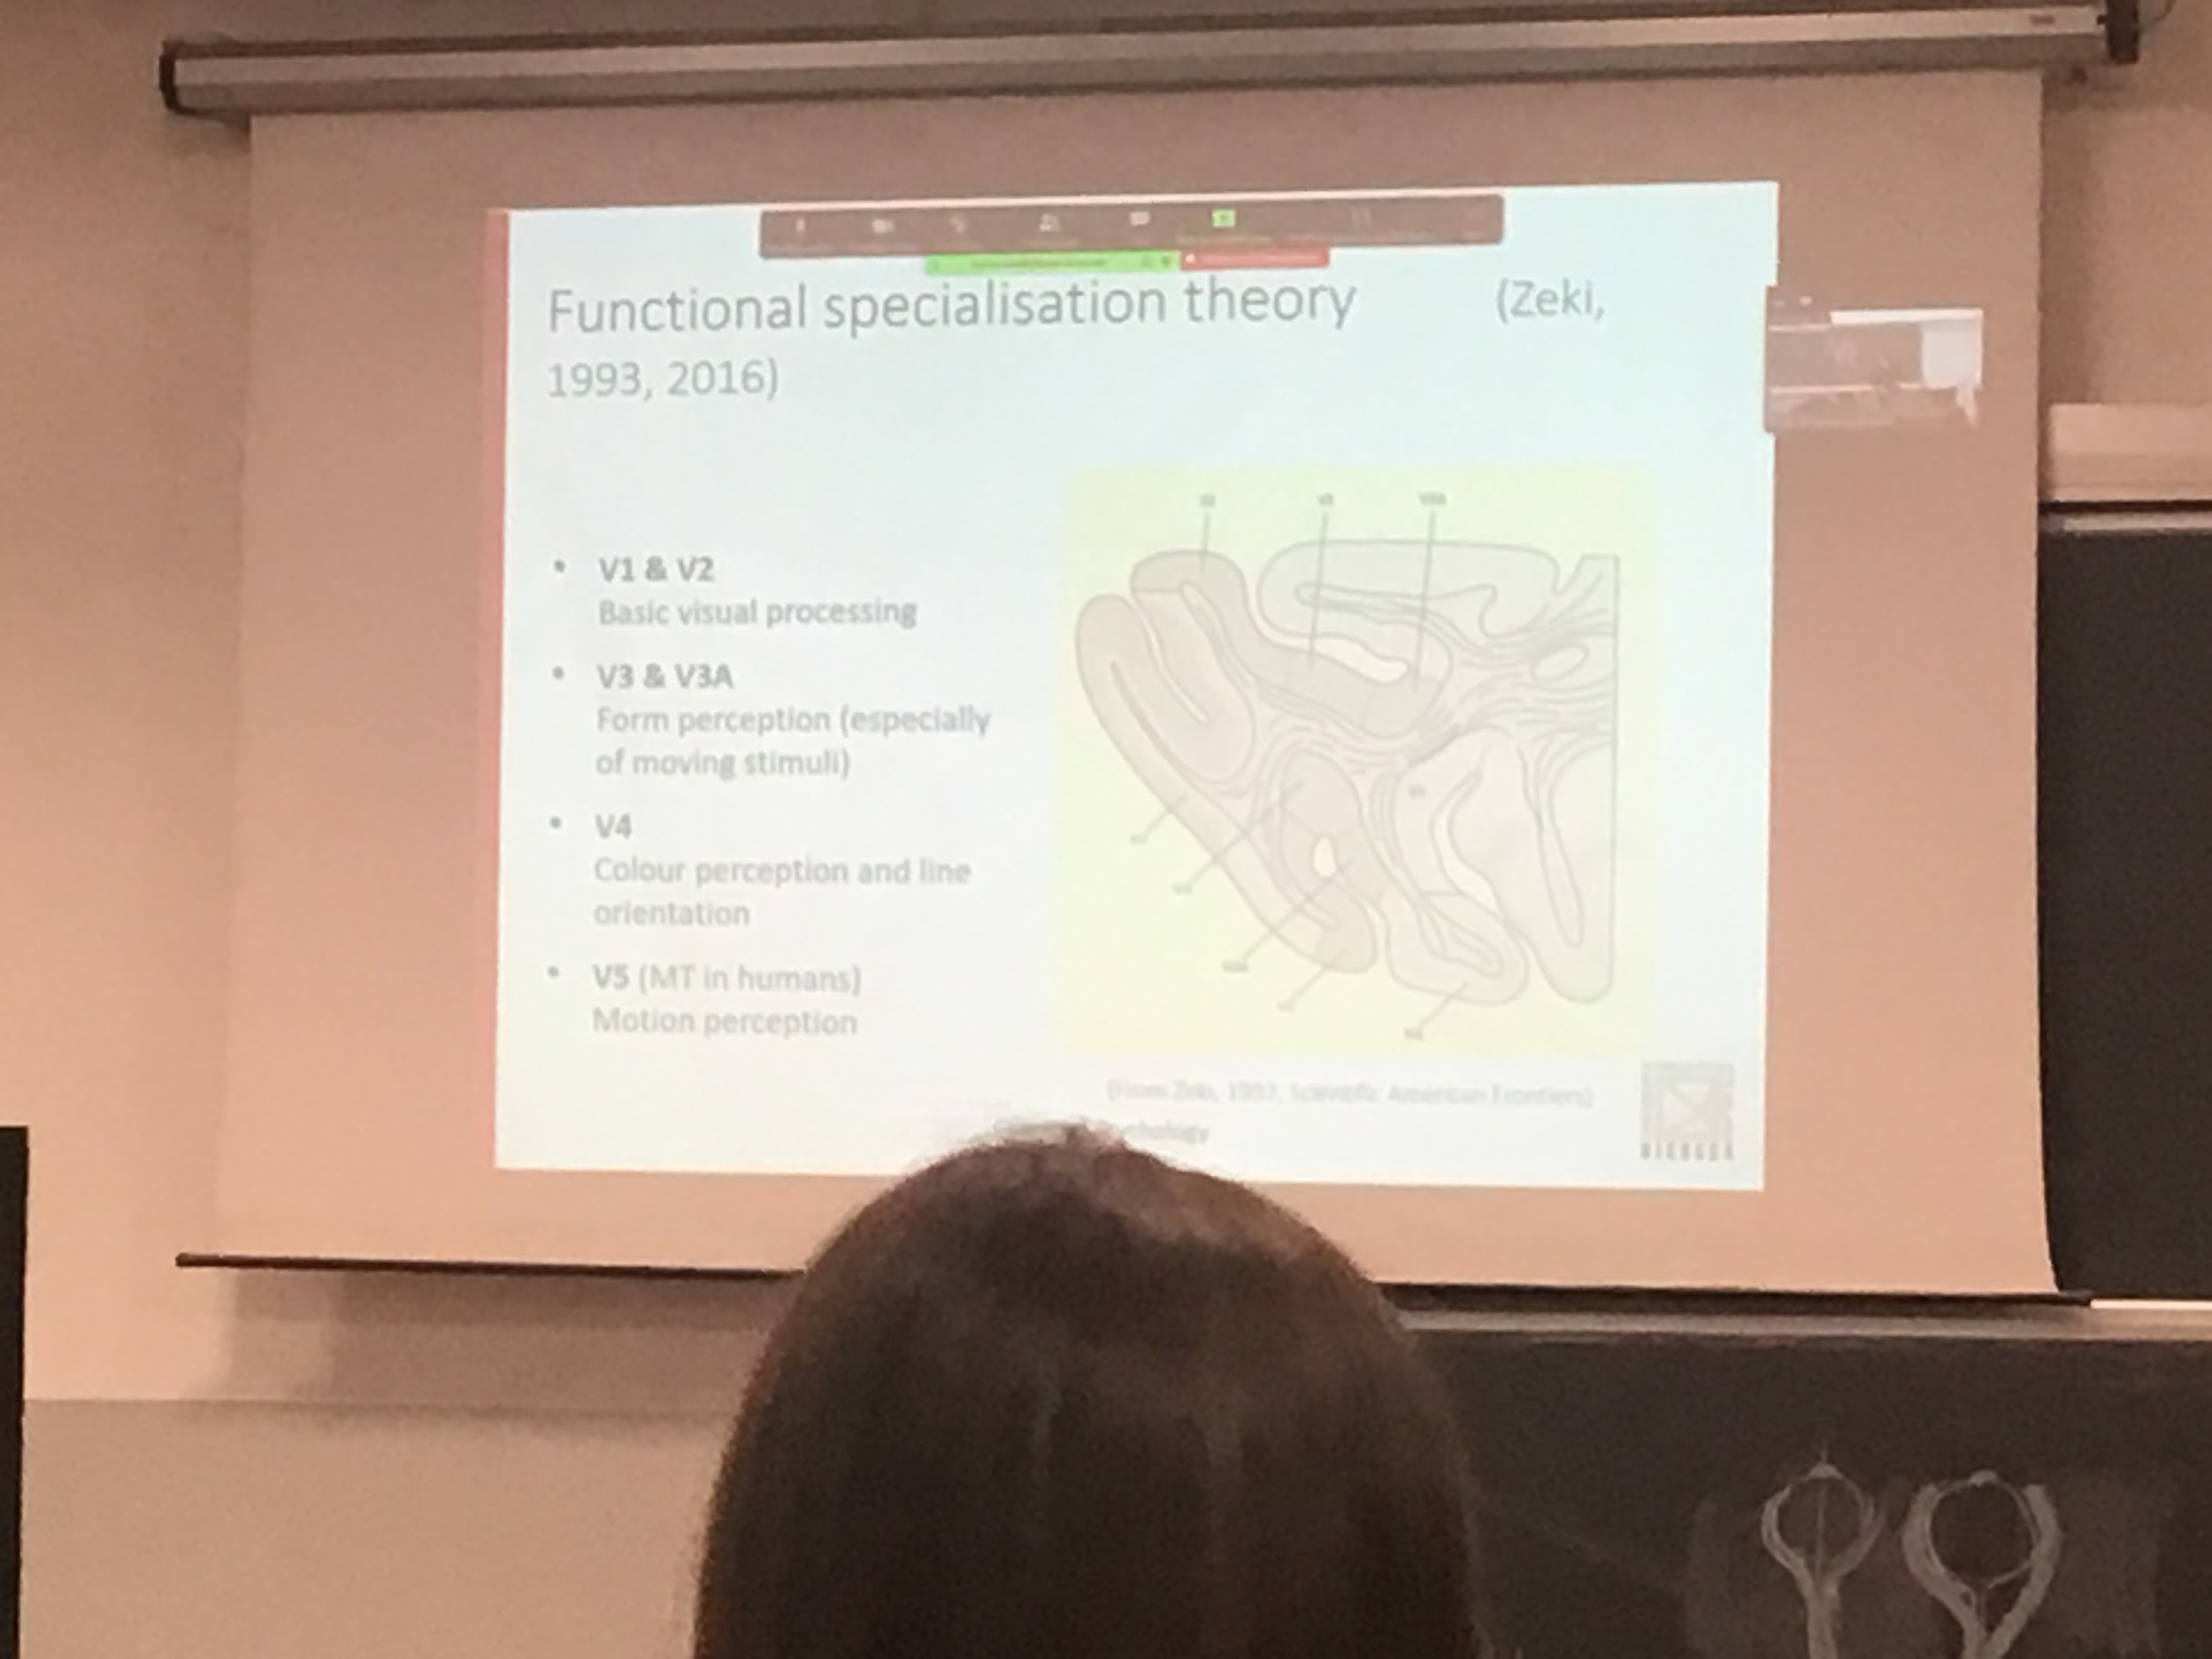

Functional specialisation theory. The brain surface can be divided into different areas (brodmann areas) are just structural areas. Different numbers have different types of cells. Don’t care about what they do.

Different cortical areas are specialised for different visual functions

Zeki (researcher that worked a lot with patients and monkeys) said that what these areas correspond to they have different functions. Not just anatomically different but also different processing.

V1 (back, area 17 of brodmann) and surround v2 do basic visual processing. Put information from the two eyes. Code general details information.

V3 & V3A: form perception of moving stimuli.

V4: colour perception

V5: Motion perception

different aspects are differently codes in different part of the brain

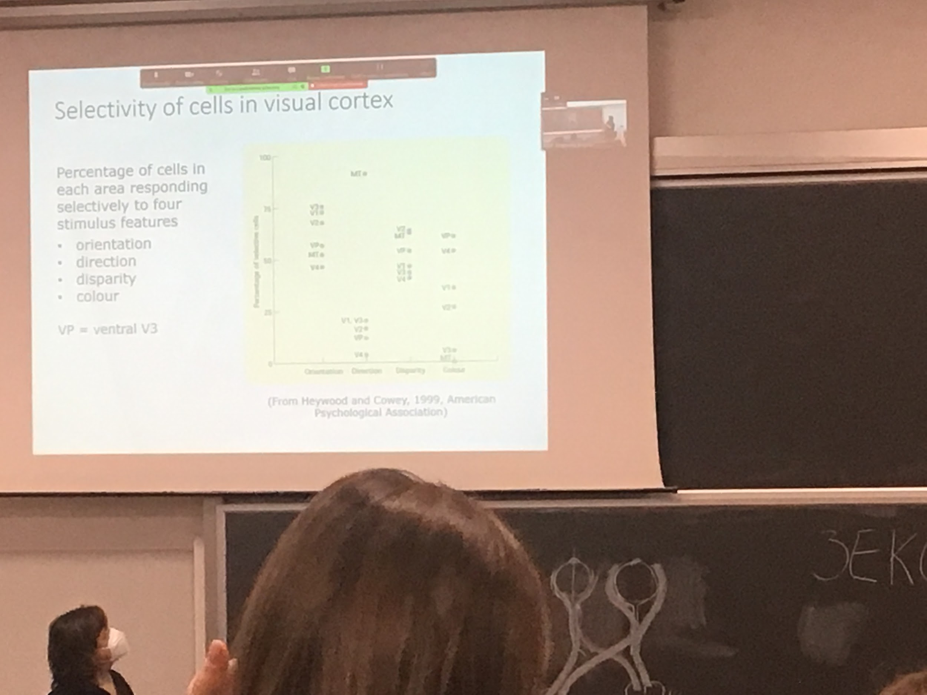

Different areas of the brain compute different types of properties of the signal coming in.

Disparity. Difference in the picture of the left and right side.

Except direction. Orientation, disparity and colour are more distrusted

All area are functionally selective, but is not a pure selection

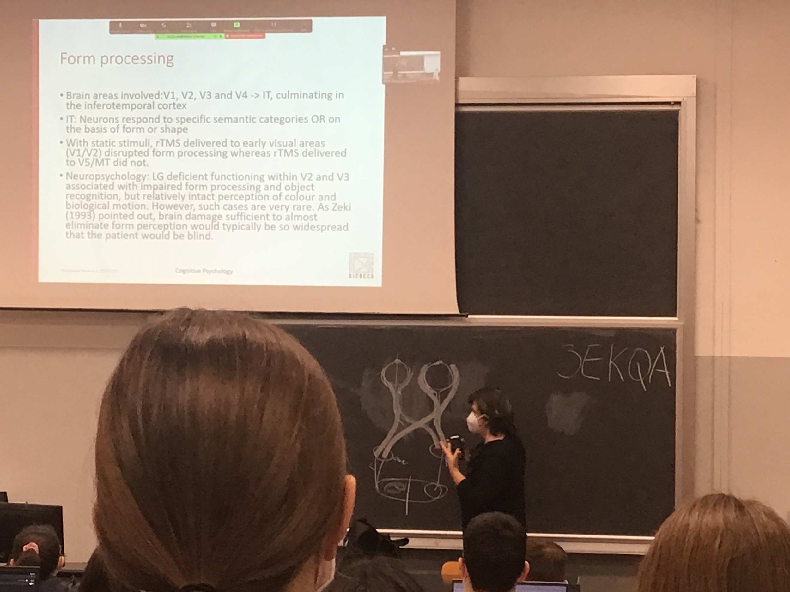

Form processing is mostly done by the temporal pathway.

From v1 and v2 we go to v3 and v4 and the inferotemporal cortex (at the end of the pathway) in this area we find cells that codes shapes and form of objects

When somebody is not able to do task associated to form processing most of the time they have also problem in other kind of processing

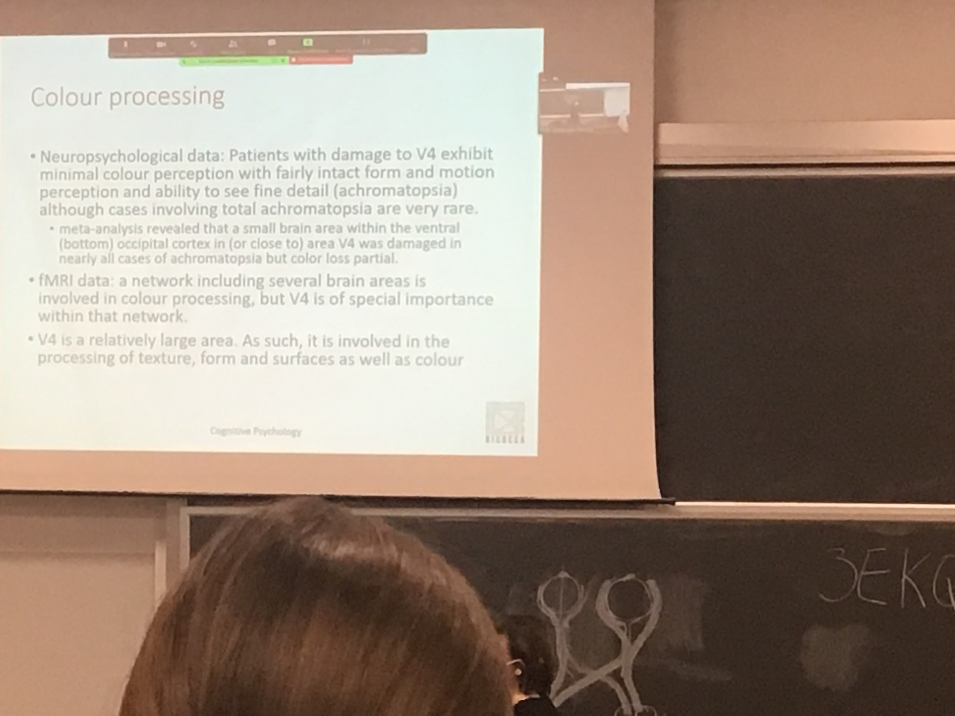

If we find a patient with a lesion in V4 mostly have problem in colour perception they can still detect motion and form and see fine details

Acromataxia: not able to see colours. Pure cases are very rare

When we look at fMRI (activation of area when people perform task that require colour perception) we see some area active but V4 more activity.

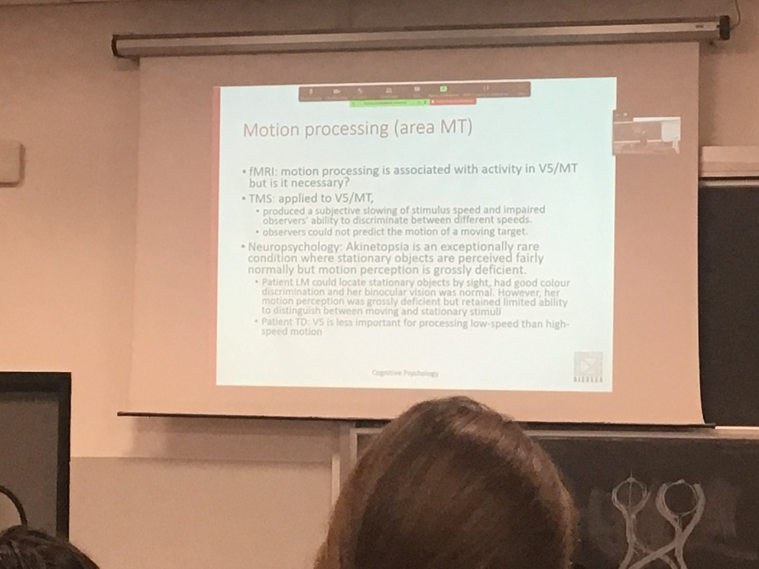

MT is the most important area dedicated to motion perception.

Akinetopsia: don’t understand when things move. Can not predict where the moving object will be

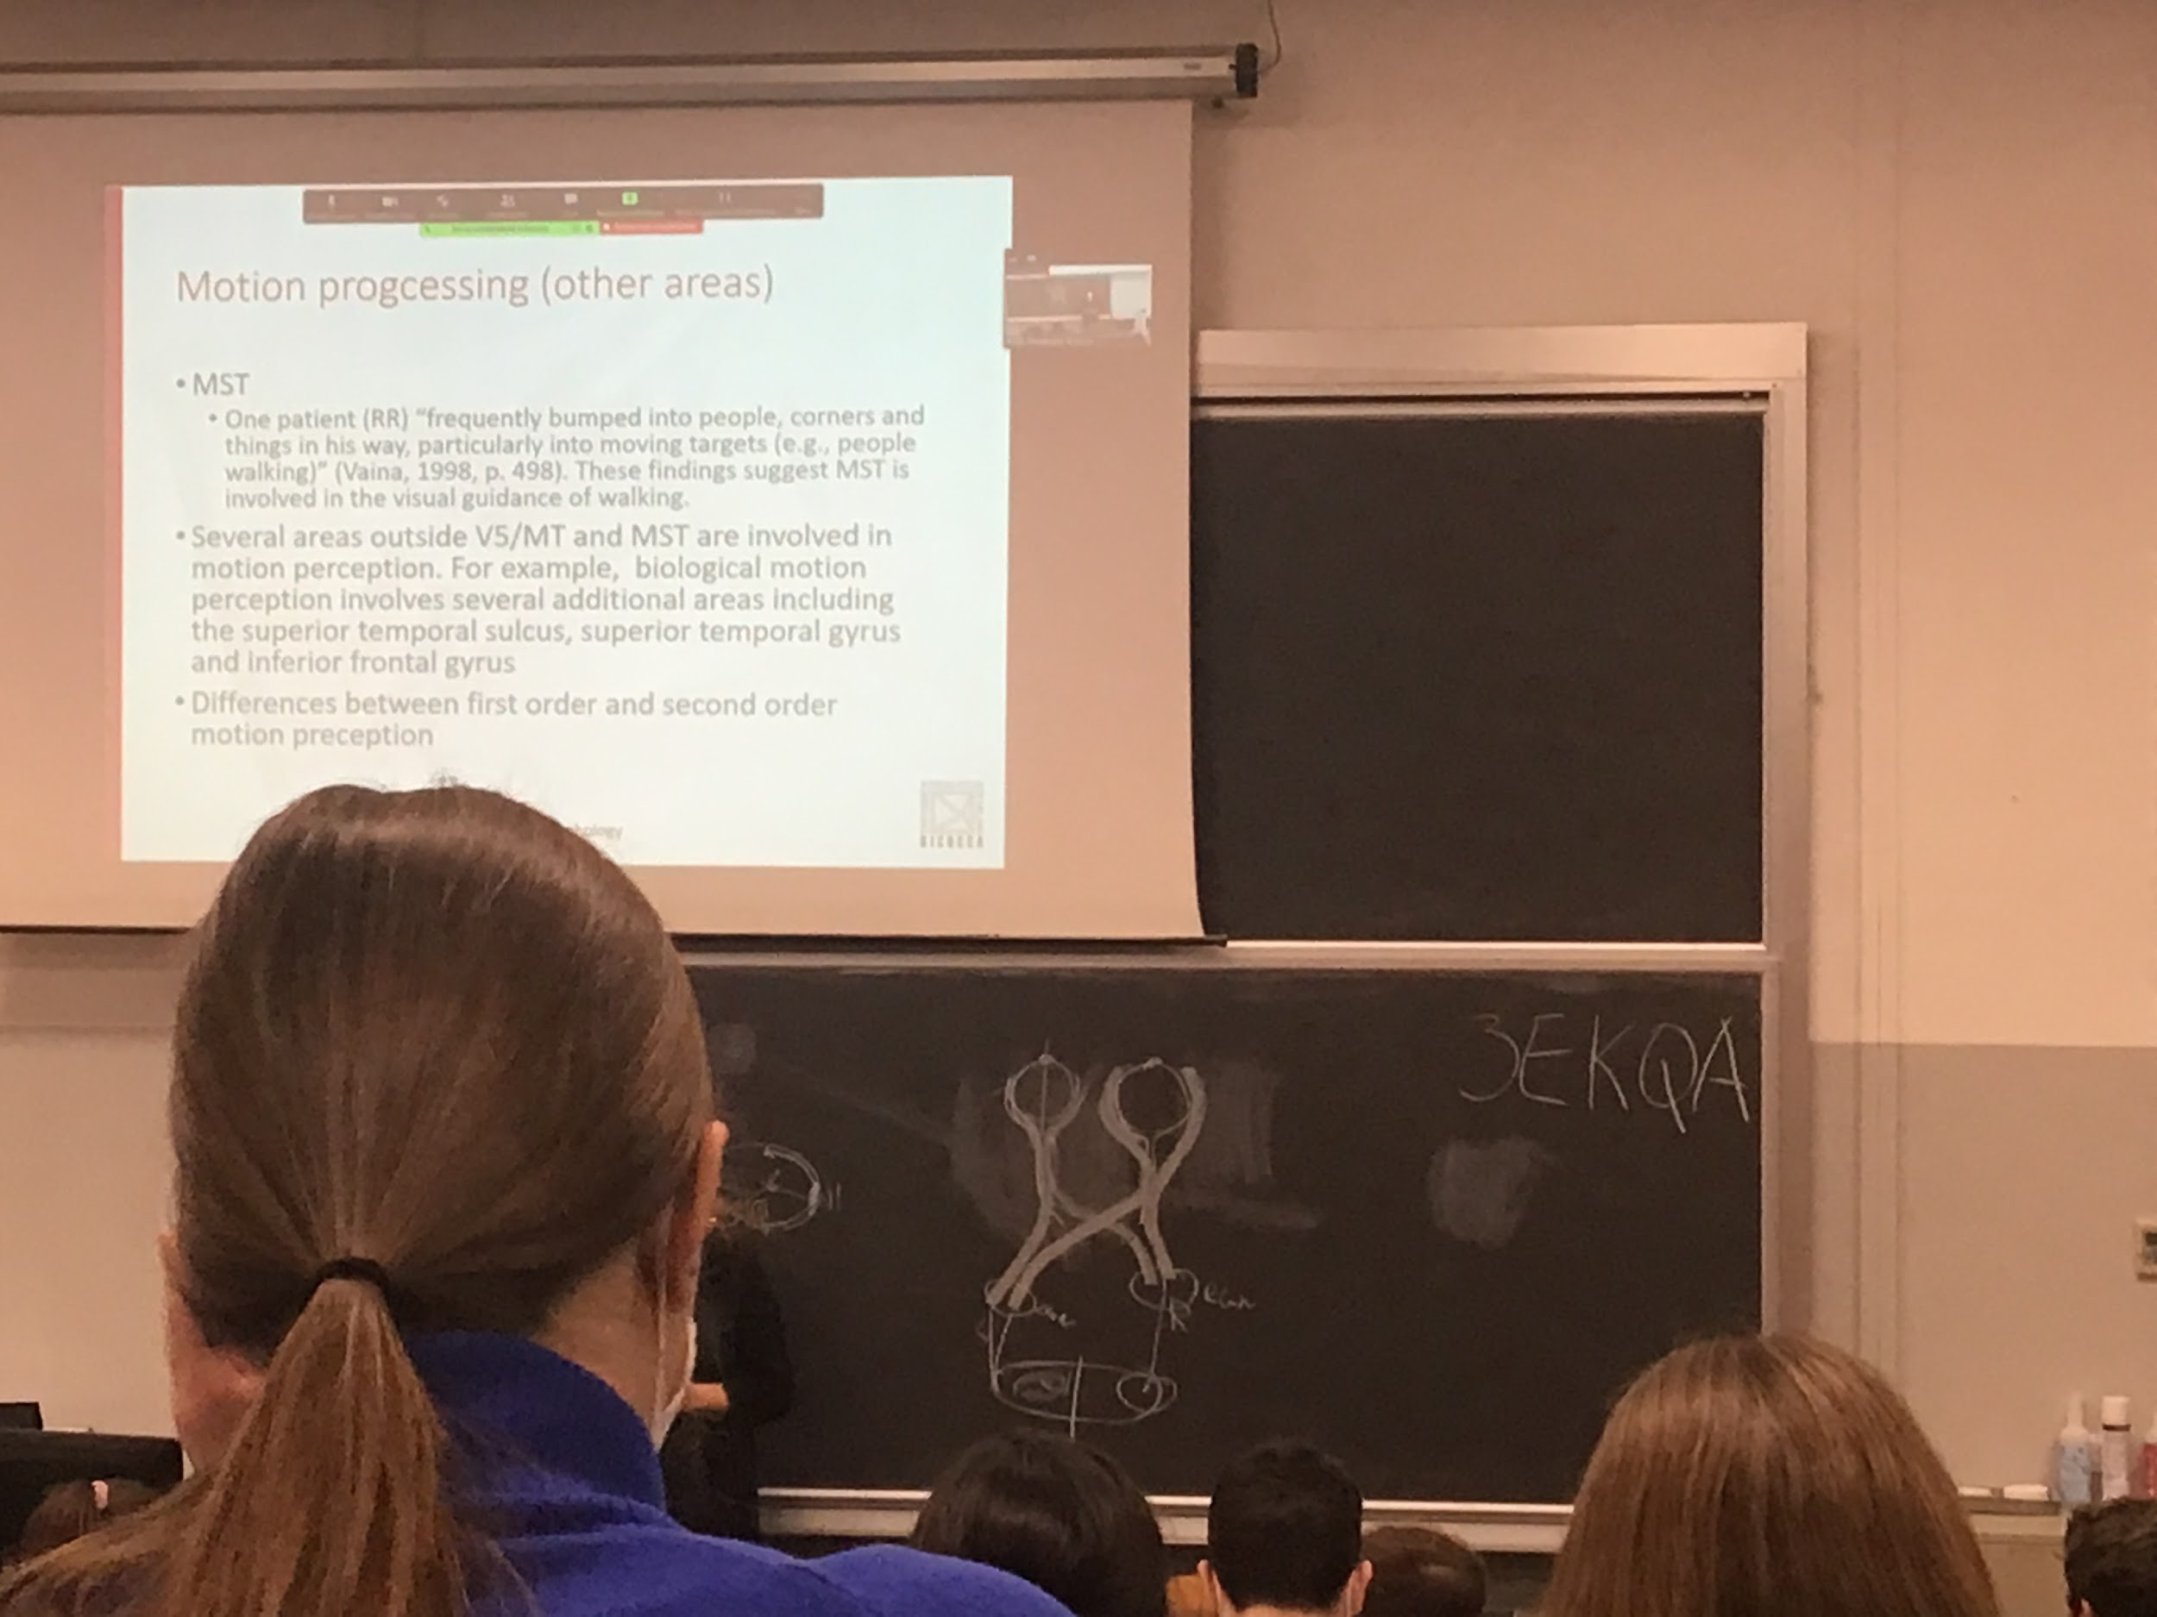

Patients with this kind of lesion they have a deficit that does not allow them to understand where things are. Don’t understand if things are moving in on direction of another.

Coding the position of something stable is done in an area.

MST important to luminis stimuli. Stimuli coming toward and away from you. MST update fast the information about where something will be in 2 seconds if you keep moving at this velocity

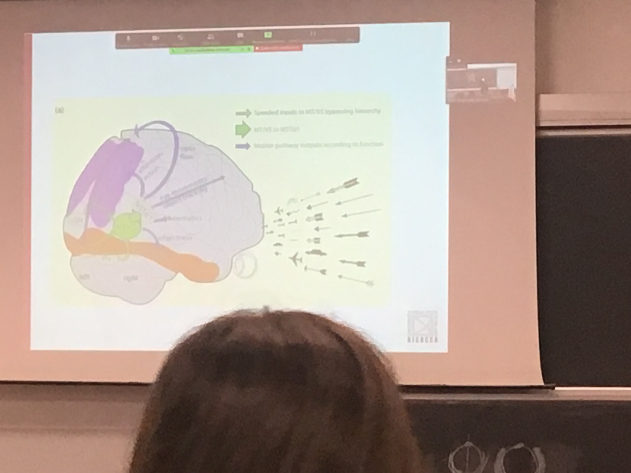

To detect motion you need to know the borders of an object.

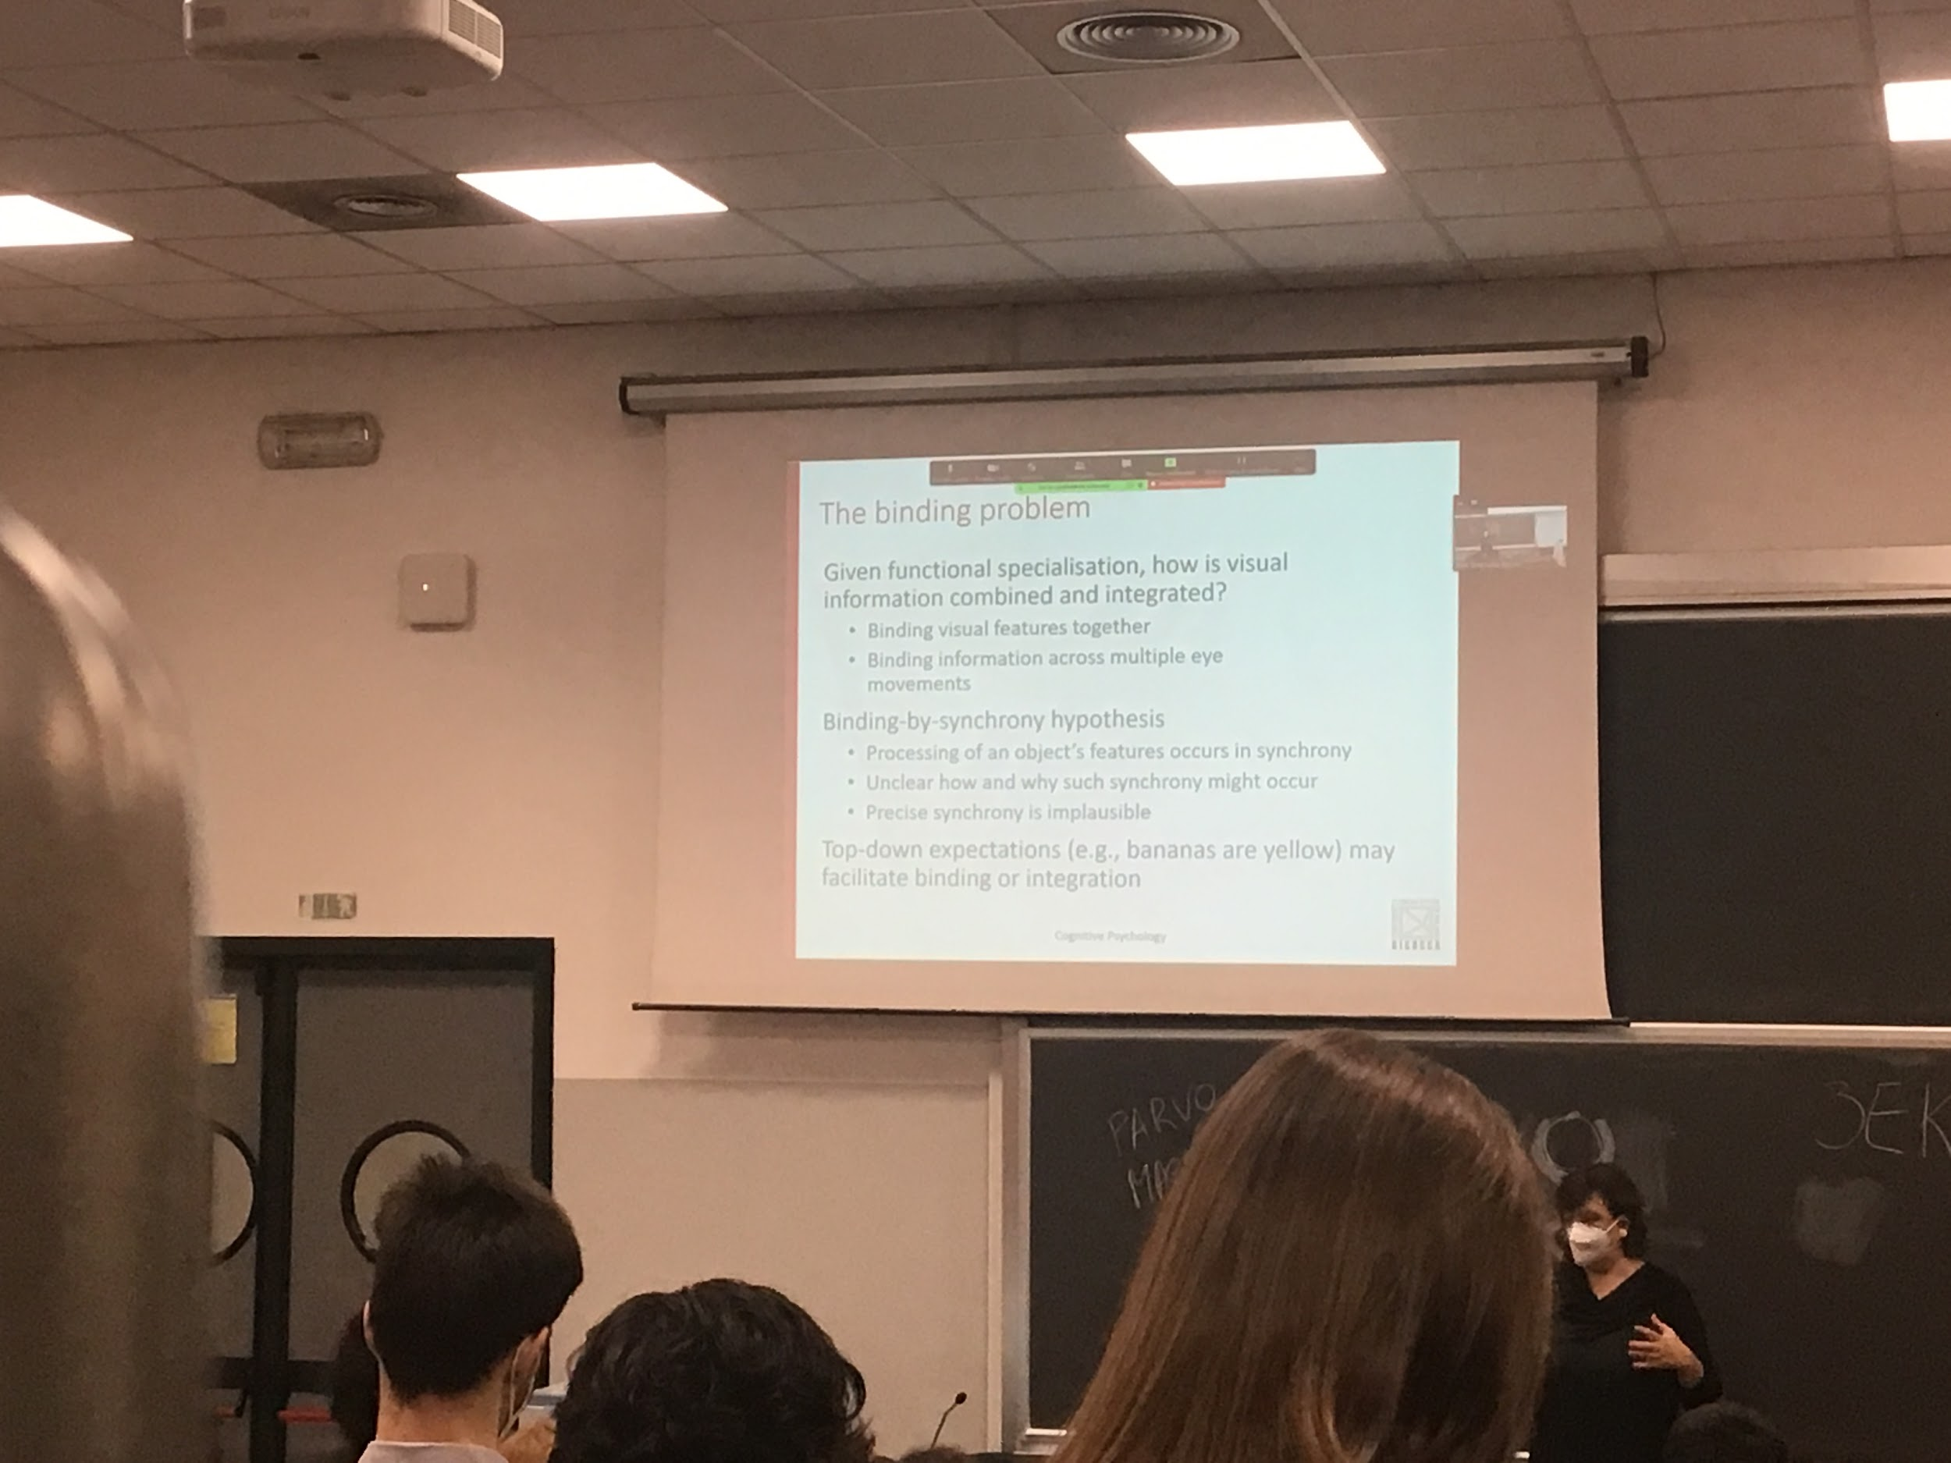

If different modules compute different types of information.

We don’t perceive either motion or colour. We perceive everything together. I have a feeling of a single word

In each millisecond we move ourself, the objects and the eyes… we have to keep putting together informations, informations keep chaining

One hypothesis is that we use syncronhy.

Once I see an object the information goes to V1 then is spread in the brain. But if I synchronise the information, everything that comes out of v1 at the same time is relative to the same object.

Use the timing of the numerous activities to put together the information. Different areas take longer or shorter time to code. Nobody have demonstrated this synchronism theory

V4 (colour) takes longer so is more difficult to syncrnise.

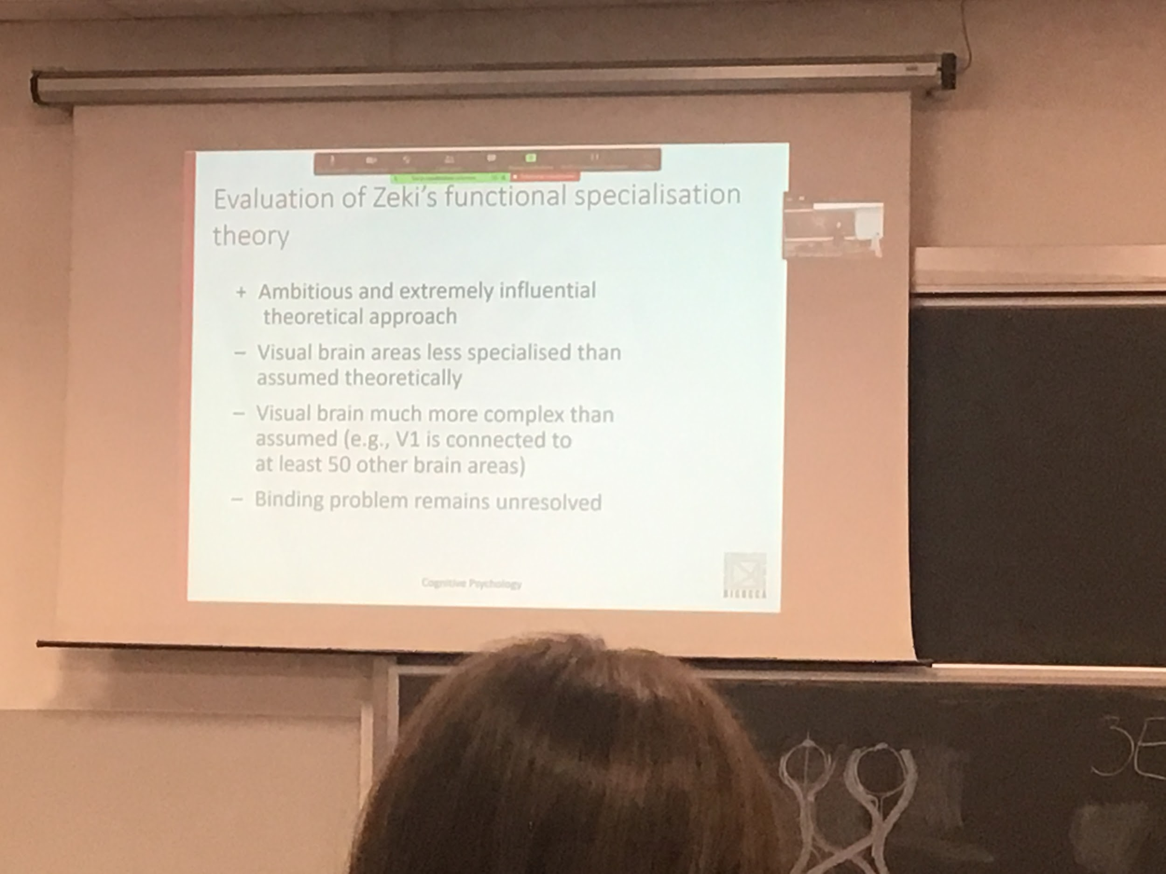

The idea of functional specialisation is still in the literature. The idea of different areas doing different things is now granted.

V1 projects to 50 different areas, not only to V2.

The binding problem remains unsolved. How do we put all together to get a global perception is still a mystery.

After break

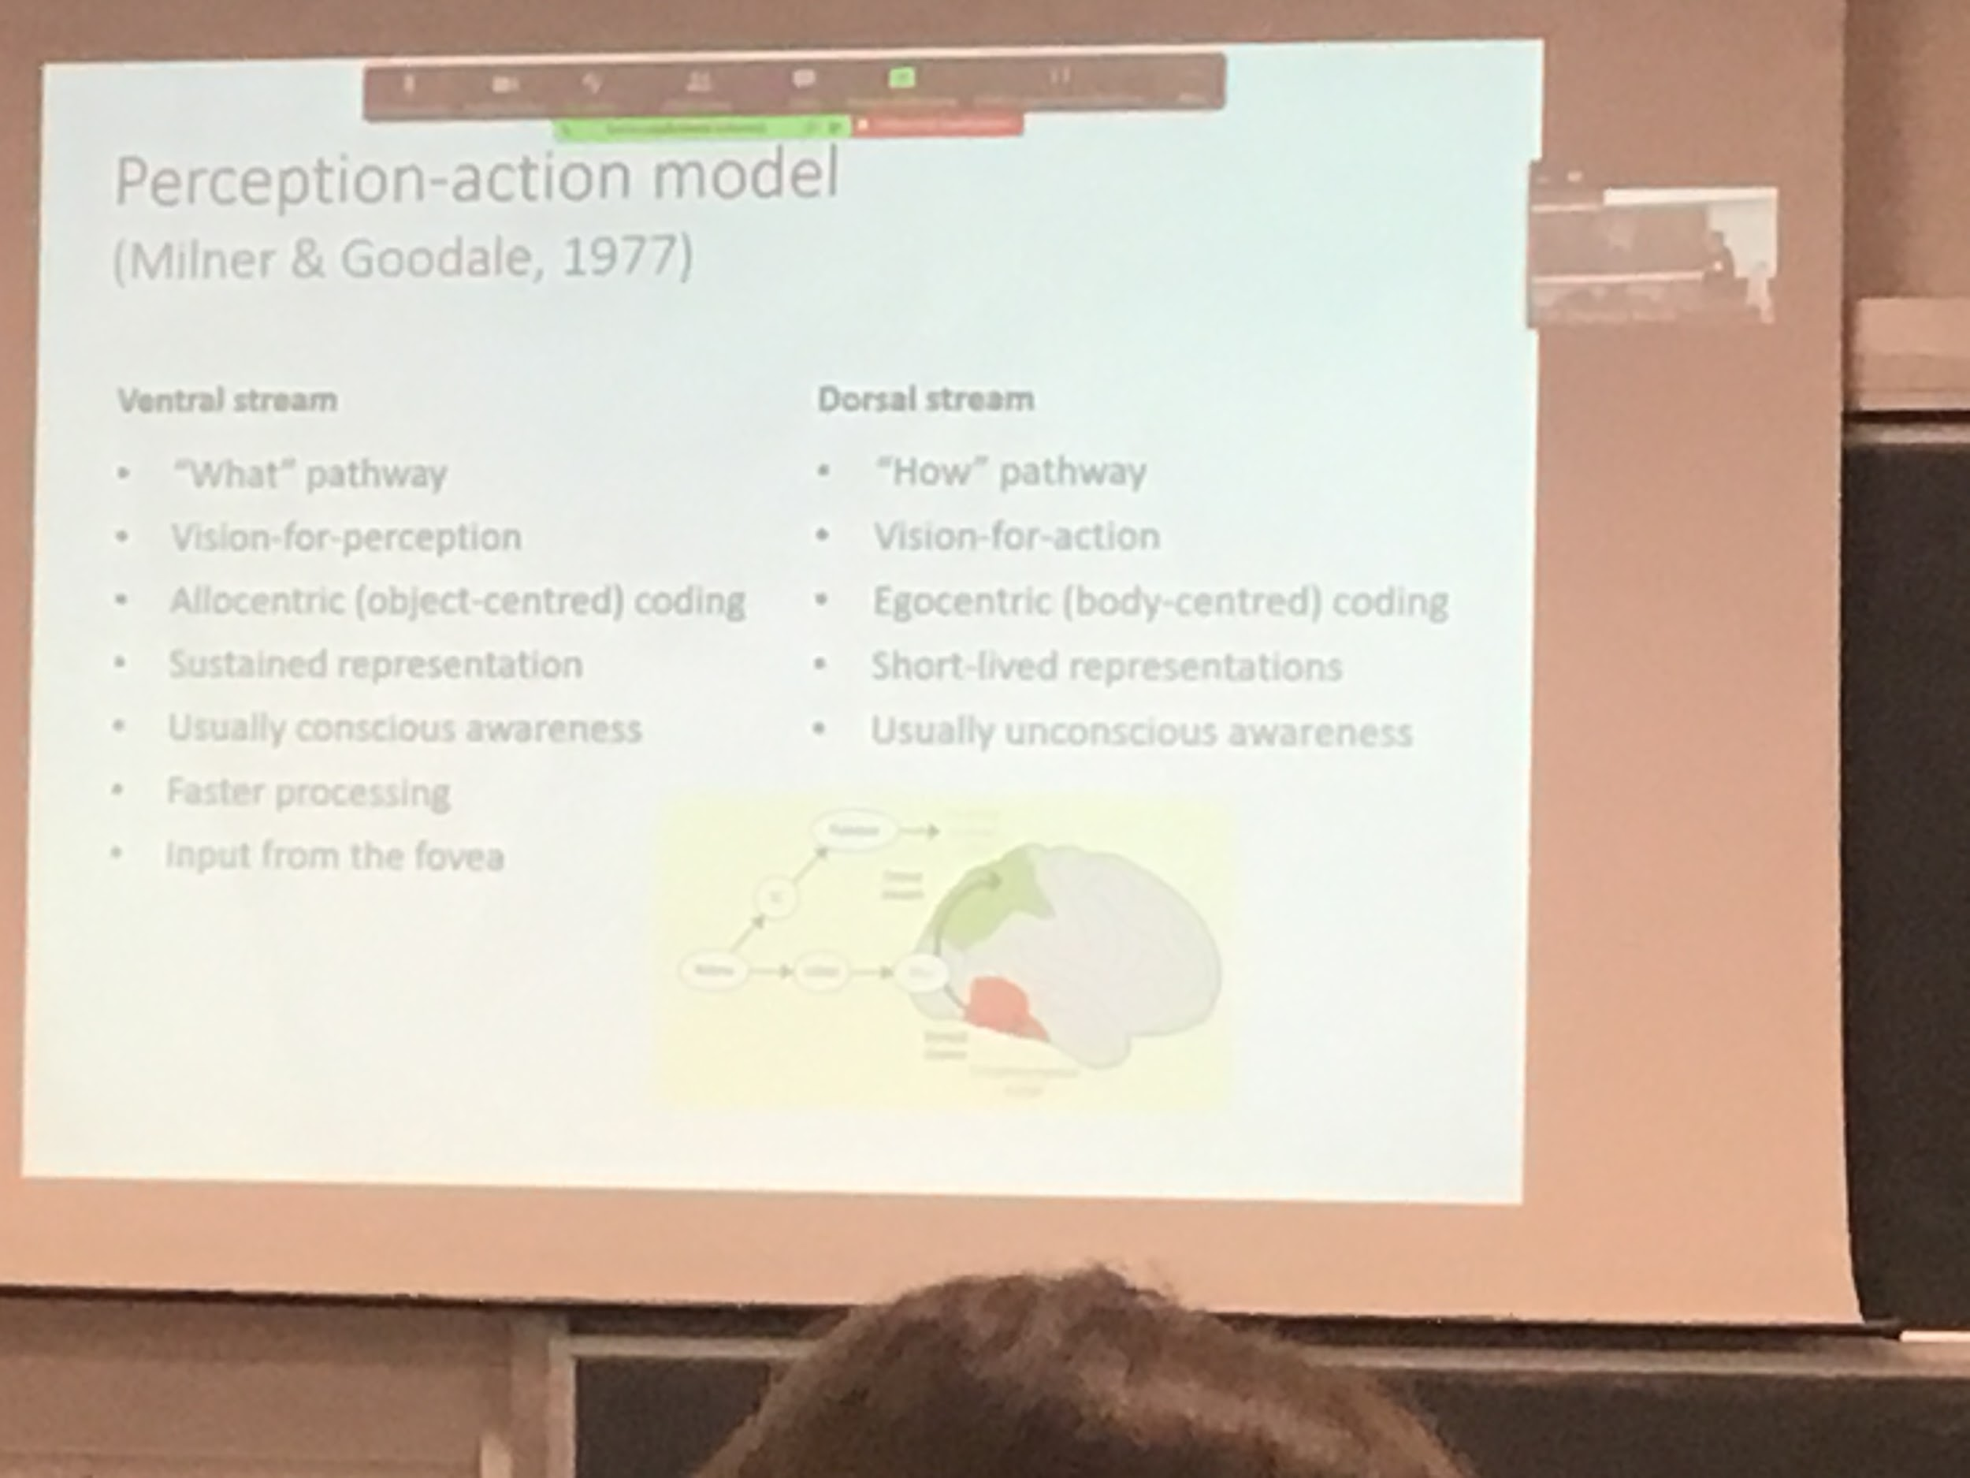

Milner & Goodale, 1977

Propose this model starting from data from an Italian patient.

They say that the information from the retina goes partially to the superior colliculus (SC) and the pulvinar. Also from retina goes to LGNd (dorsal lateral geniculate nucleus) to V1

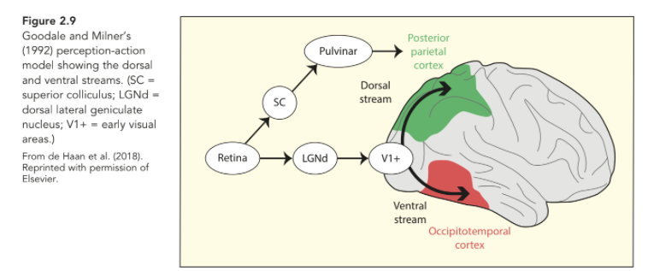

**Ventral stream**: what pathway. We code *what* the object is. Is a mountain, a person, a bike?

**Dorsal stream**: How pathway. *How* to interact with this specific object.

Same identical input stimulus gets two different representations. One for perception and one for action.

What pathway: concerne with form and colour processing and with object recognition

How pathway: concerned with motion processing

The same identical input stimulus from the eye gets two different representations. Two different goals:

* One for perception, to know what is there
* One for action, use by the motor system to perform axe on the environment

Need two different representation to interact with the object

The different representation:

* Ventral stream has the **allocentric**: object oriented. Focus on the form of an object and isolated from the environment, don’t care where the object is. Have a mental representation of the object (like a cap) isolated from the environment
* Dorsal stream has the **egocentric**: need to know the relative position to me. The different types of representation are created to two different roots. It is stable and maintained in time. Keep information for a longer time. The representation is short live, need to change and update very fast

When we perceive an object we build a representation along the ventral stream, usually this information reaches consciousness. I am aware of what I see. Not necessarily true along the dorsal stream (all the axioms that we do without being consciously aware).

When you automatize a motor task you are not any time conscious of what you are doing

In the ventral stream there is a faster processing.

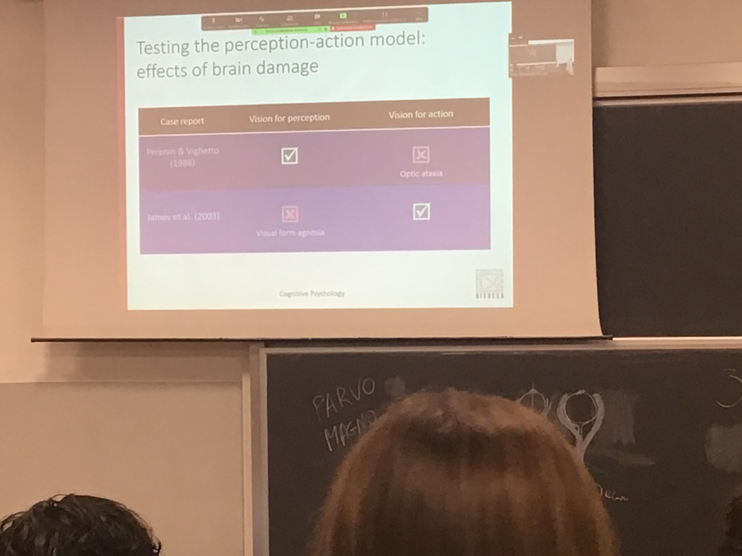

One way to test is to see if we have the double dissociation. People having lesions in one type of area but not in another and vice versa.

**Optic ataxia**: lesion in posterior parietal cortex. Have a perfect object perception unable to perform task and interact with the object

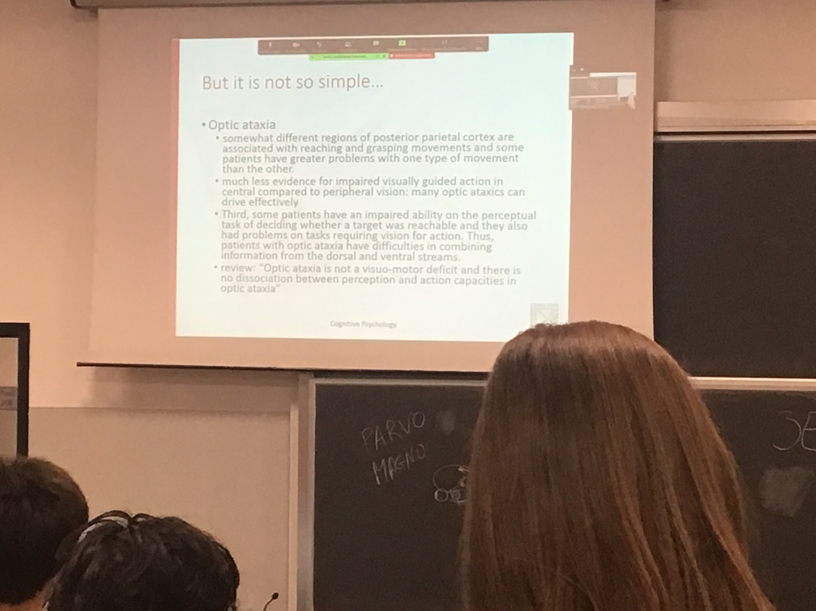

People with this type of lesion don't perform well to reach and to take an object. Lesions in this stream show deficits in this kind of movement and not in perception.

Some have problems in object recognition because these two roots have a lot of interconnection. We always need to remember that there are a lot of interconnections.

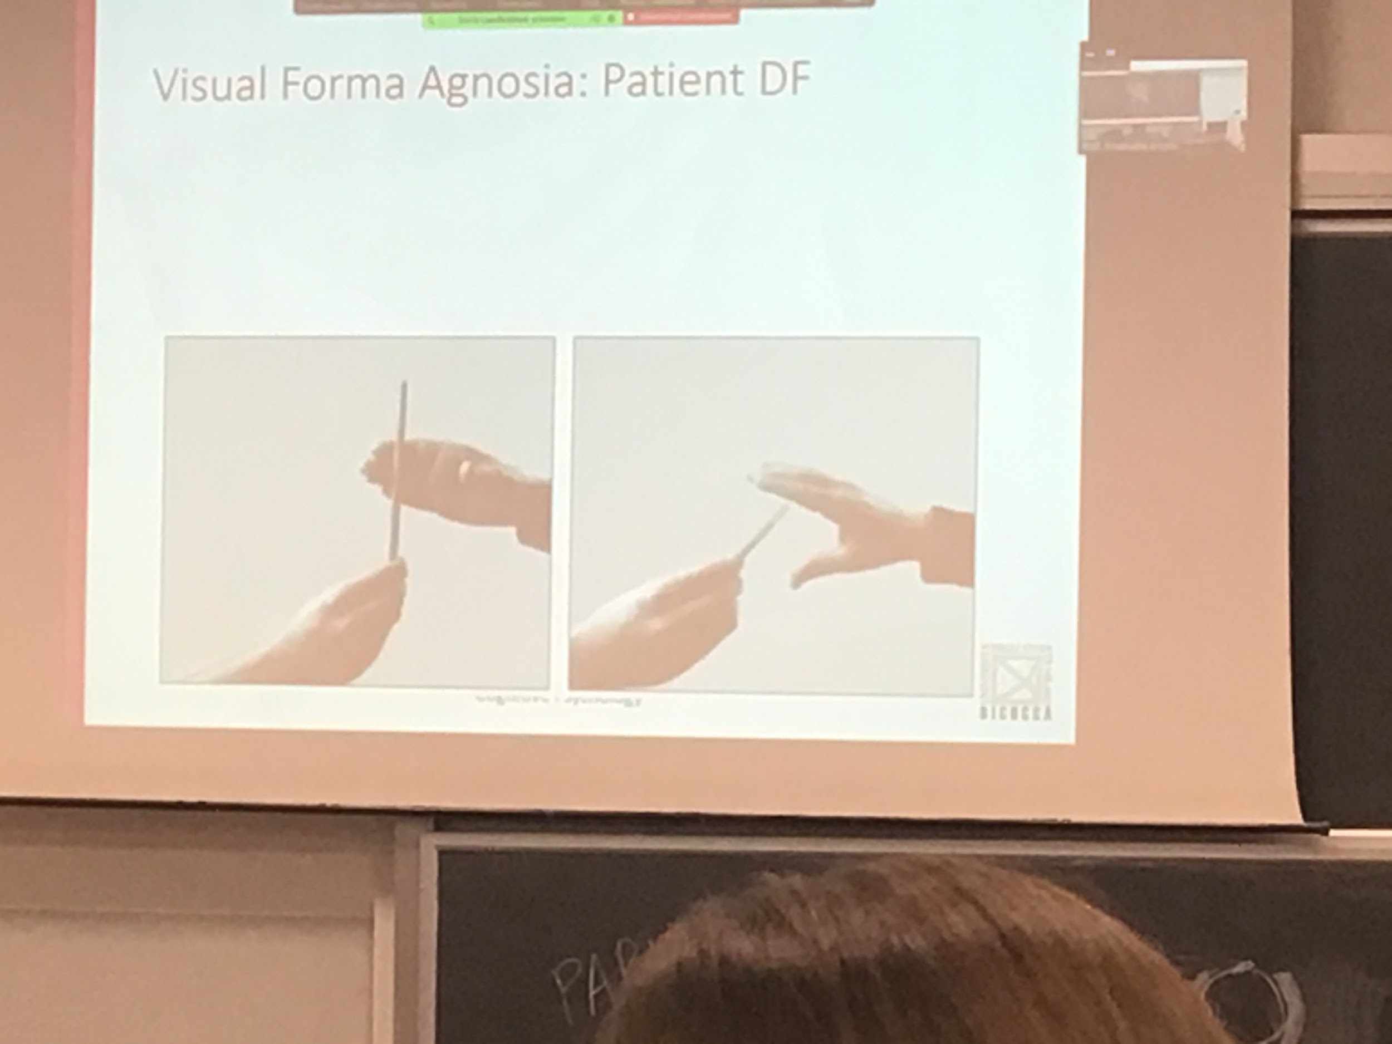

You have to test a patient.

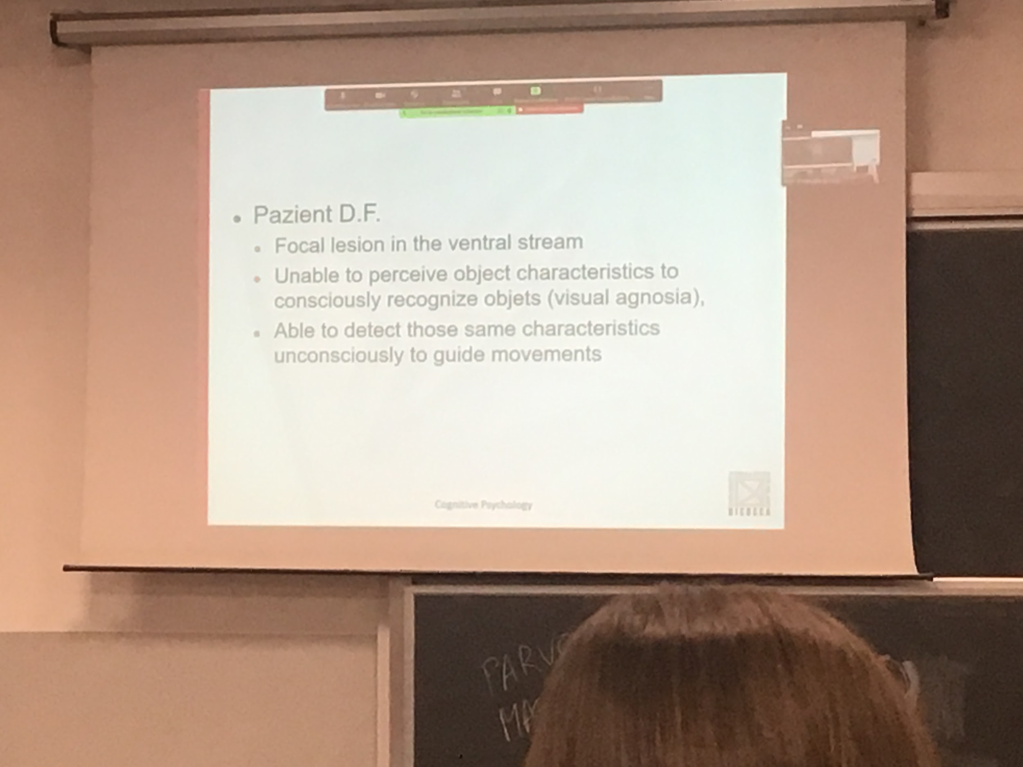

But she can perform action on the objects correctly.

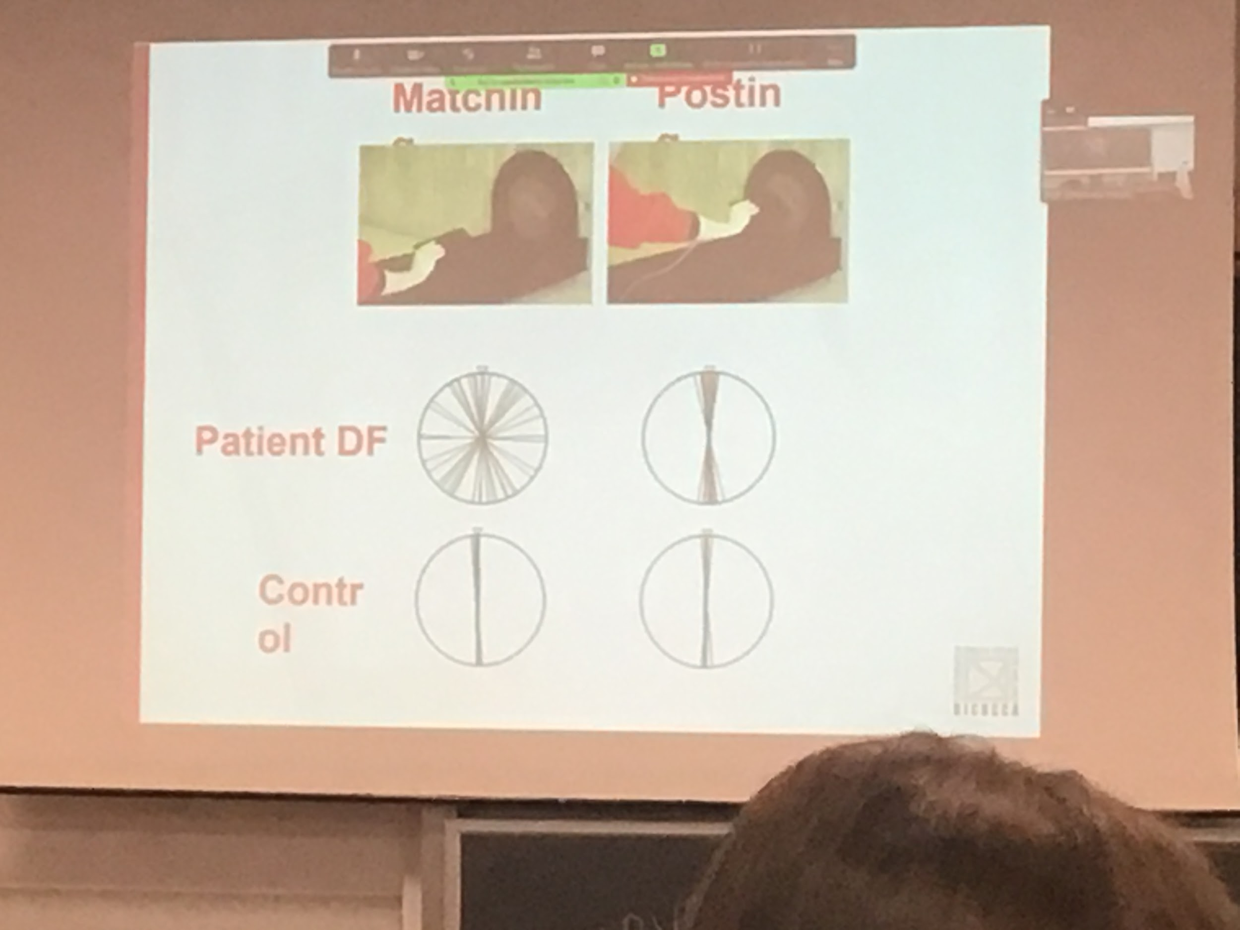

Ask the patient to do two task:

* keep the object in your hand and orient the object in the same orientation of the red light.
* now thing as the object to insert in the red line.

First task (orientation matching):

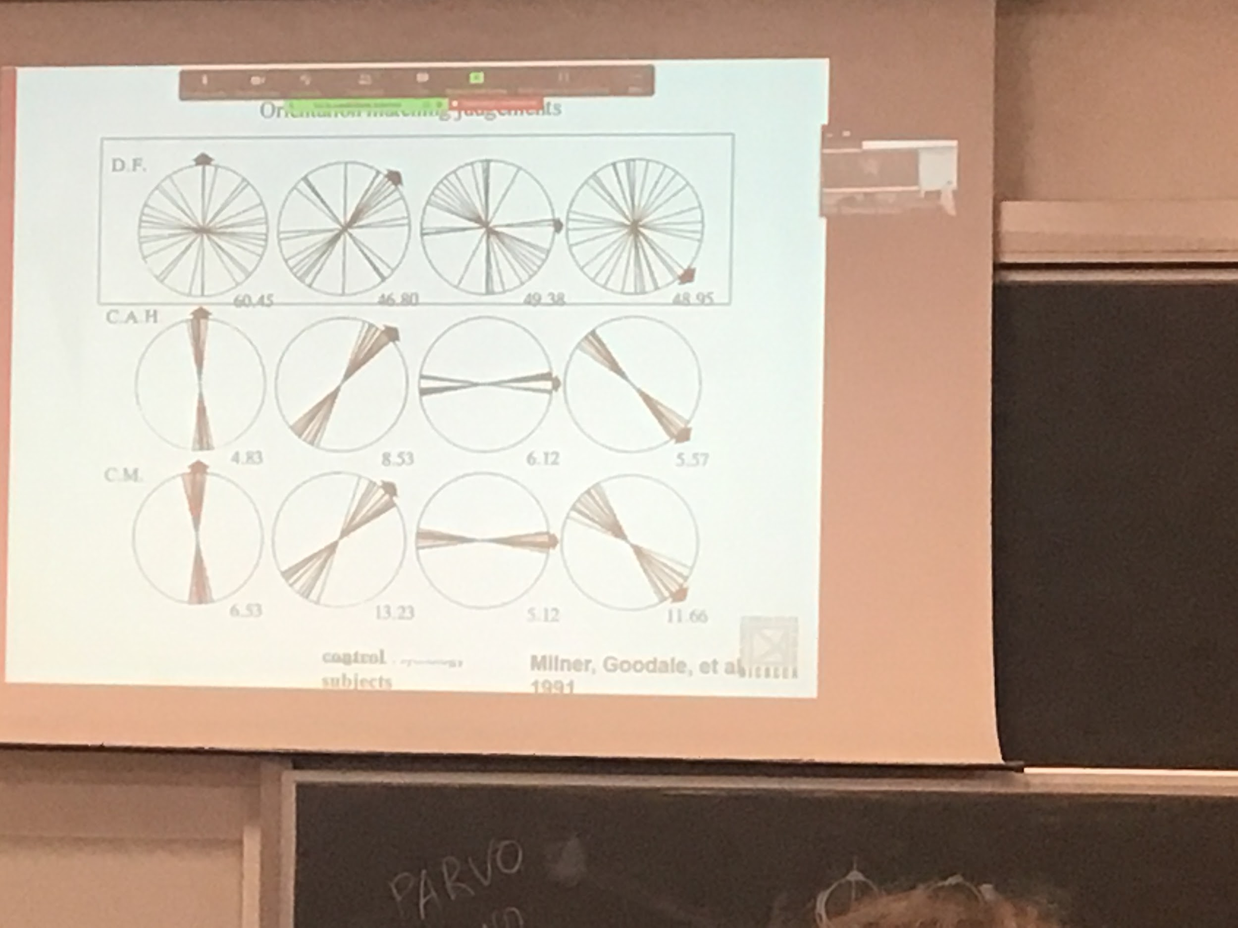

1st row is the D.F patients, 2nd and 3rd are the control subjects

D.F. Has no idea, does the first task complexity random. There is no perception

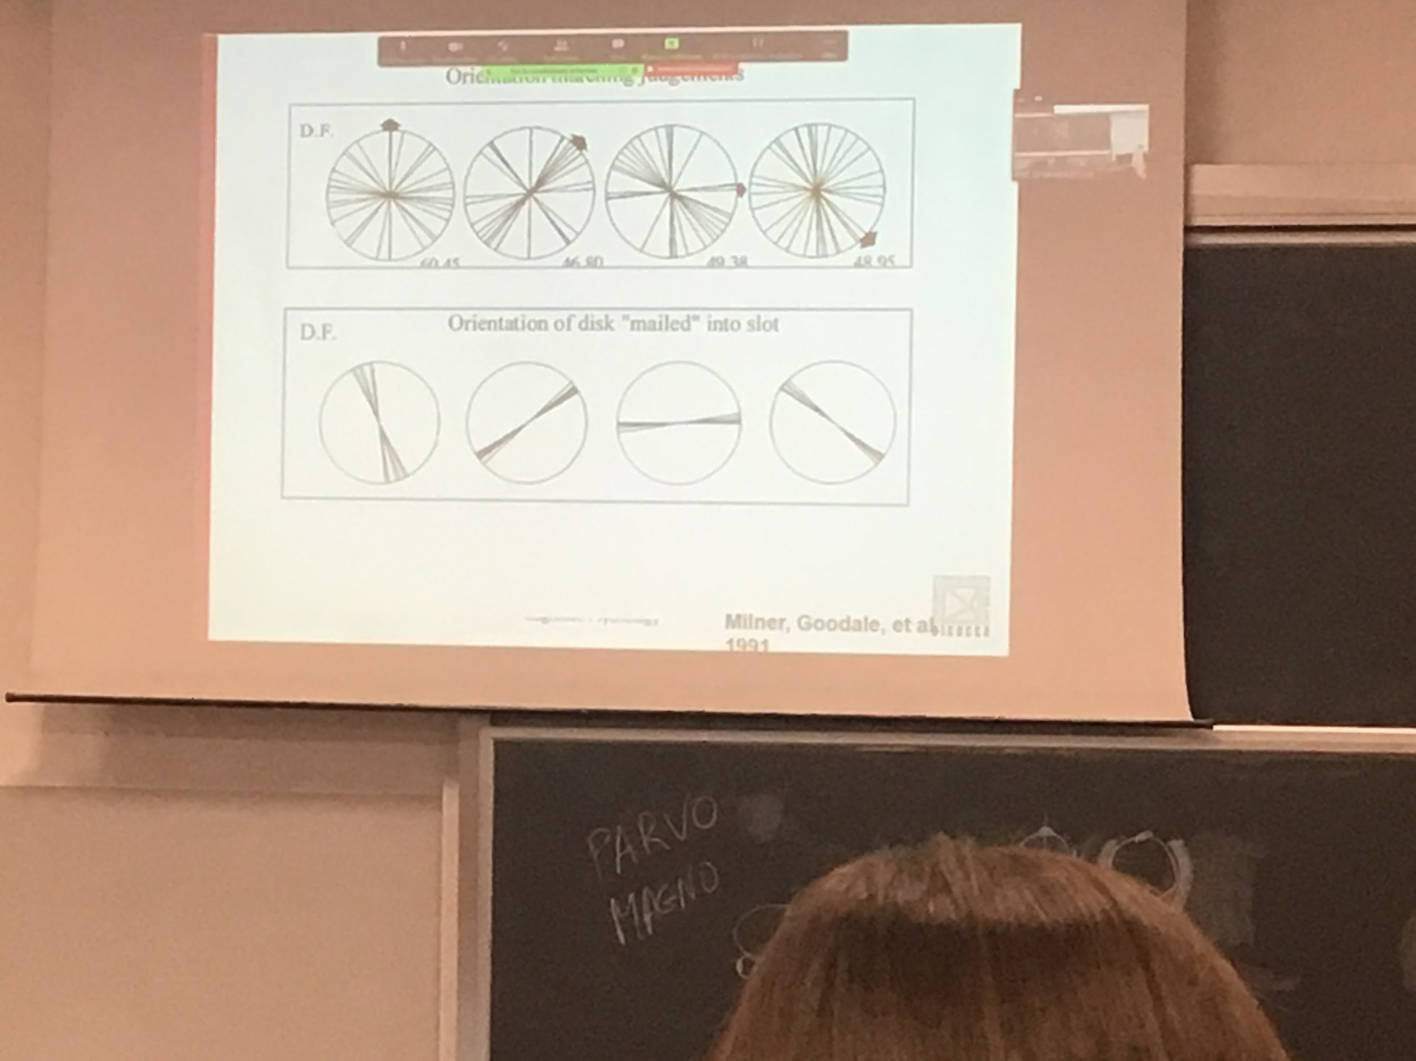

But if you ask to insert (perform the action) her motion system knows how to do it. This is visual formalnoxia: inability to perceive, ability to produce an action to visual representation.

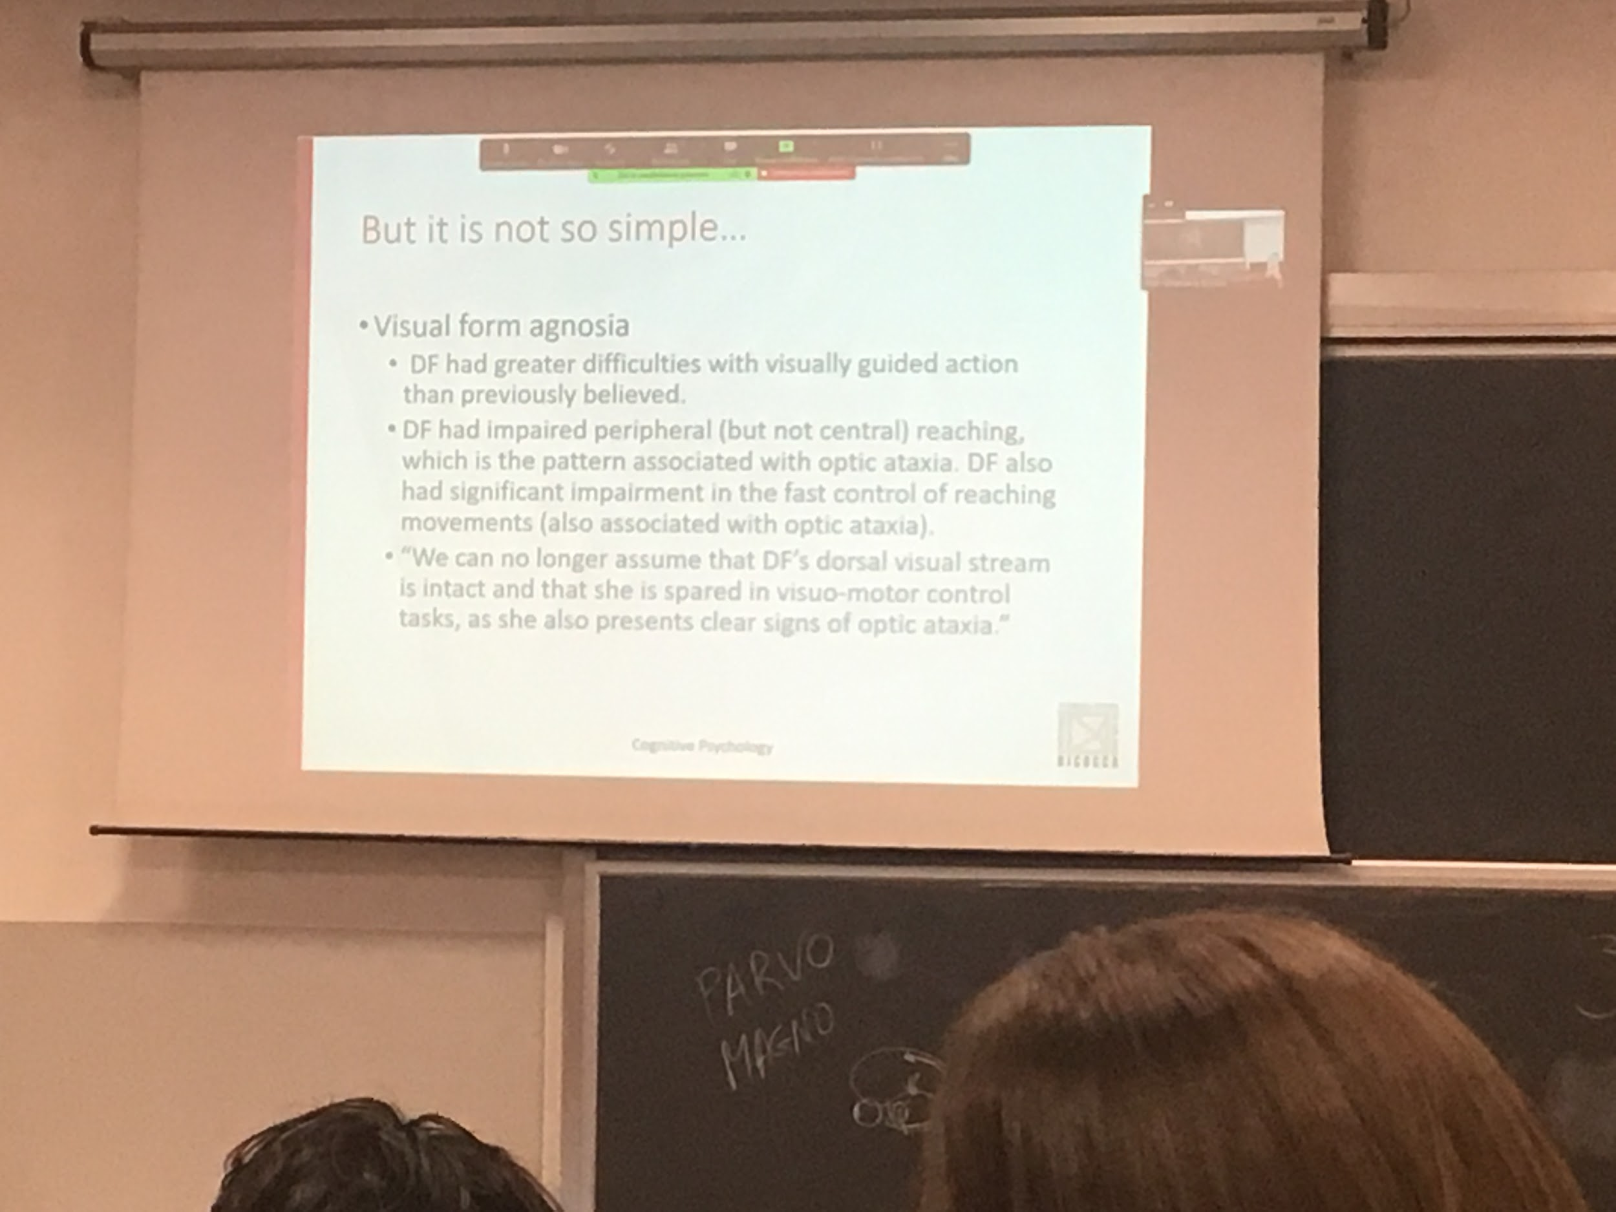

Some people say that it is still lesion study. In the healthy brain can we separate perception and action? One way to study this is with visual illusion

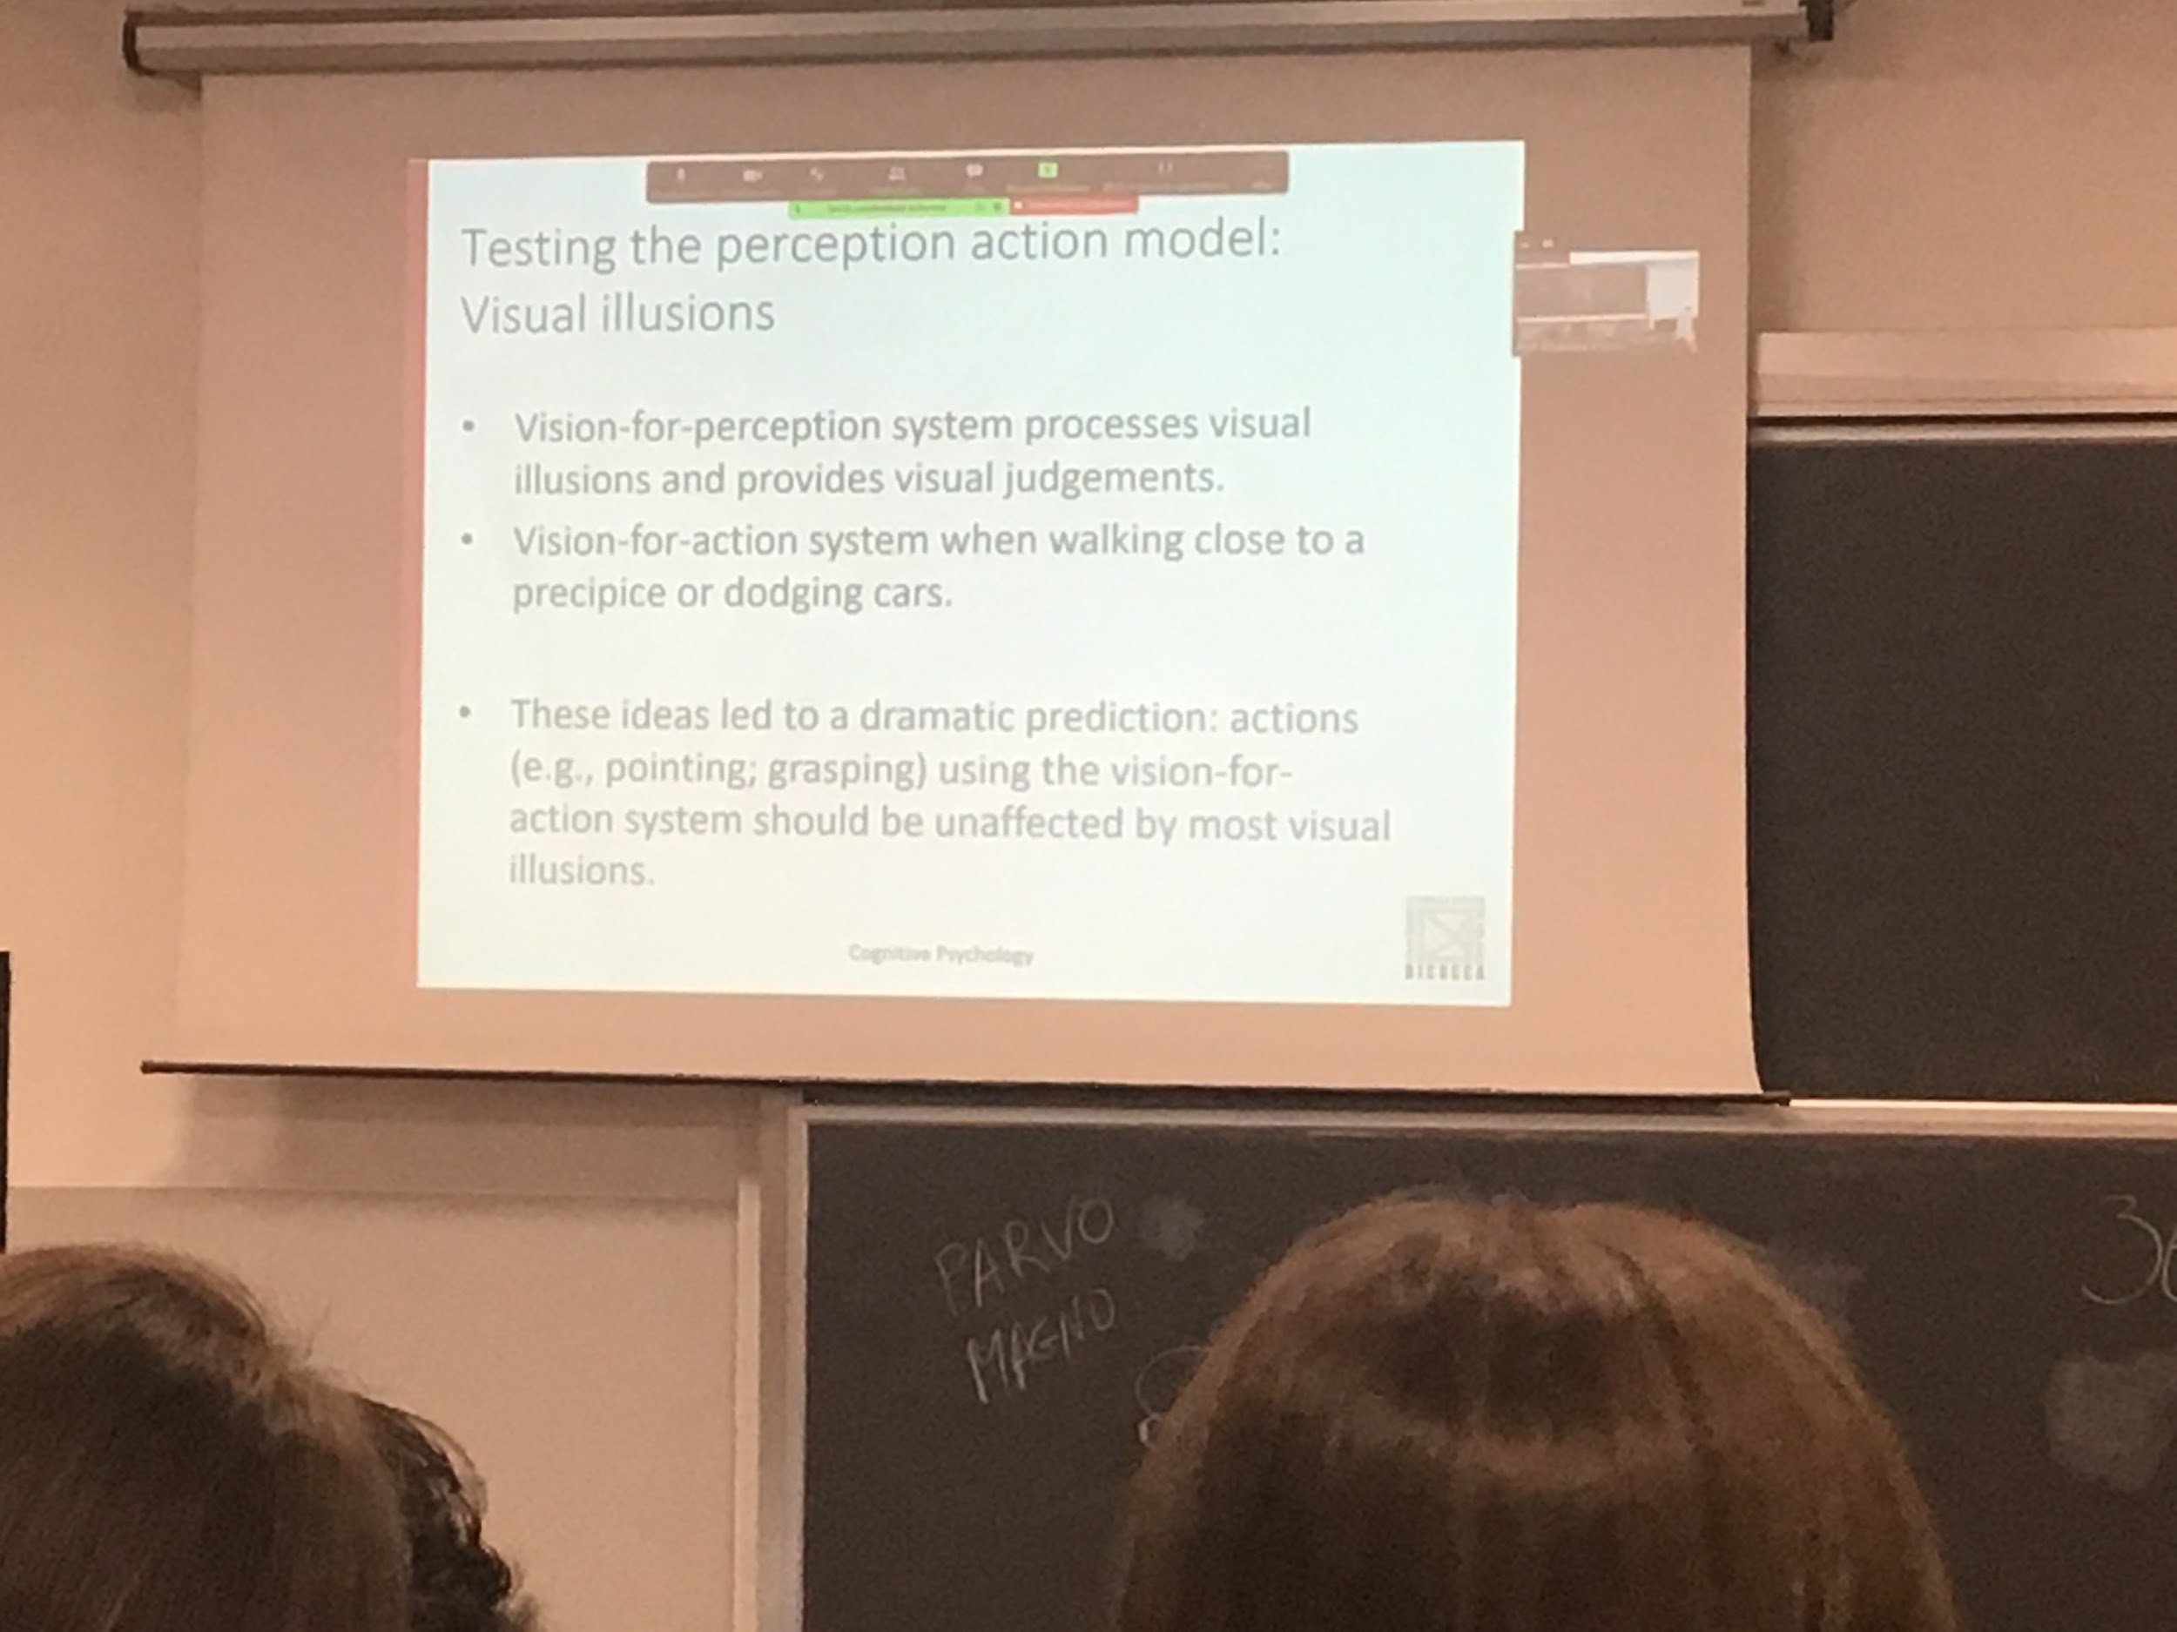

Stimuli that have some kind of properties but our perception is different from reality.

Our brain knows that it is working in 3D but is starting with a 2D image.

Visual illusion should work for perception. The temporal pathway use this original hypothesis and truth this pathway we have visual illusion

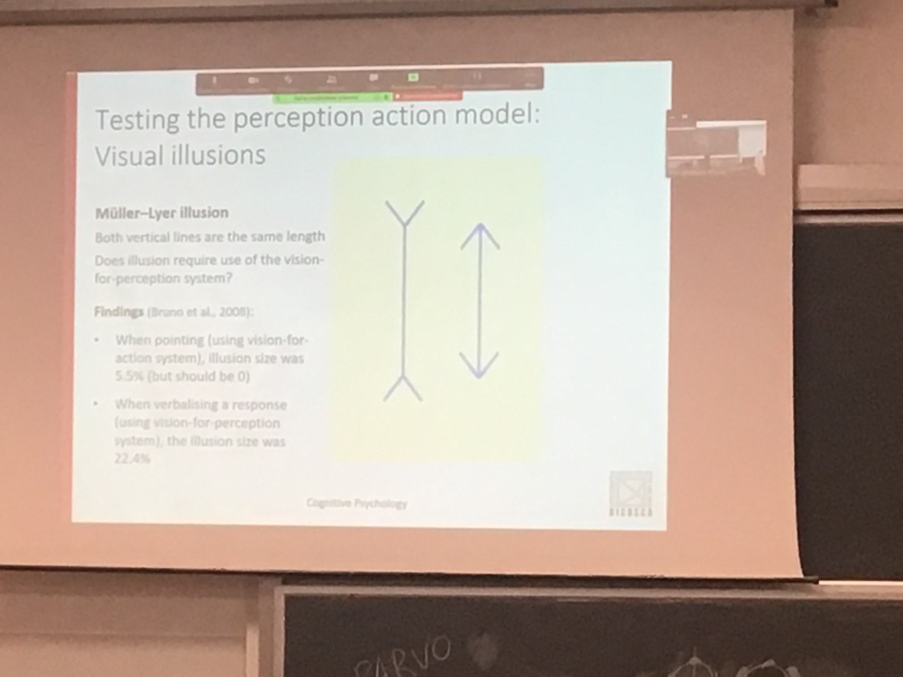

**Muller-lyer illusion**

Two lines of the same length

Your perception is that the left one is longer.

Reason maybe is that 3D it looks like a corner

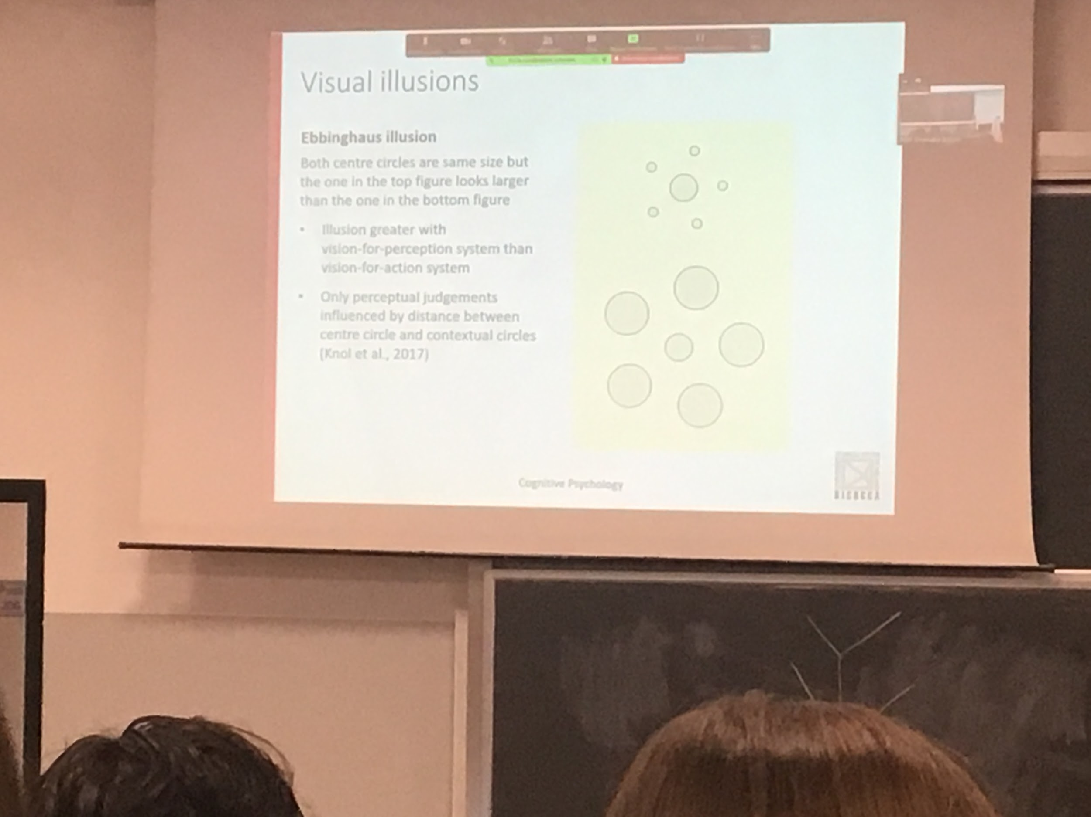

The central circular are same dimension

The perception is that the upper one is larger.

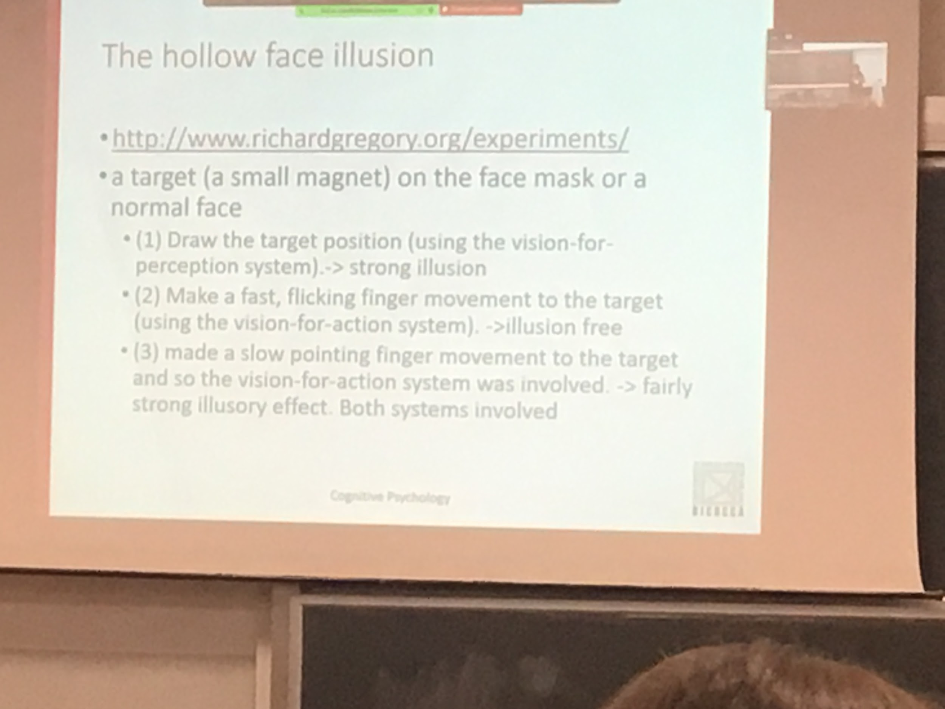

<http://www.richardgregory.org/experiments/video/chaplin.htm>

Trick the visual system that is coming out.

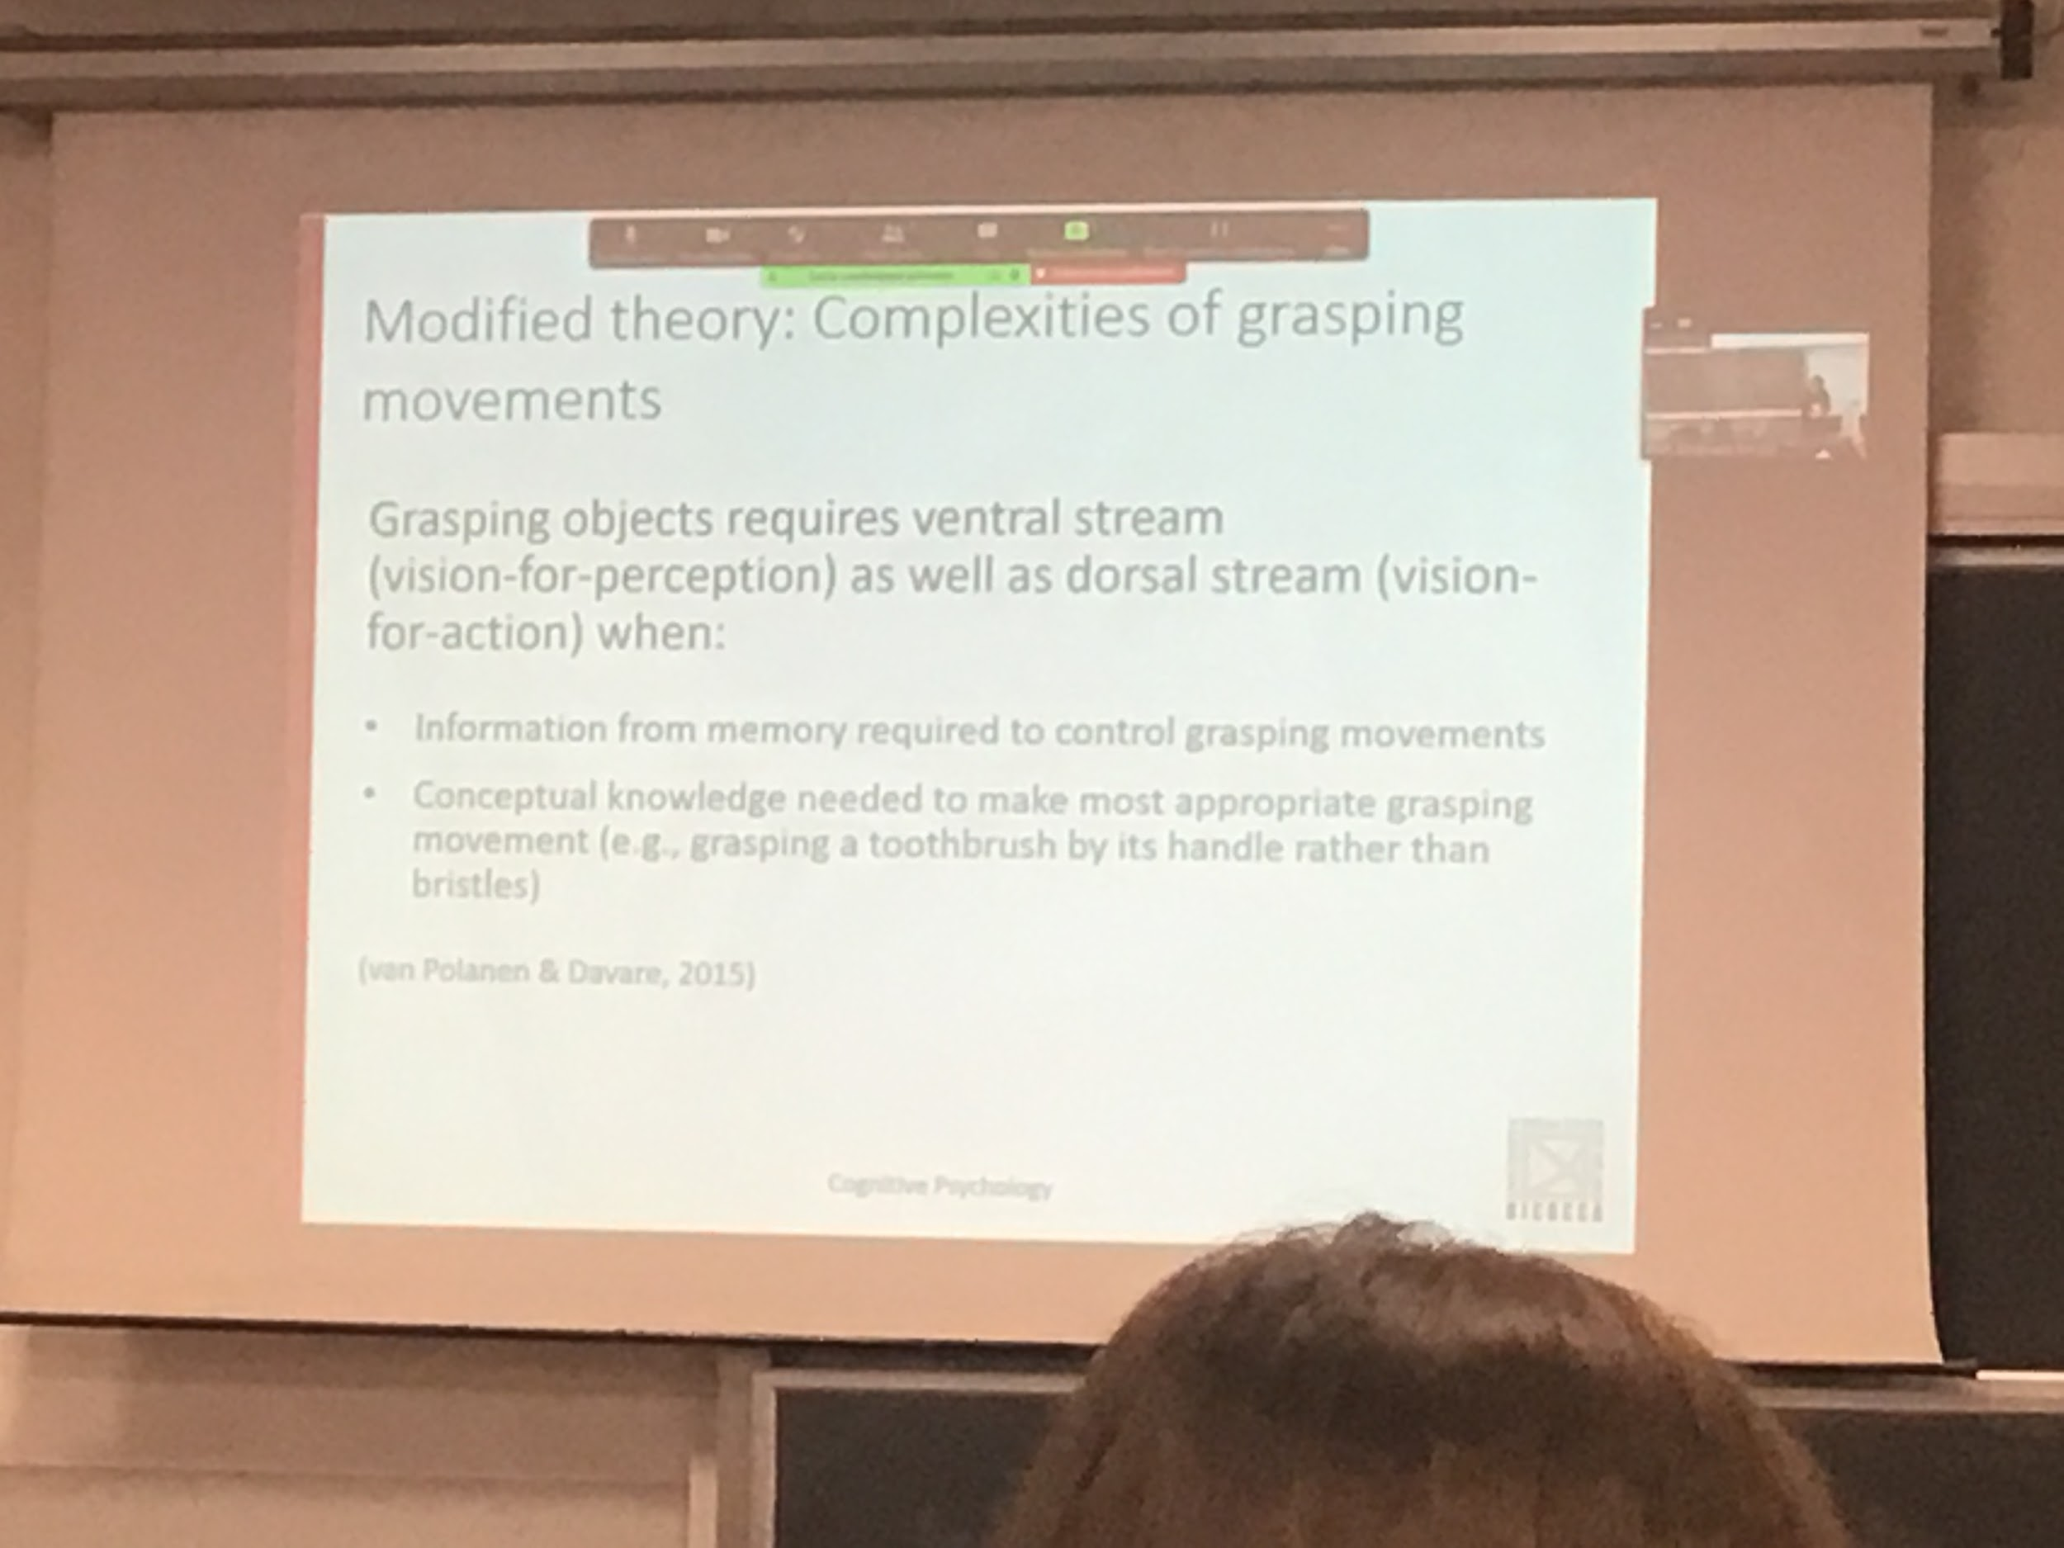

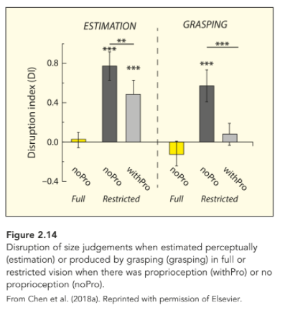

Experiments that show the interaction of the two systems.

Proprioception: know where our body is

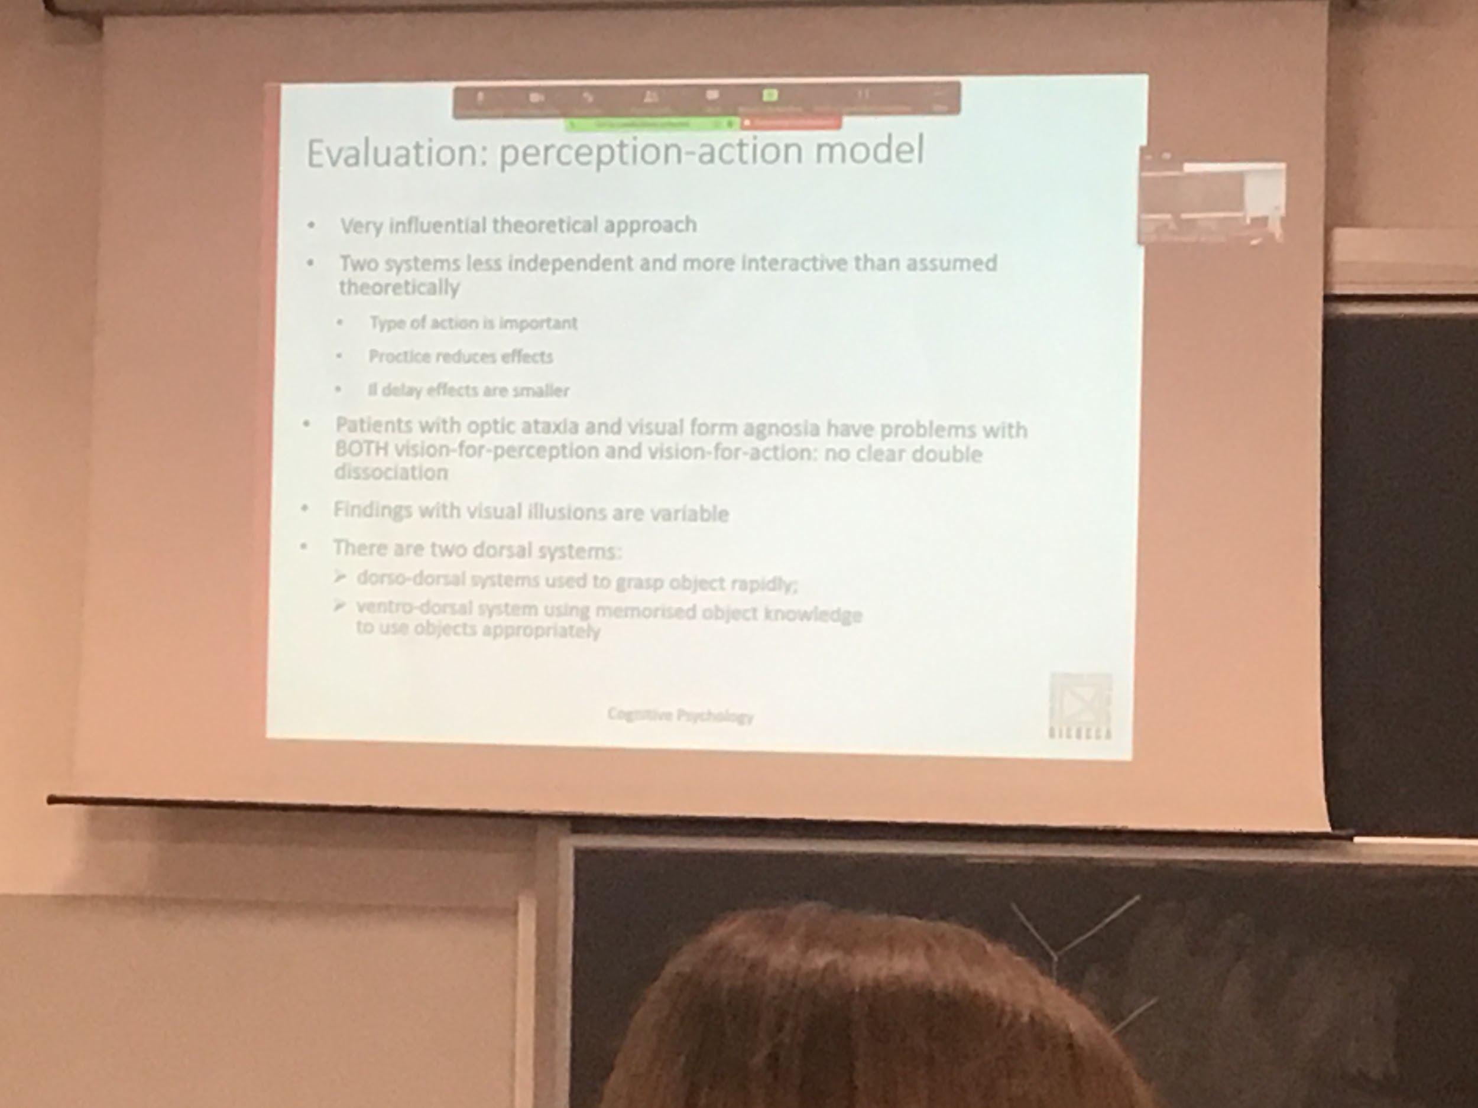

Perception-action model: still used to explain different findings. Even if there is interaction between the roads we still use it as a framework for two data. The two system are not completely independent

When you practise with a task

Three root DSA

* fast movement
* Perception
* +comple

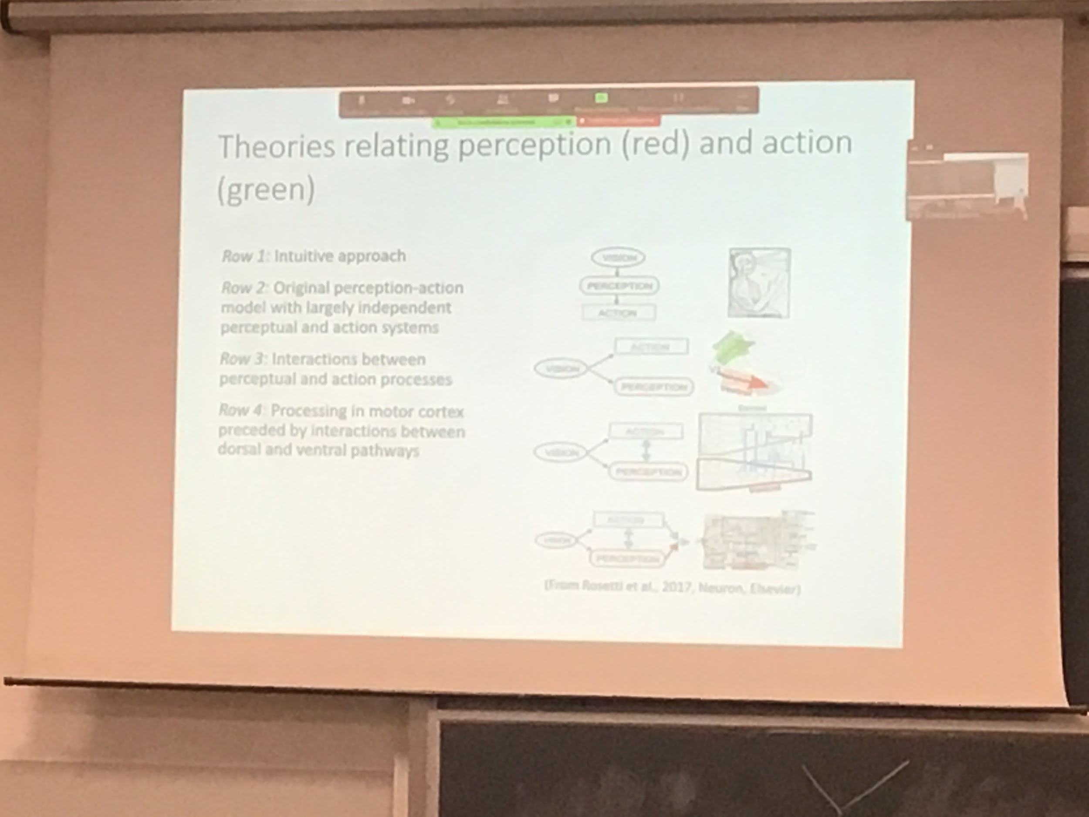

The first inductive approach is that vision vision bring perception

At the beginning the two roots were supposed that they had no connection.

The two roots commute in different aspect but then everything is put together.

**CH 2: colour perception**

Why colour? We can use the colour to discriminate between different aspects.

If we add colours we can see more differences. You can direct more borders

Colour is an experience given by the pattern of light falling on the retina. Objects do not have colour they responds to specific way when hit by light

Aim of perception is to recognise colour. Without light there is no vision. We need some source of illumination to see. Most of the object in our environment are not illuminant, need some form of light to see

Light hit the object whit a specific angle and it reflects with respect to a specific axis. Visible light is just a very small range: 470-700nm is the only wavelengths that our receptors code.

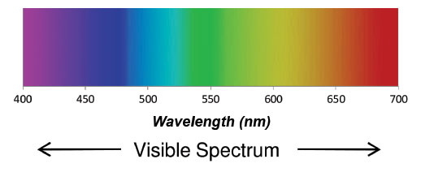

The brain build the perception of colour

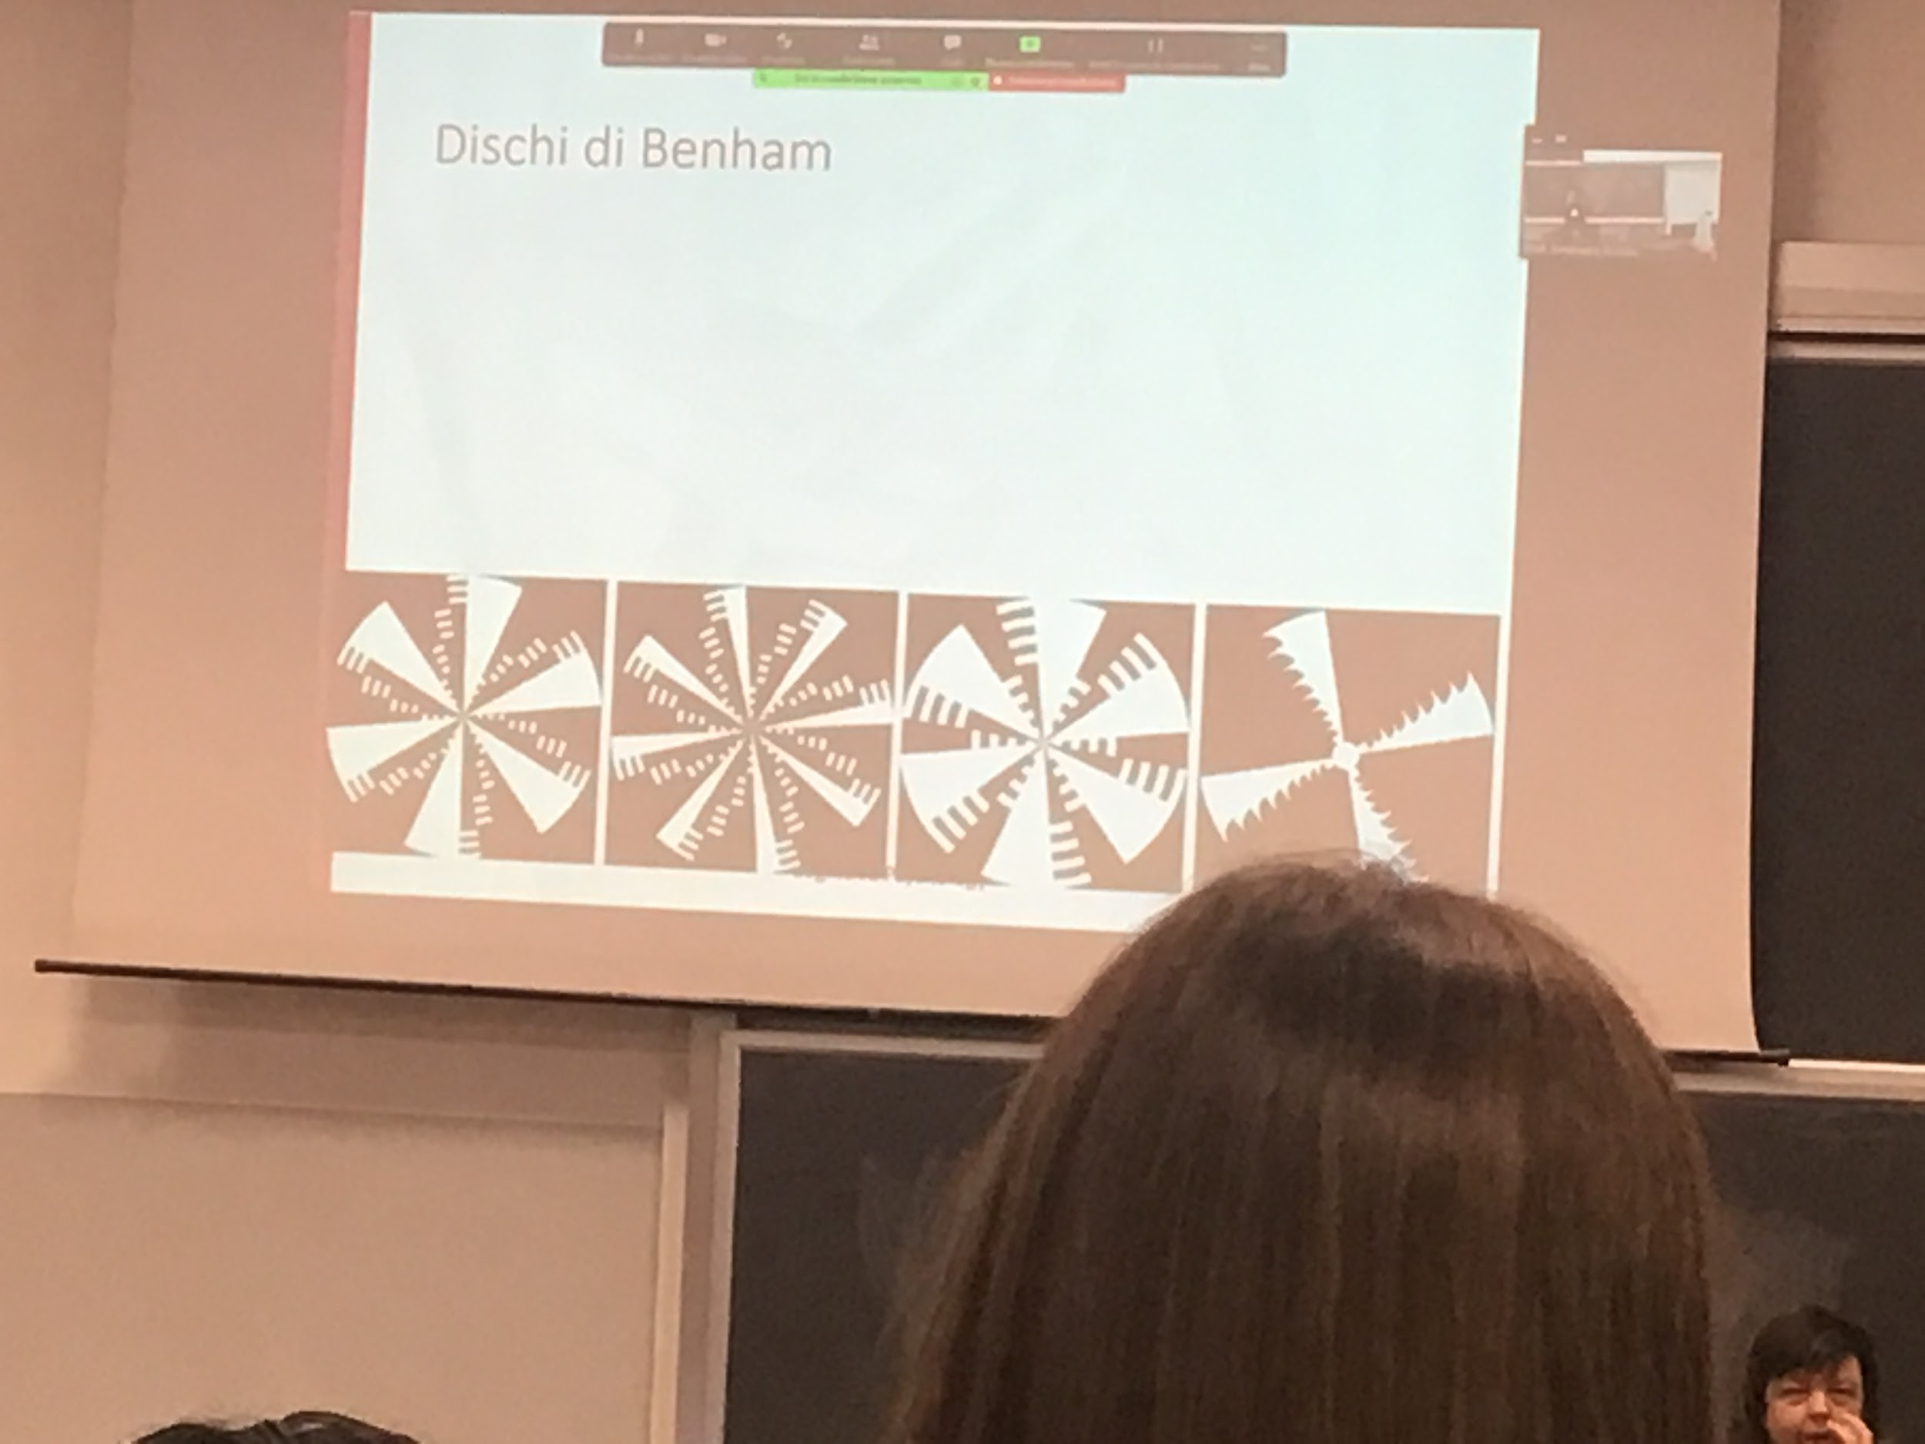

If you rotate then very fast. You see colours

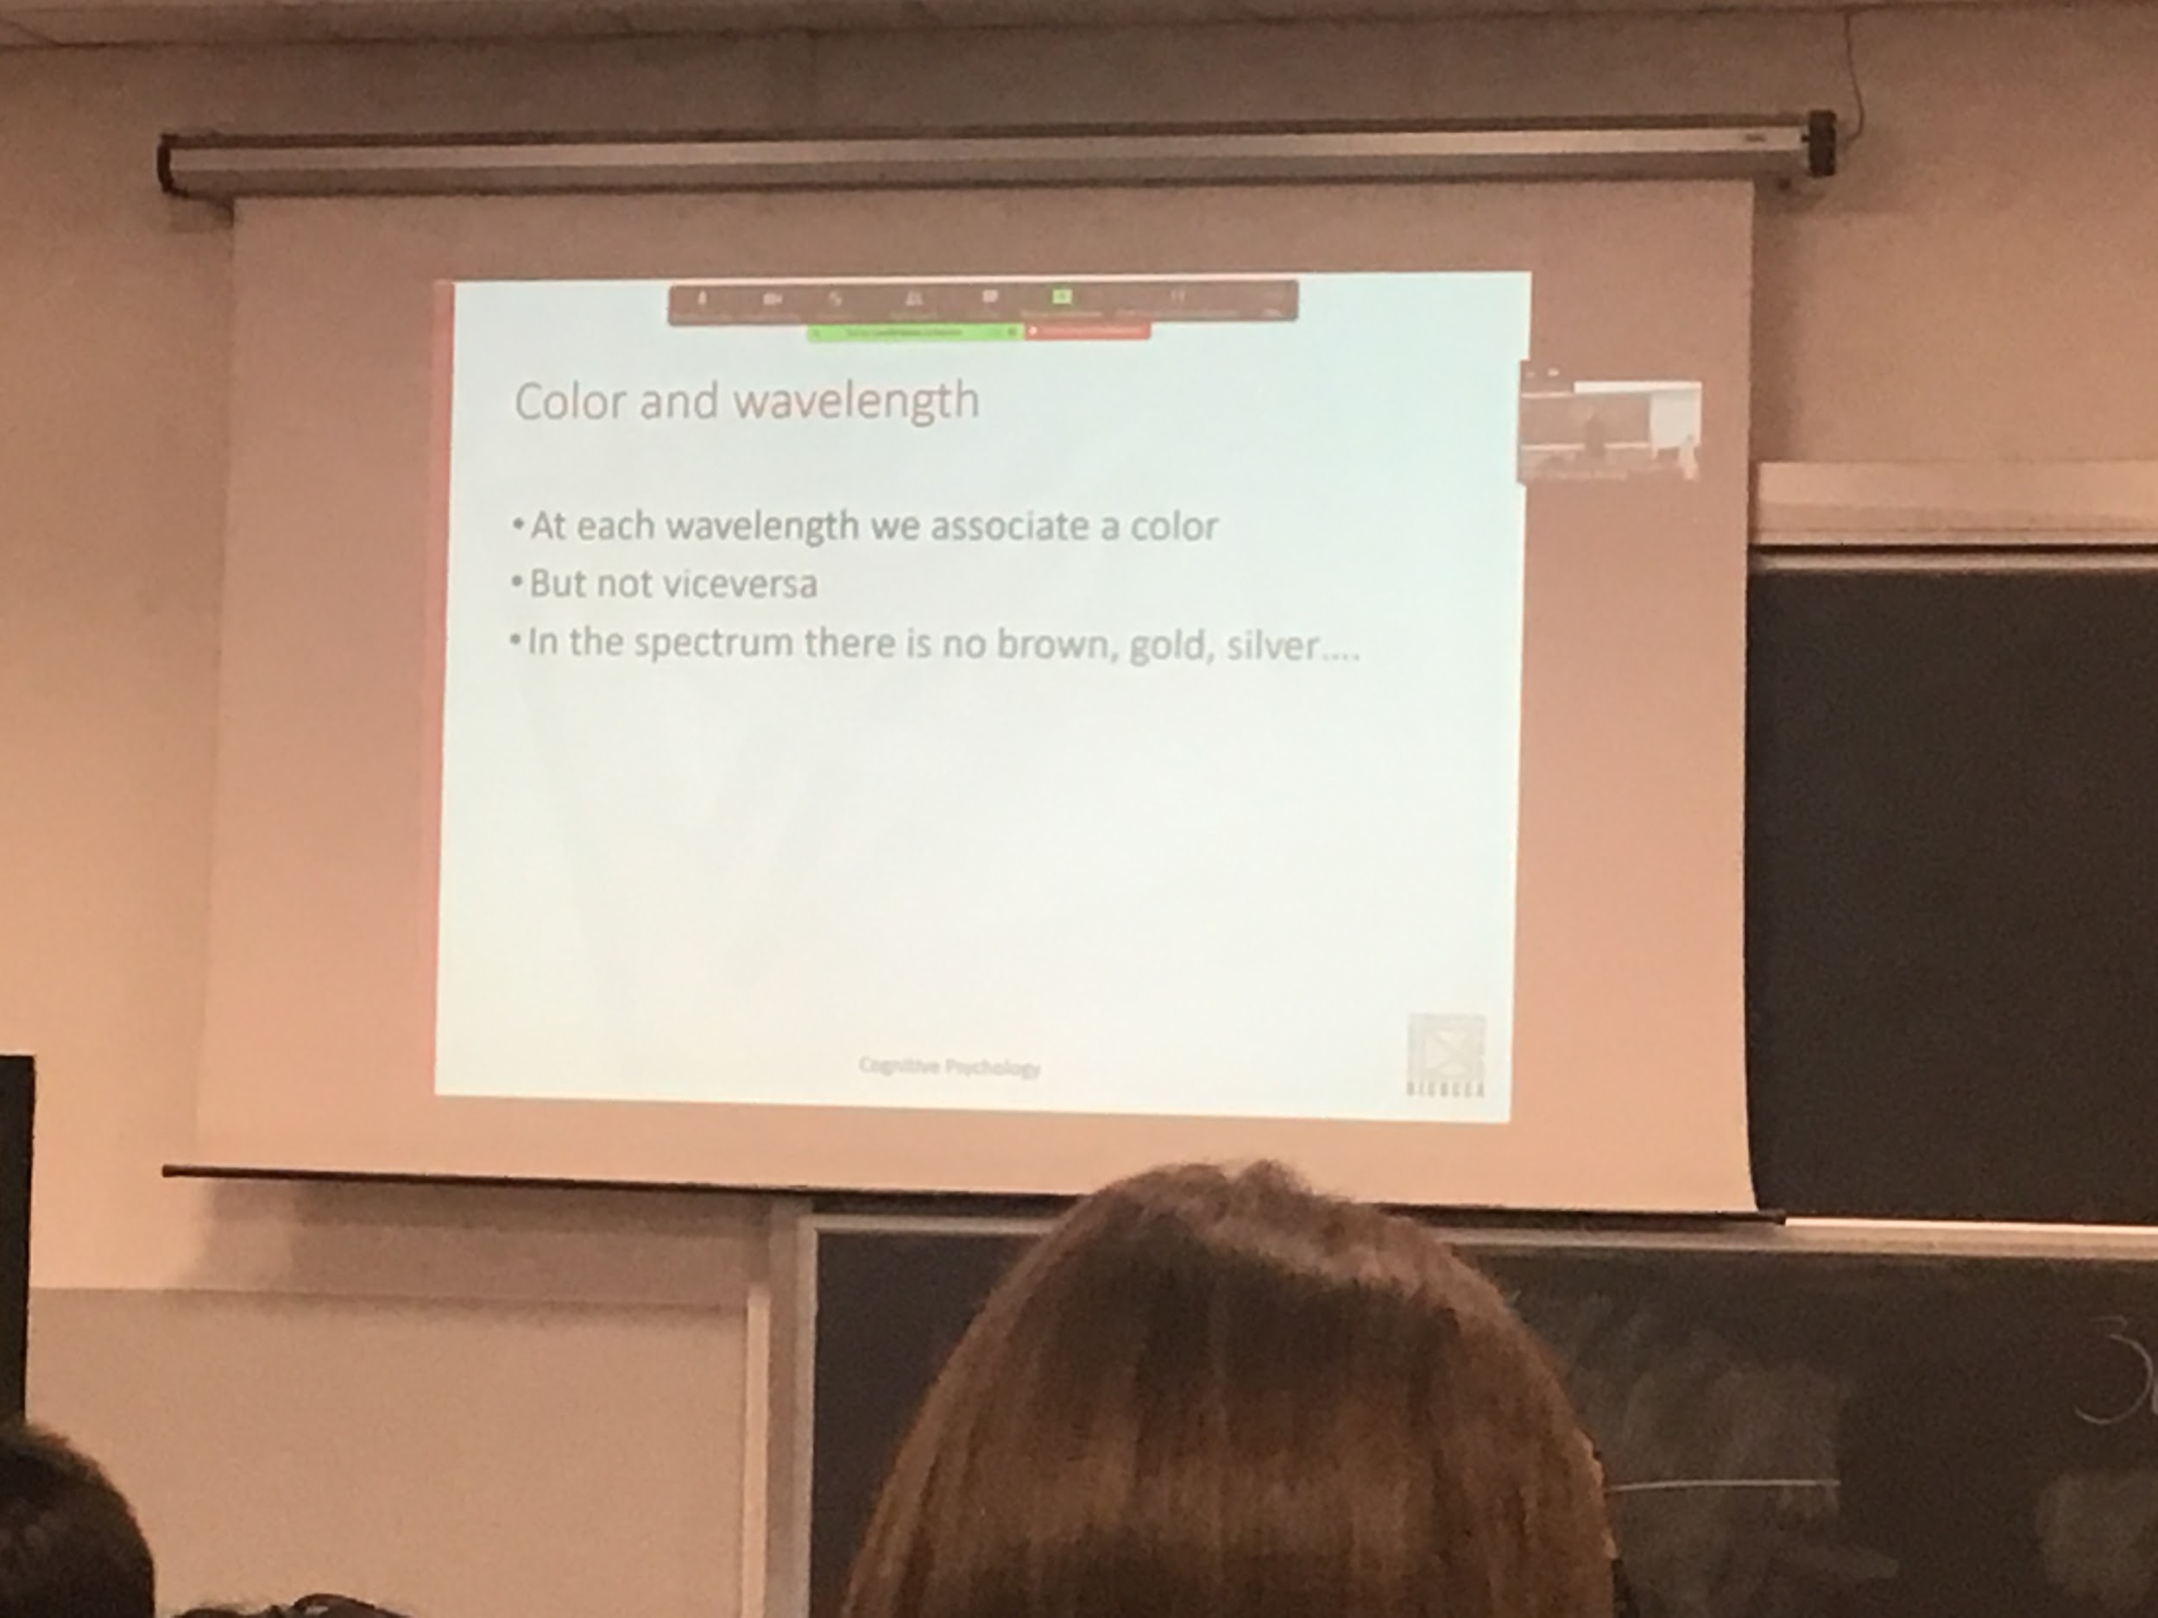

A pure wavelength around 480nm will be perceived as blue. Each wavelength has associated a given colour (not true in the other way around).

There are colours that are made by mixture of wave lights.

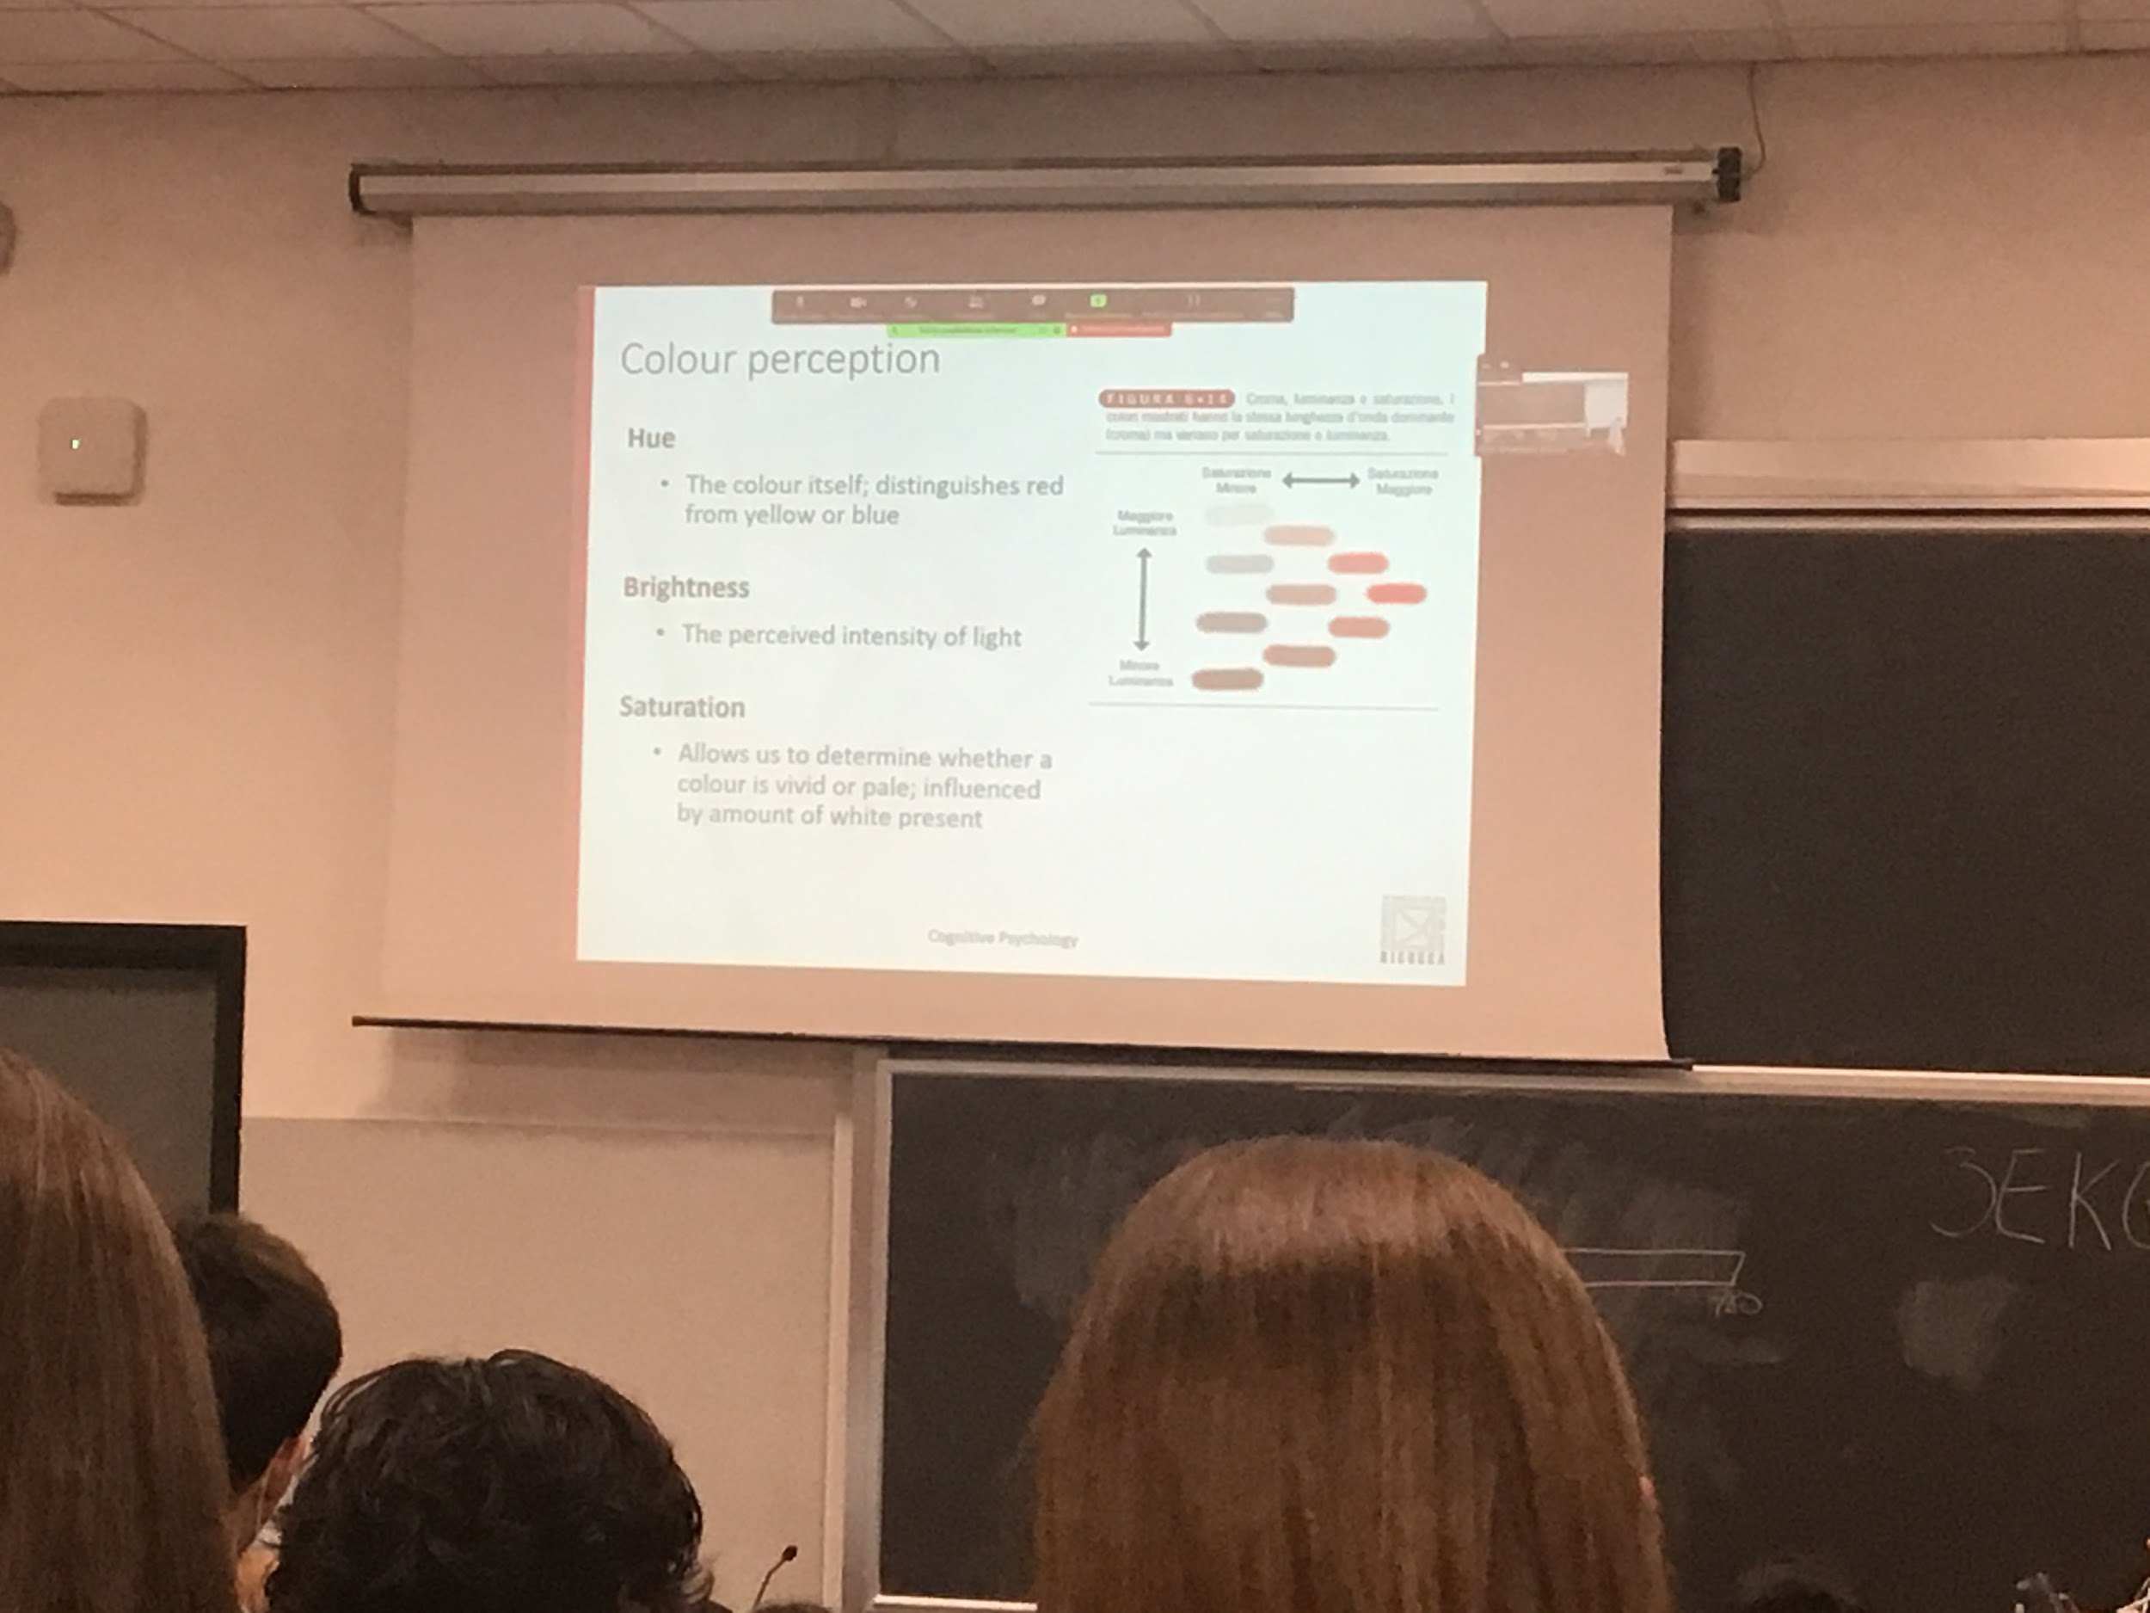

Colour is a 3D pavements, ended to distinguish in difference of

* Hue: difference between colours
* Britishness: given a colour we can change the brightness and obtain a different colour. How much light there is. Same distribution of wavelengths but more amount
* Saturation: distinguish if the colour is just one wavelength or others wavelengths, if you add others will become less or less vivid

These are perceptual properties, if I change intensity of light my perception is not proportional. Our perception is very detailed at the beginning by keep adding light after a while it will stop

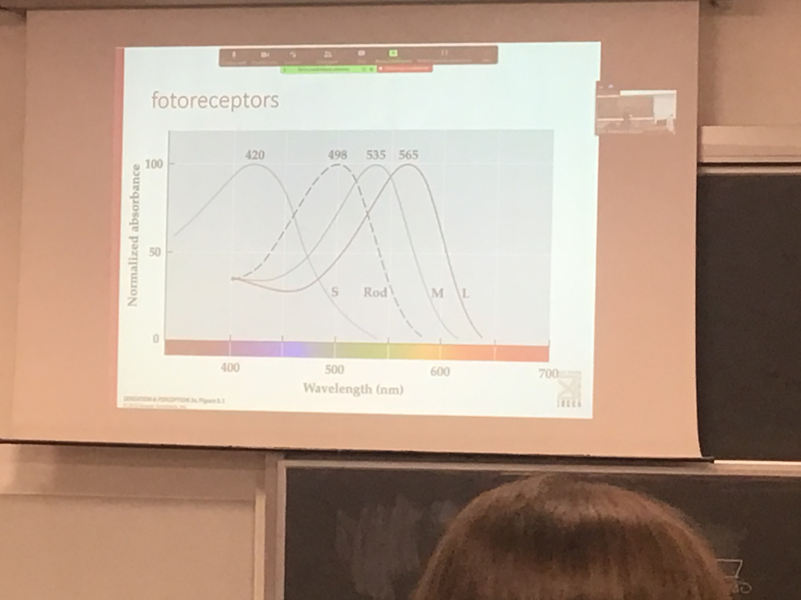

We perceive colours only during the day

We perceive colours because we have 3 cones: 3 comatic

Blue cones: preferential respond to blue, they respond to others colour also

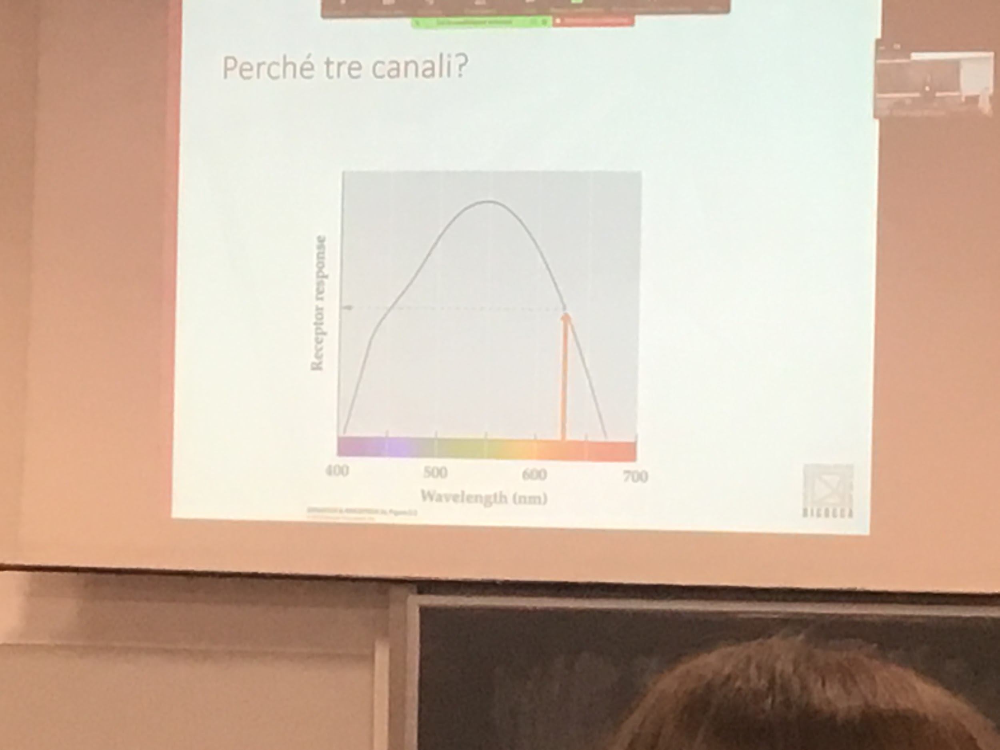

Single receptor at night

But I can find a single photoreceptor that responds with another wavelength. The brain only knows the amount of activity, don’t know the colours

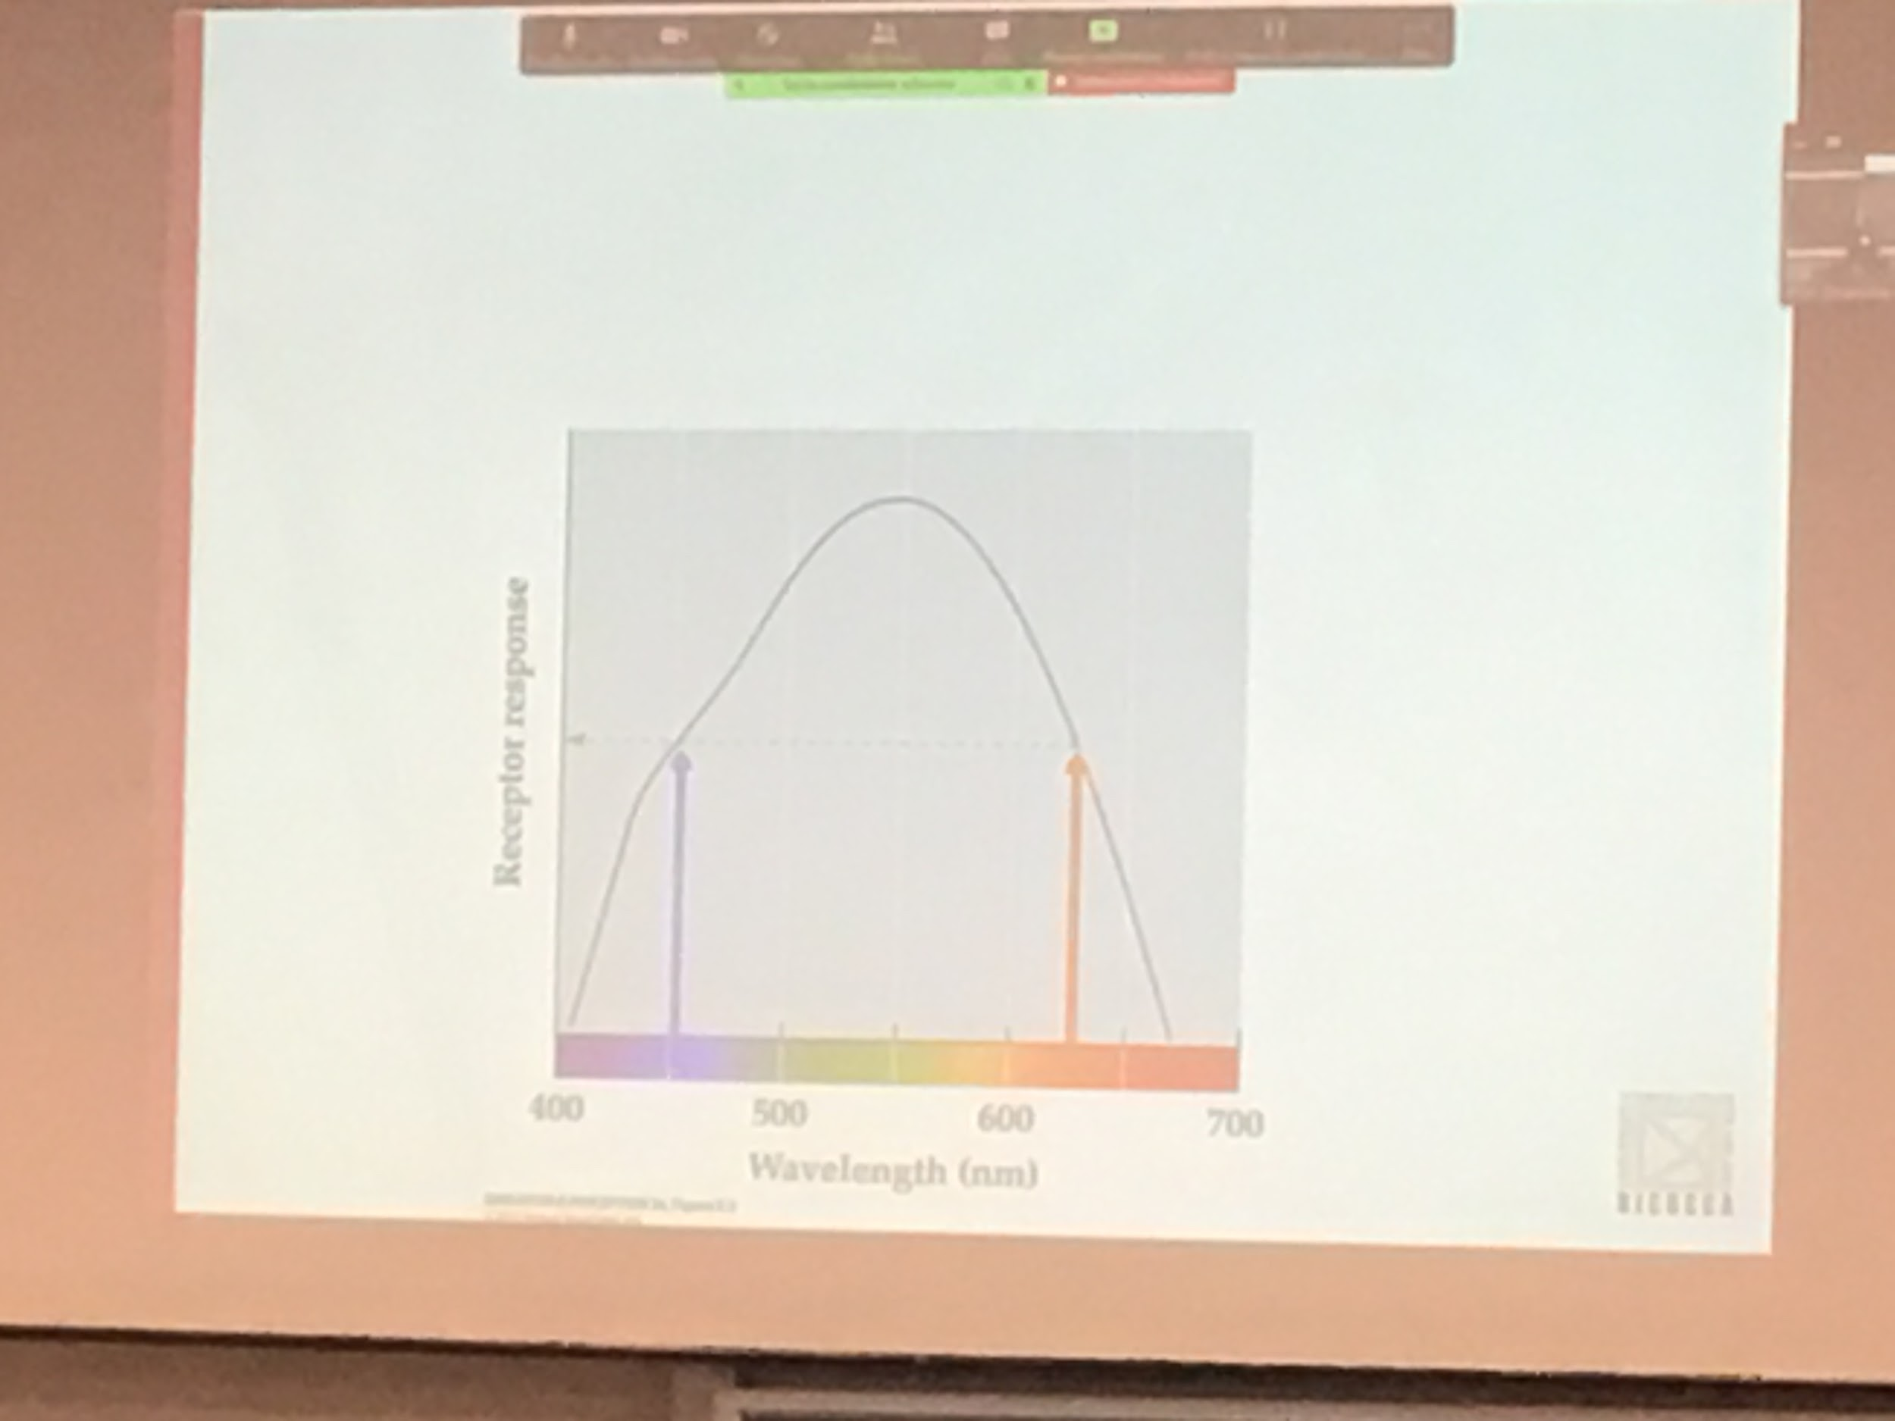

I can find another light that activate the same photoreceptor at the same amount

With one receptor we can not code colour. We can only find intensity (tell if there is or not light), we see a grey scale.

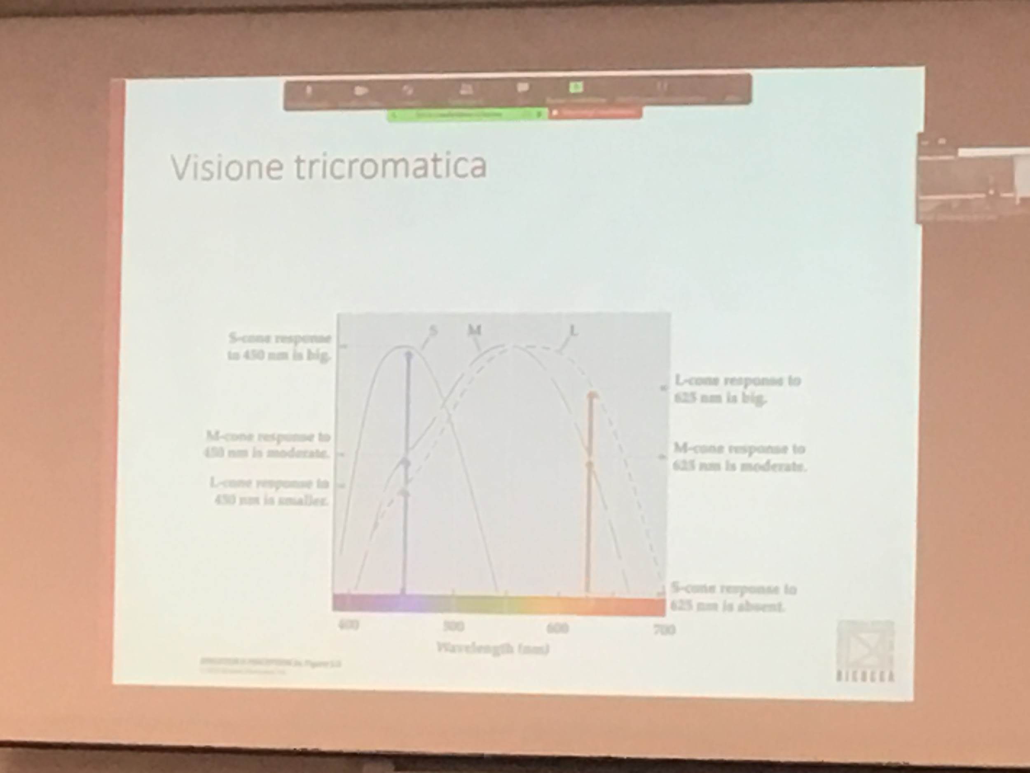

With 3 photoreceptors we can see colours. We can see many colours with just three photoreceptors. Now looking at the response of just Can

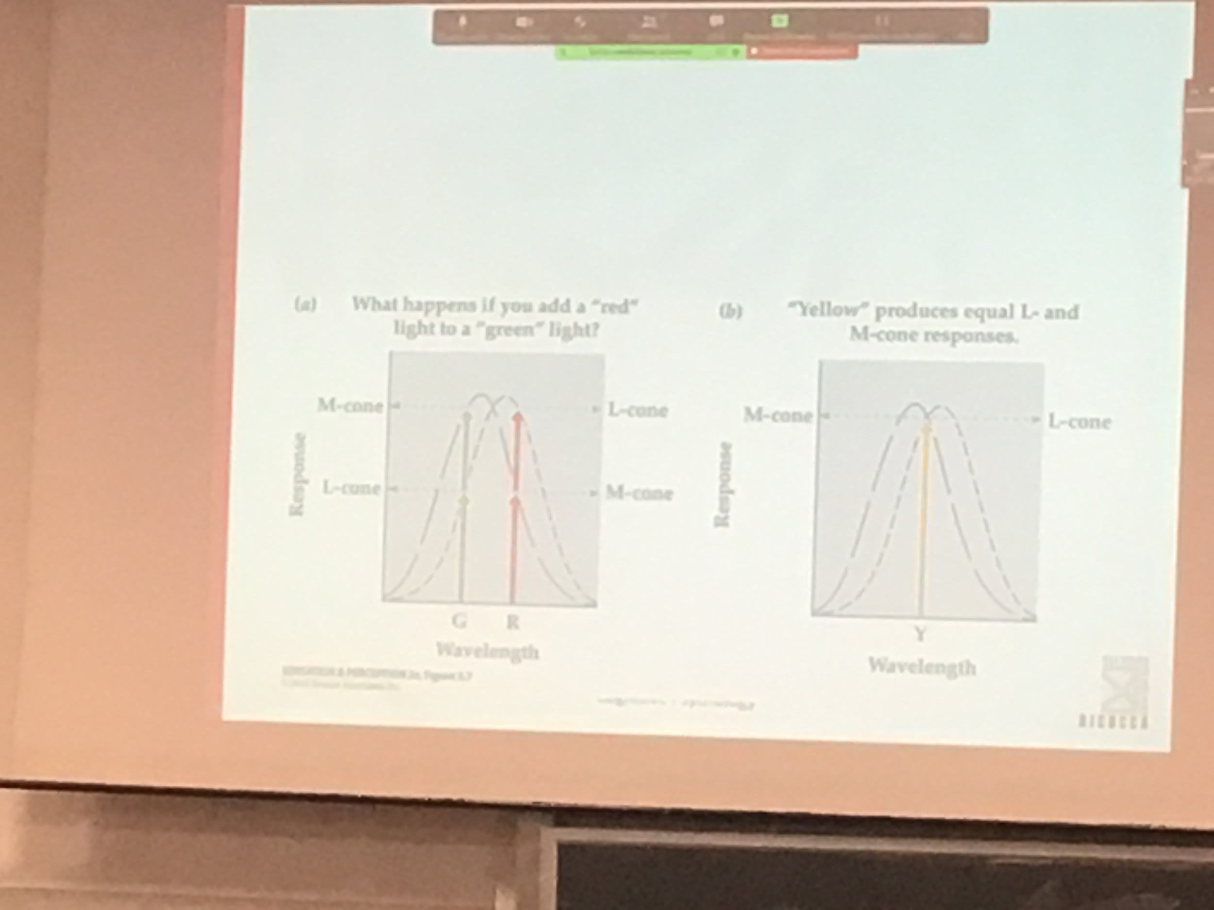

If I go to a physics lab and I create a light that have only one wavelength physical they are different but I can’t perceive the difference.

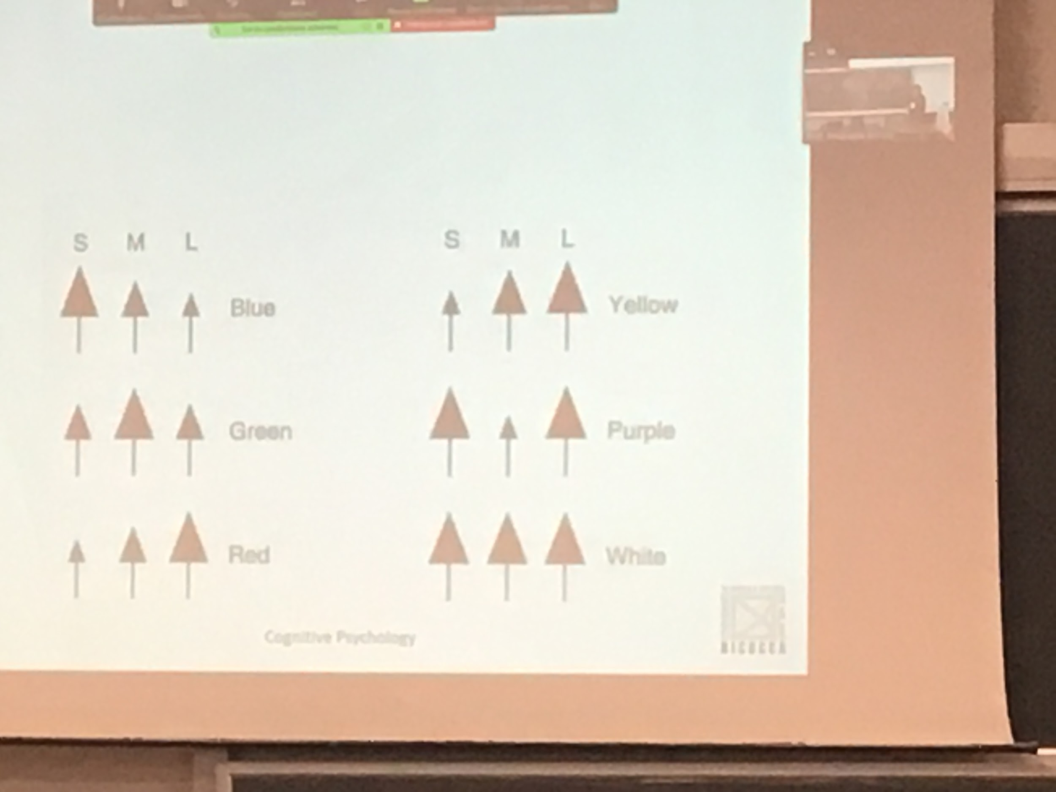

White light activates all the receptors in the same way.

Black: no light so there is no activation

Three chromatic vision:

No clue we had three photoreceptors

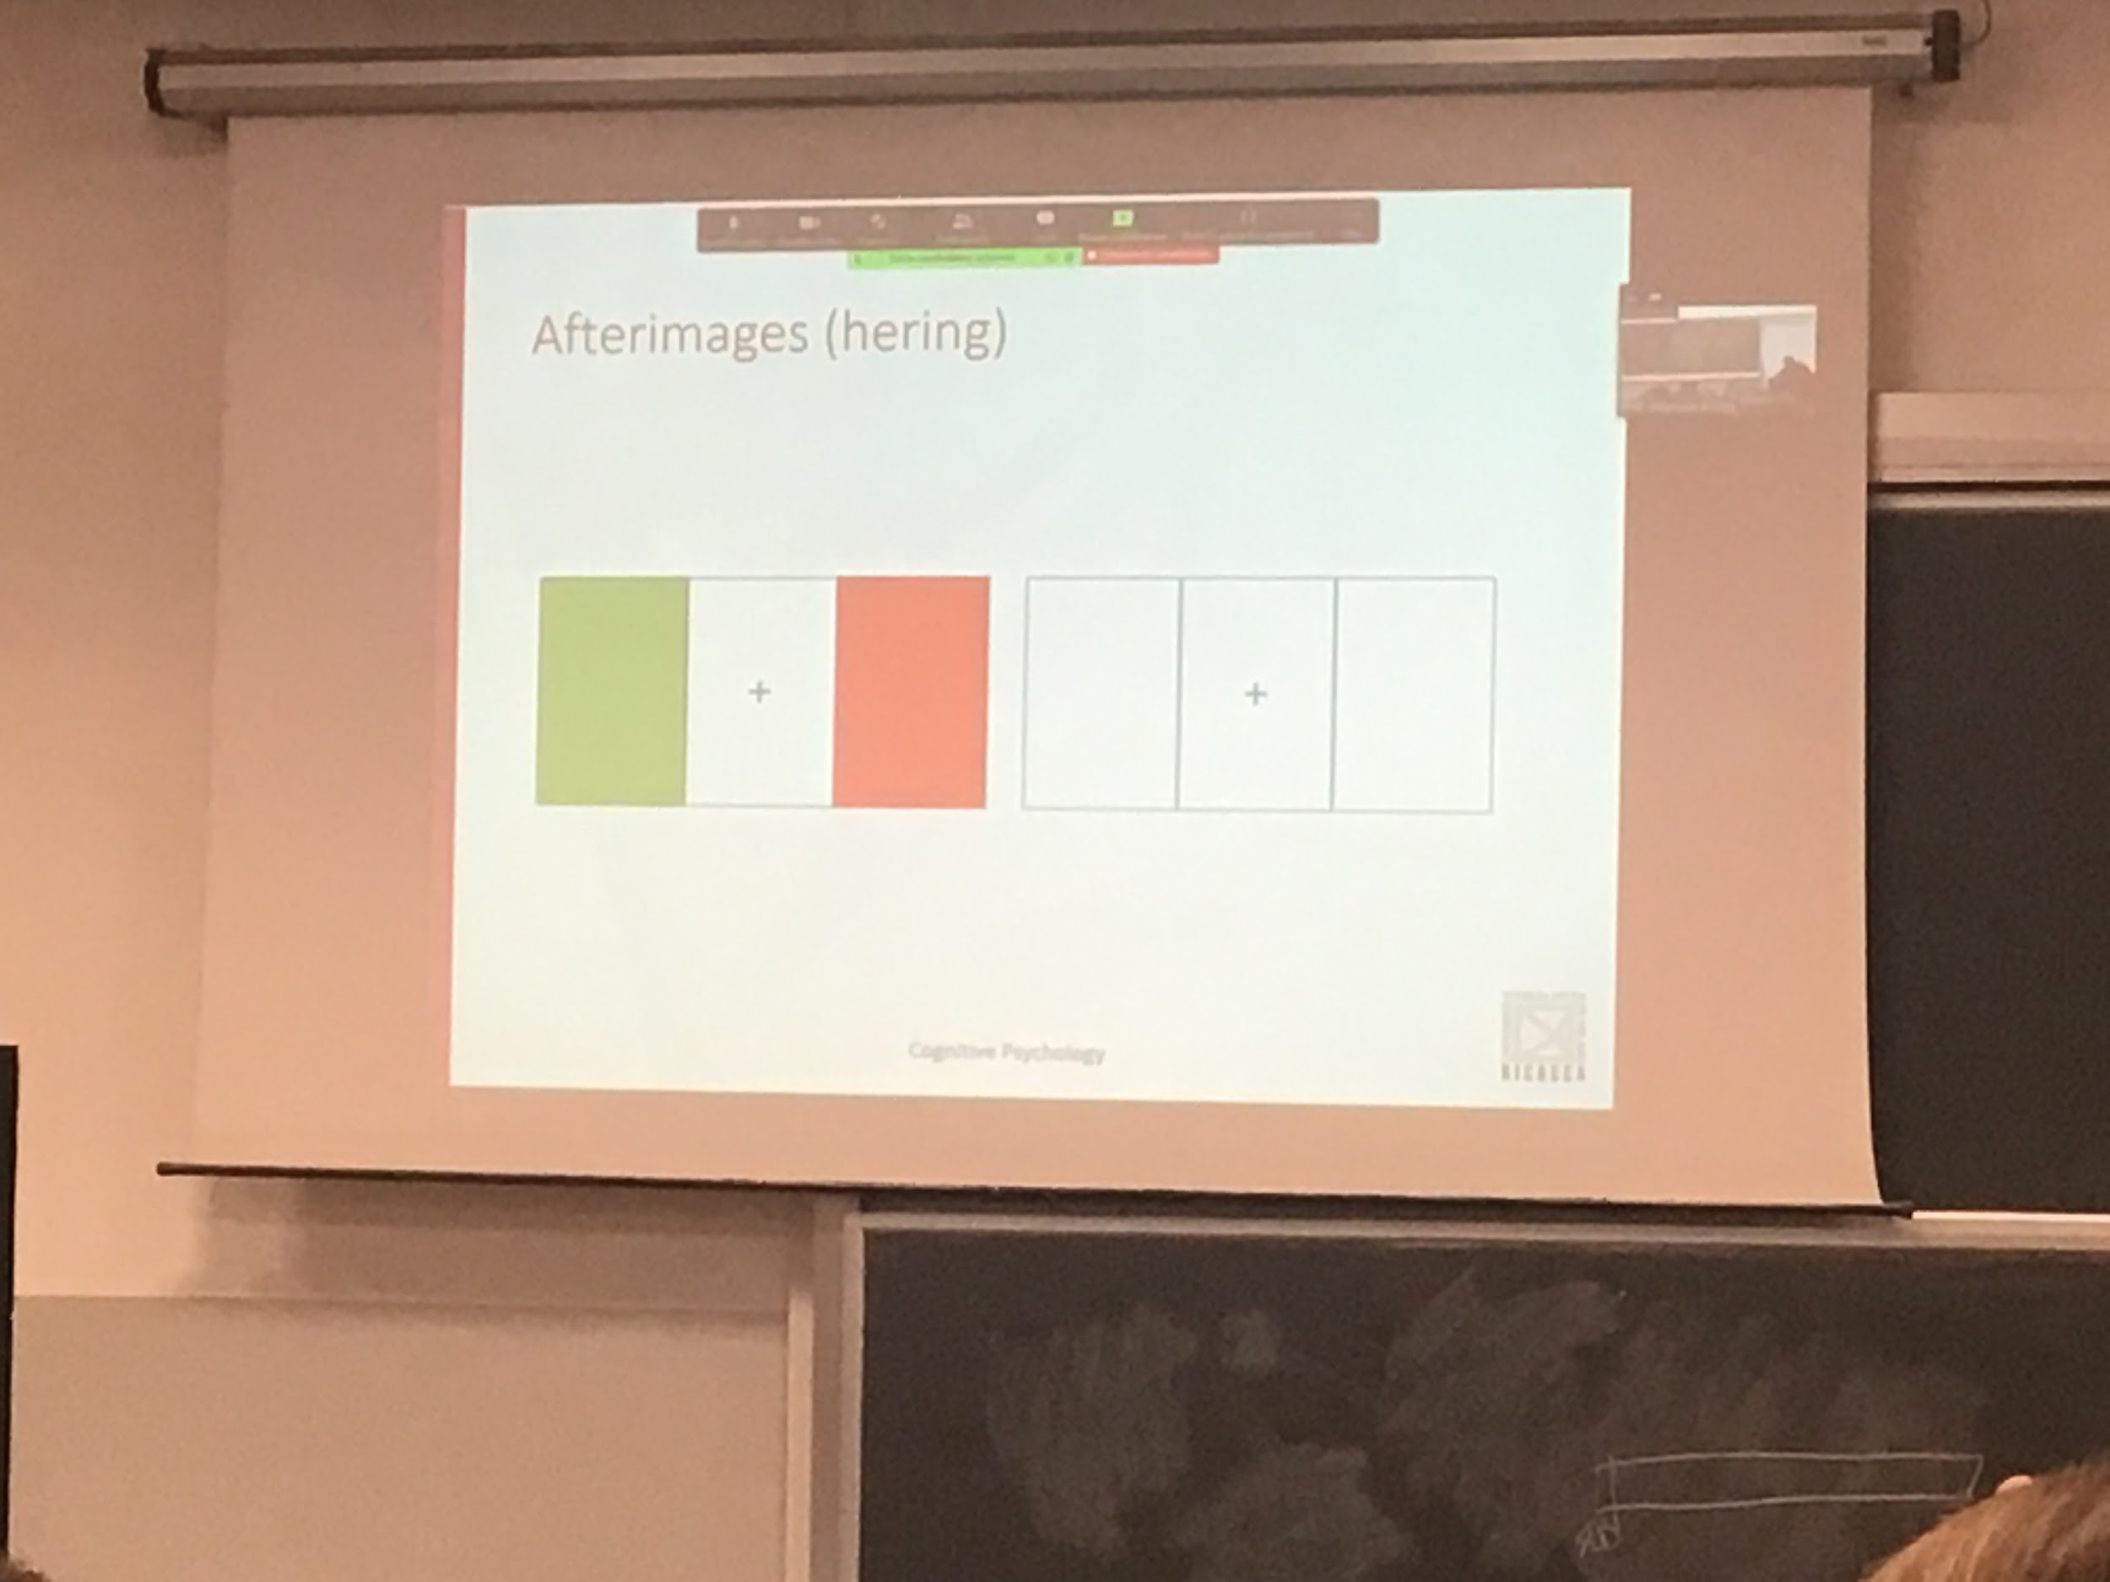

After a while of focusing on the cross you will see the colours inverted

One property is adaptation: we need to save energy. If keep answering at the same time save energy

See colour inverted. There is no reason.

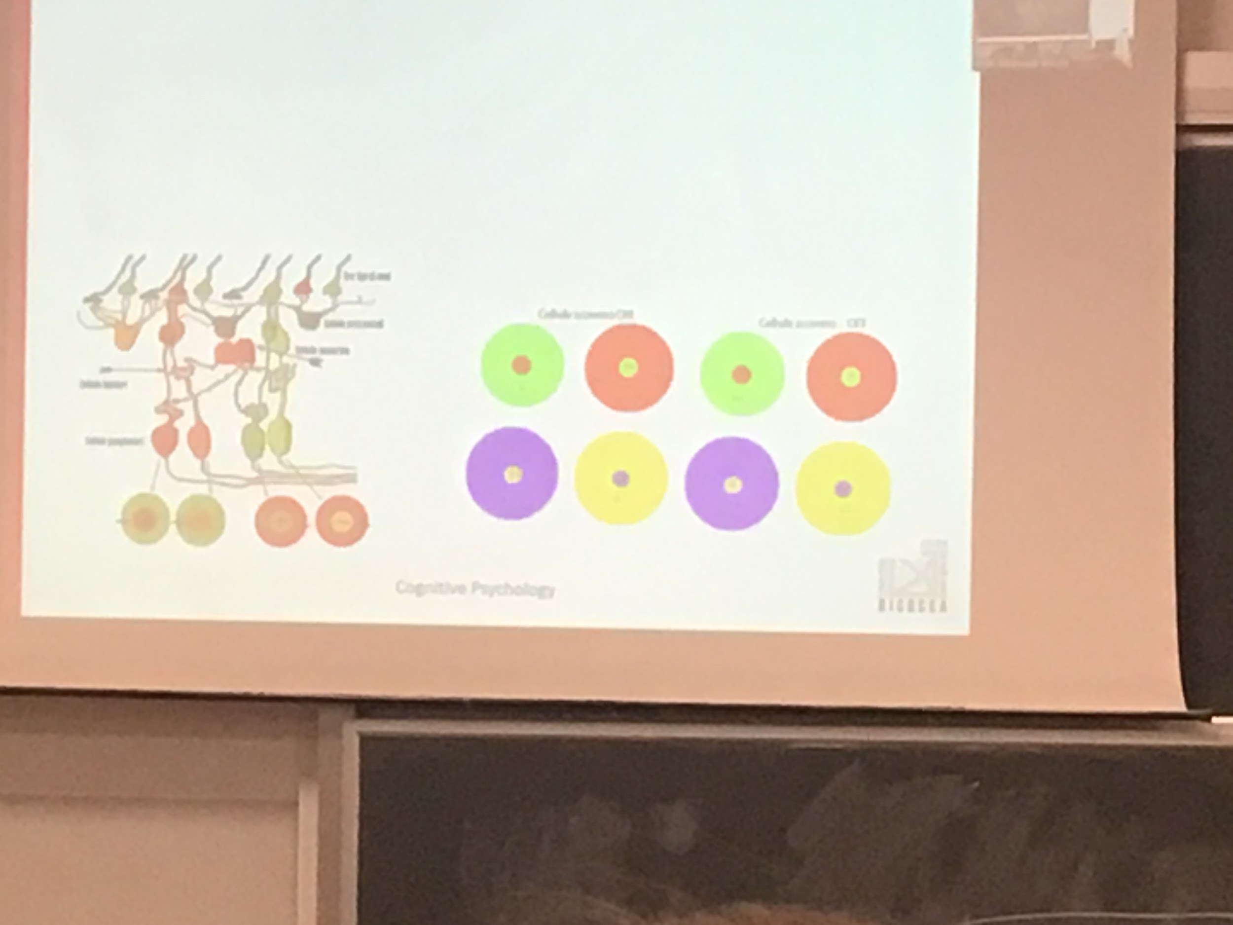

No photoreceptors for yellow.

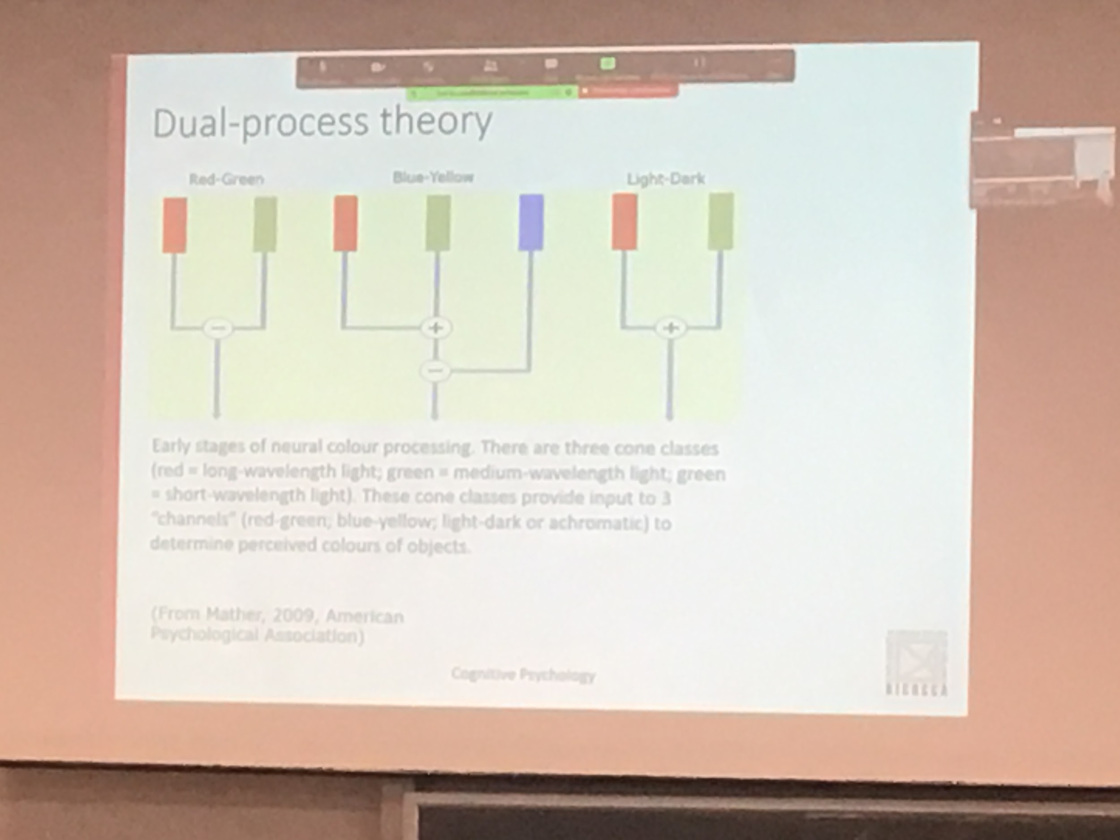

There are three cones (red, green, bue)

Three types of opponent (red-green, blue-yellow, light-dark) given from different combinations of responses from photoreceptors

Already at the level of the retina there is no photo camera

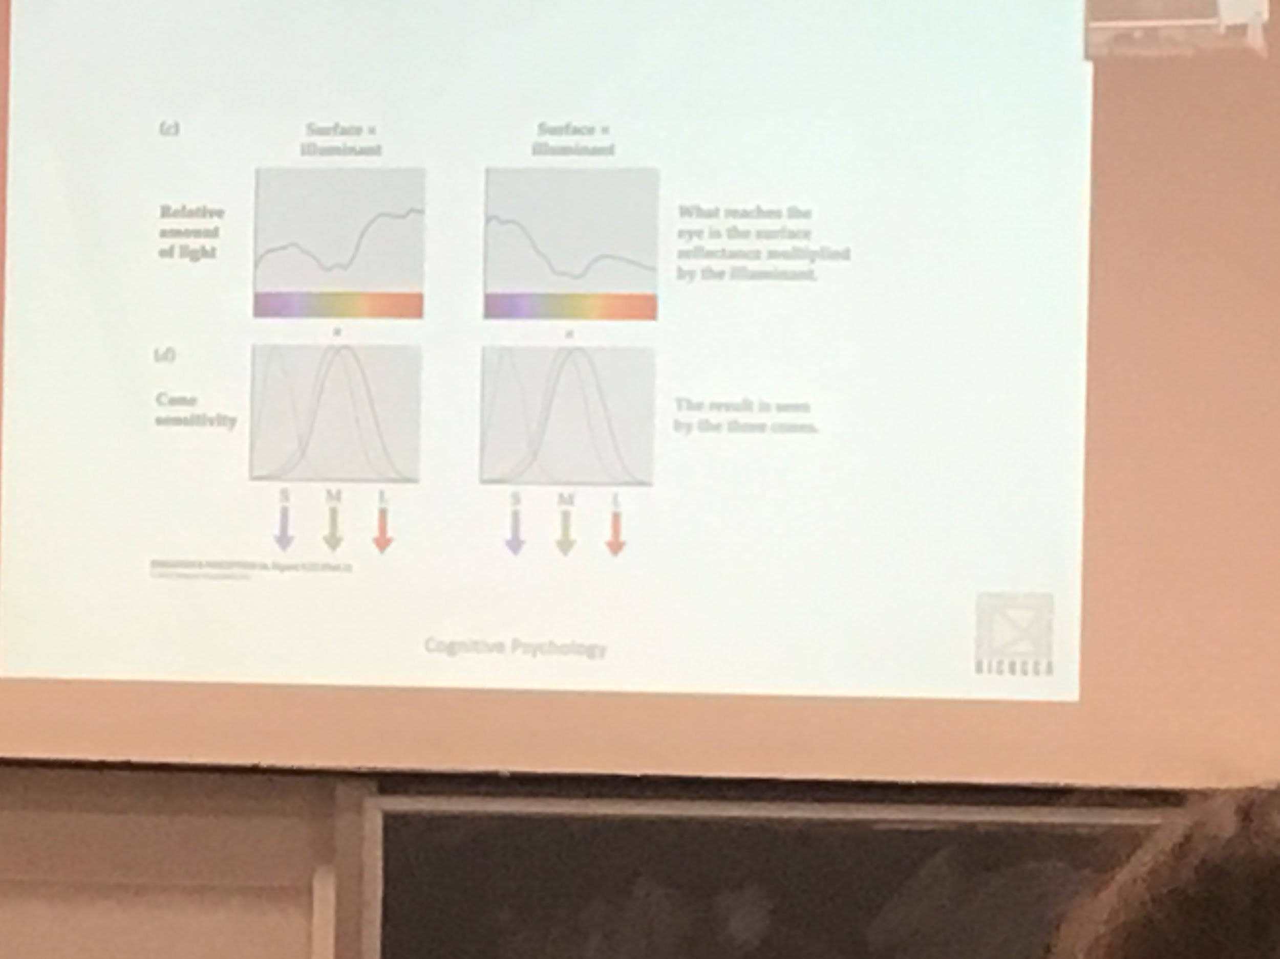

Huge problem: what we want is to compute the properties of a surface, each surface has different properties.

The light coming from the sun and from the different artificial sources is not pure white. I can have the same sources illuminated by two different illuminance: ↓

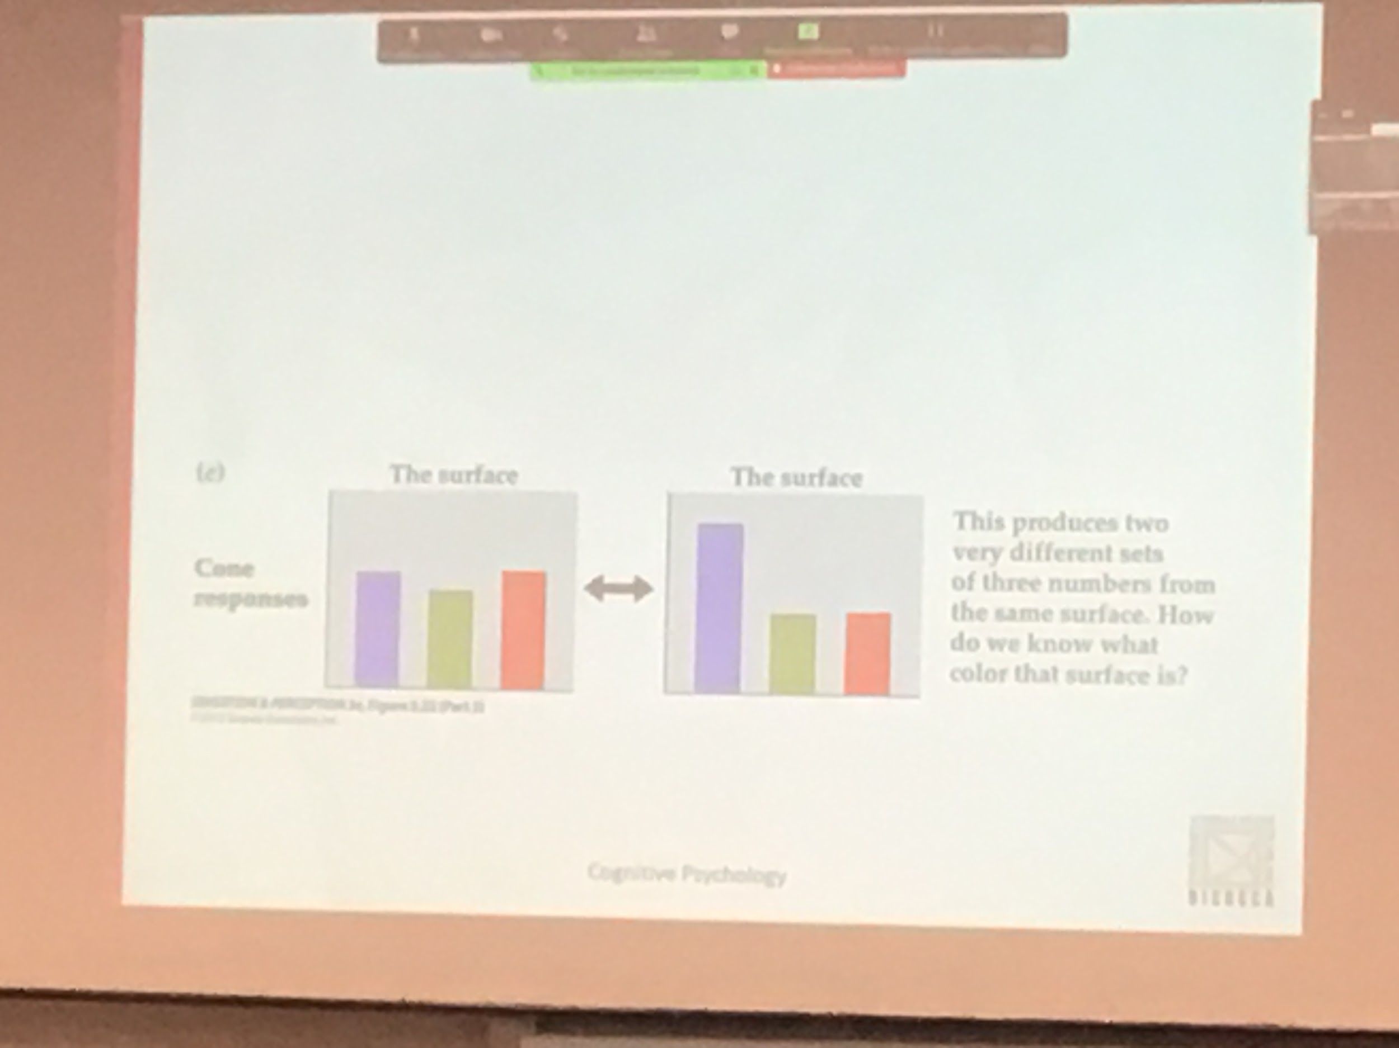

Same object but different responses depending on the light. We need to find a way to discount the illuminance and try to find the real illumination about the surface. 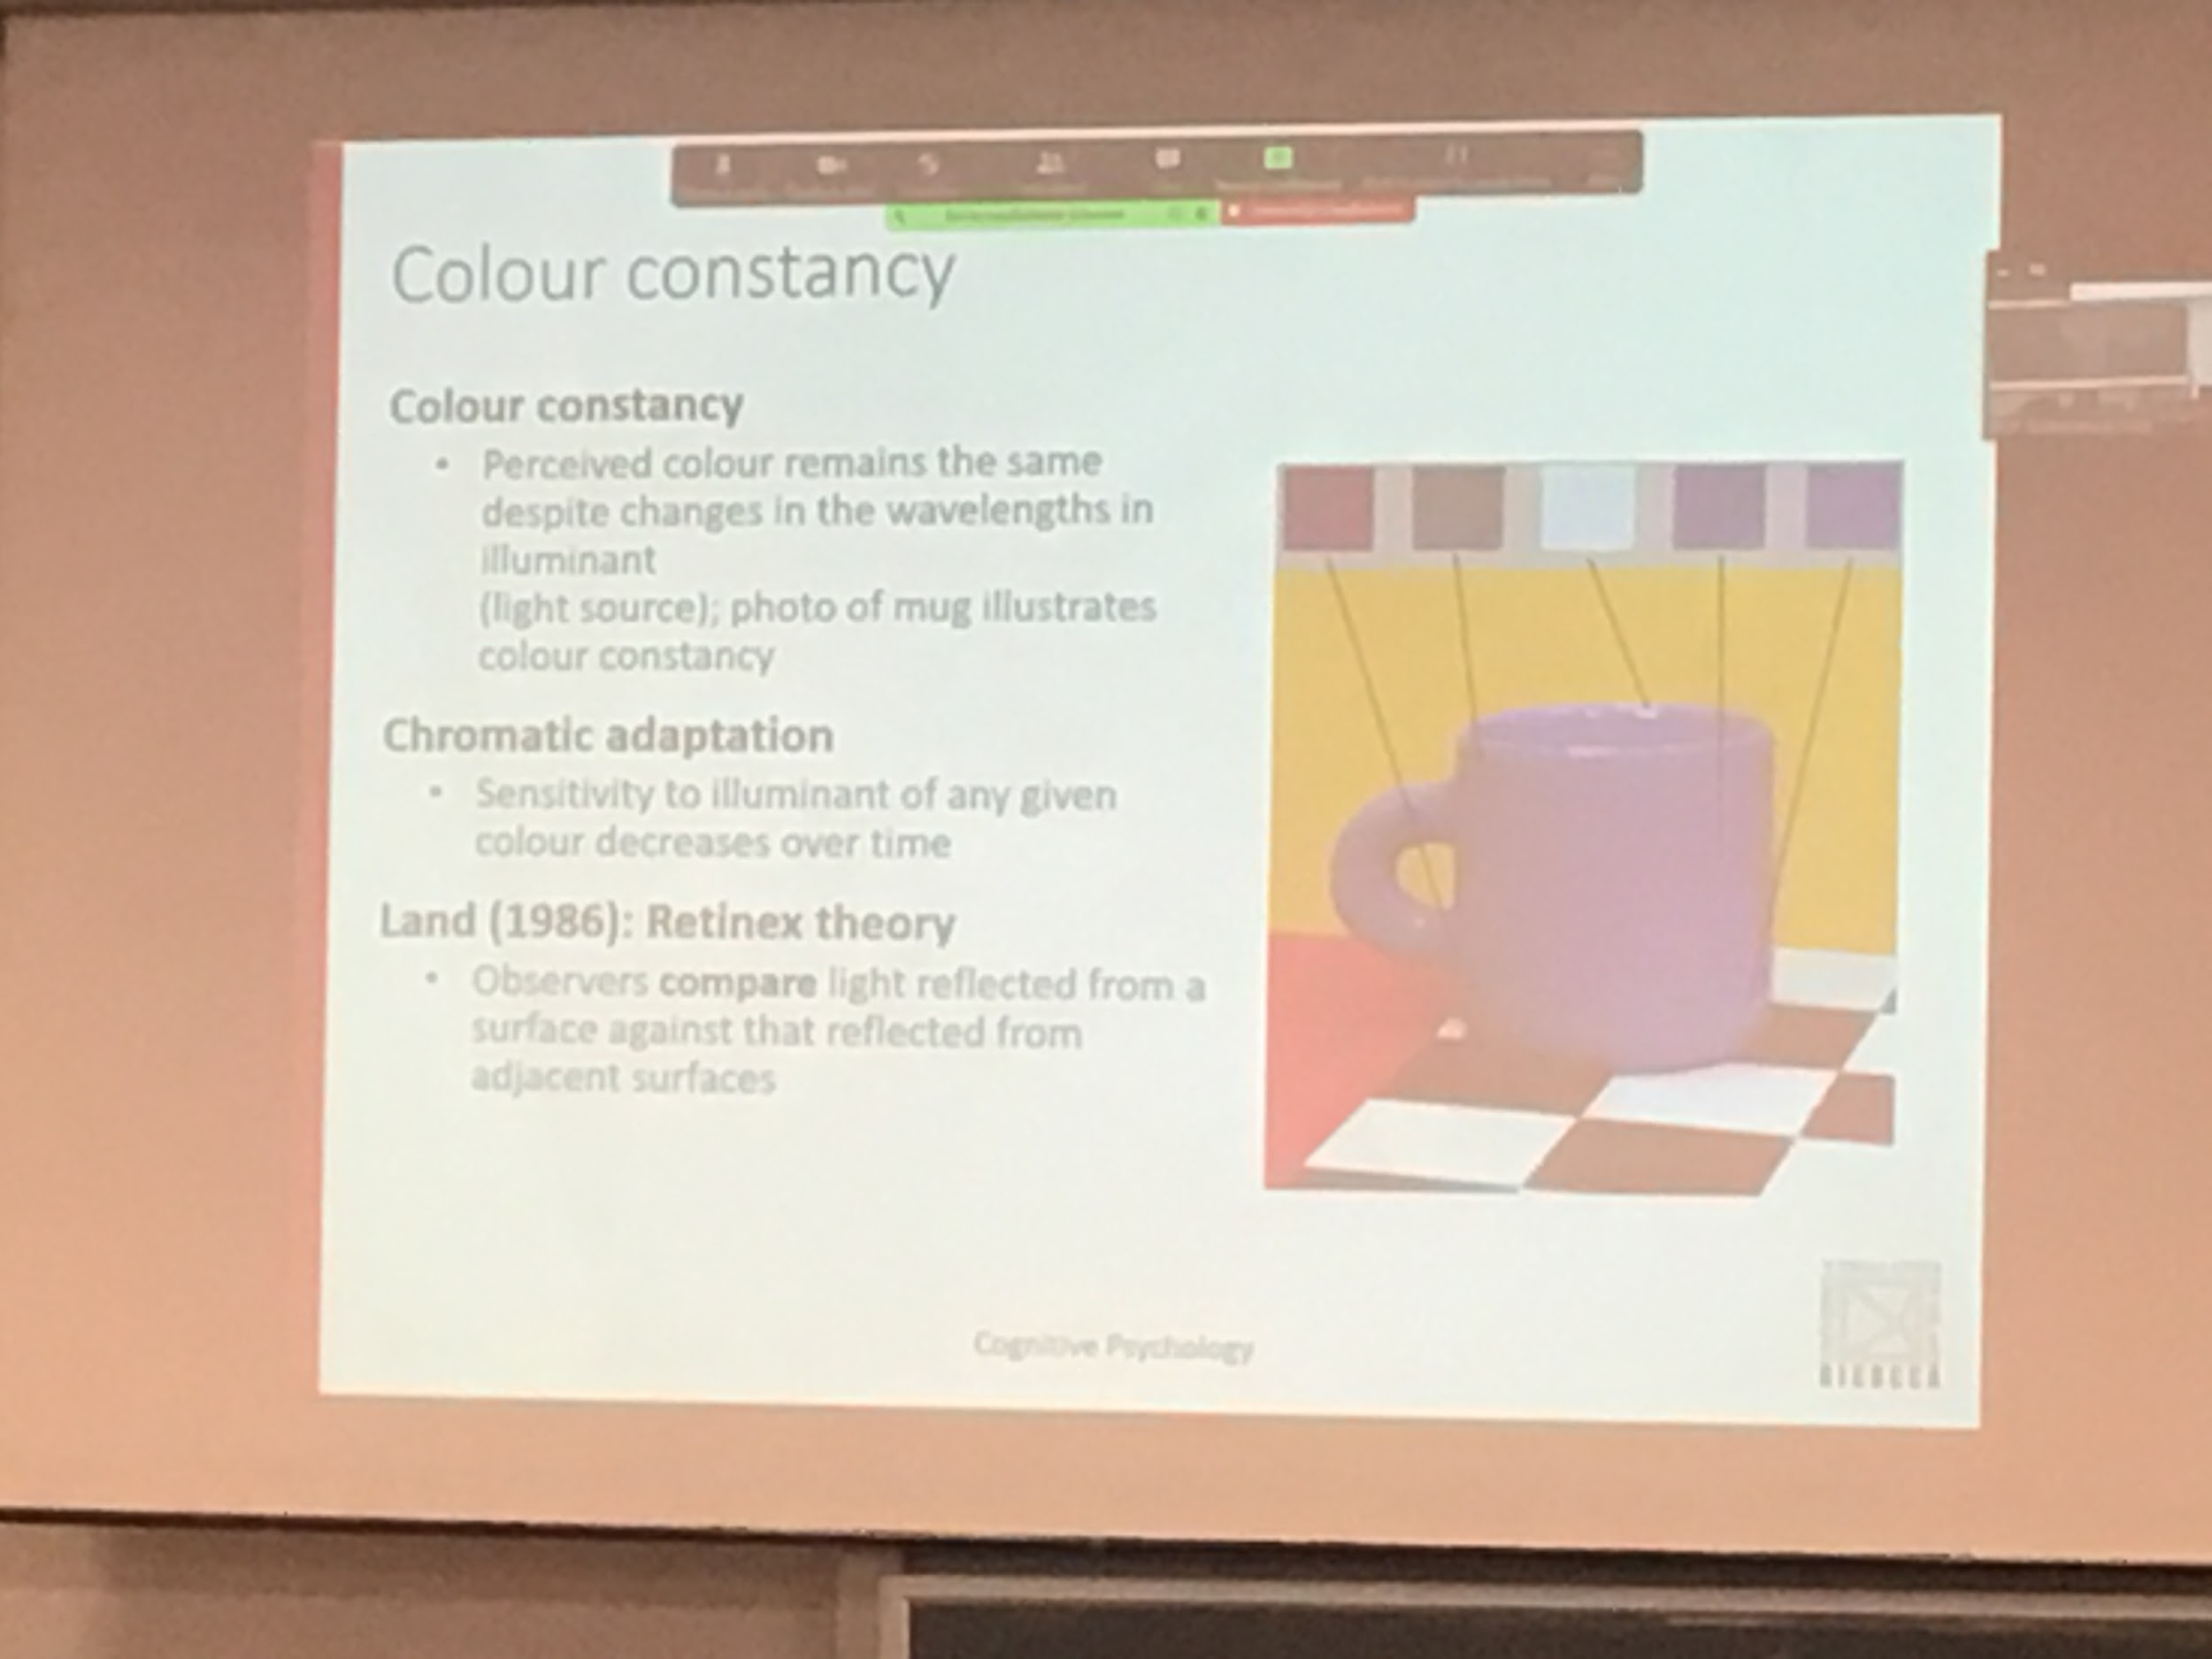

We need to **compute colour constancy**: giving the person the same perception given the same object

There is a lot of computation that the brain do for computing colour constancies

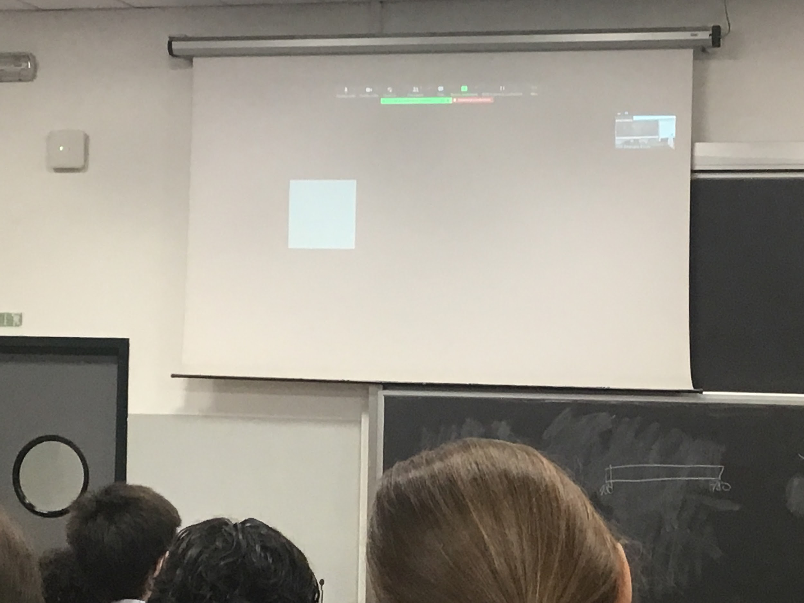

Go to the brightest spot. Ipothesys that is white. White should be reflecting exactly the luminant.

Adapting, if you add others wither spot our brain will recalibrate

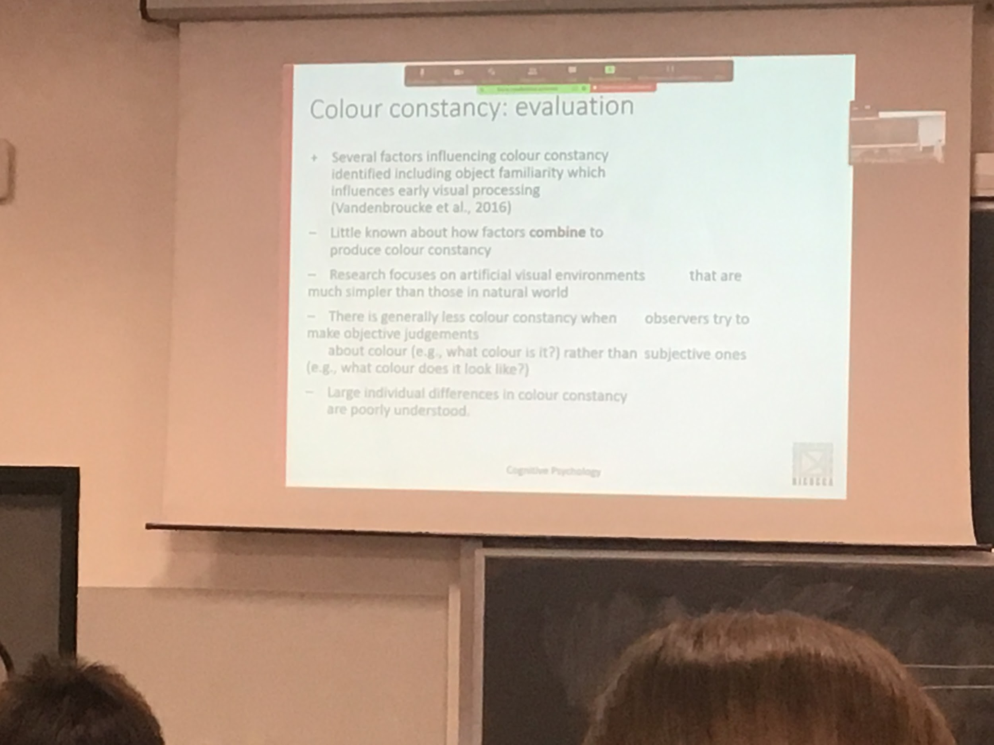

**Familiarity**: If you know the colour one one object your system adapts to that. Your experience influences your perception.

You see bananas more yellow that what they are

It is not very clear how does this information is combined. Most of the information that we use is in lab testing.

There is less colour constancy when we ask people what colour it is, but more when we ask a judgement.

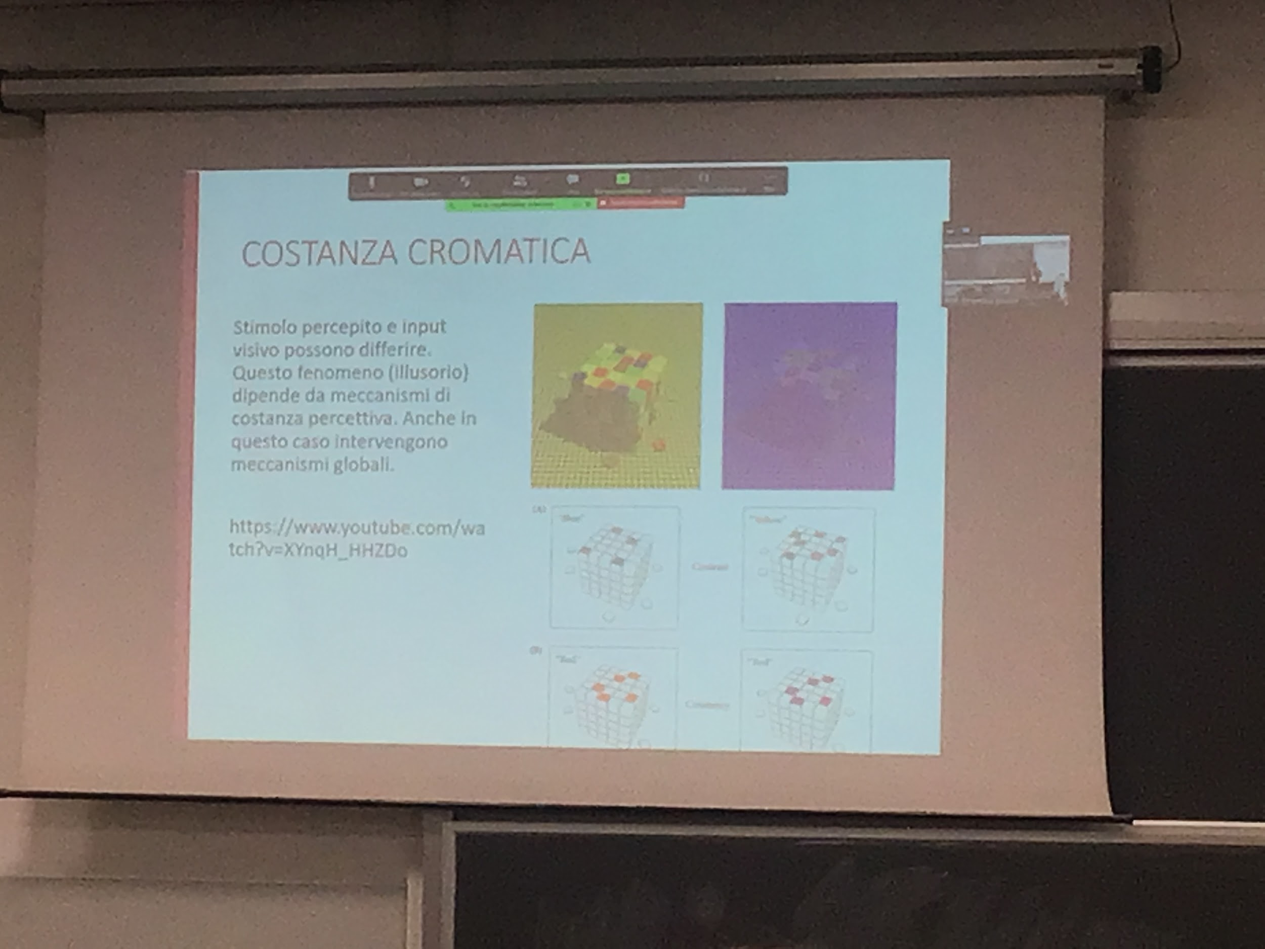

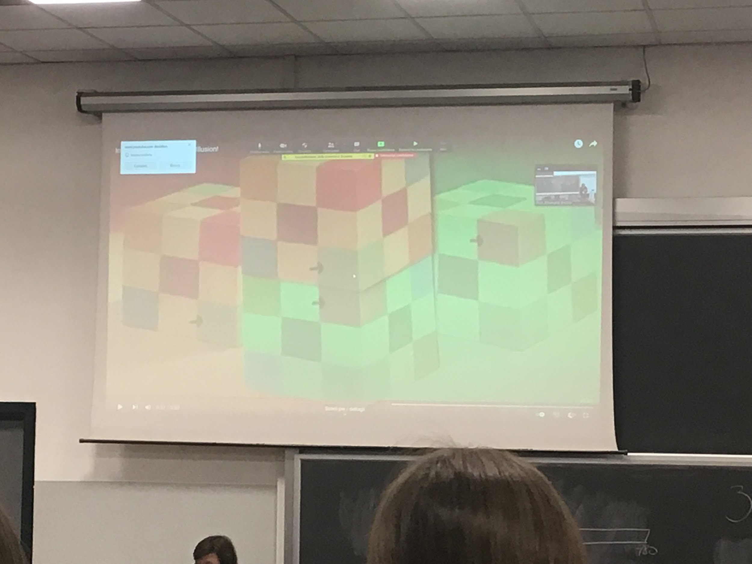

Same colour. Why there is such a different perception is the illuminance

The system is working very hard.

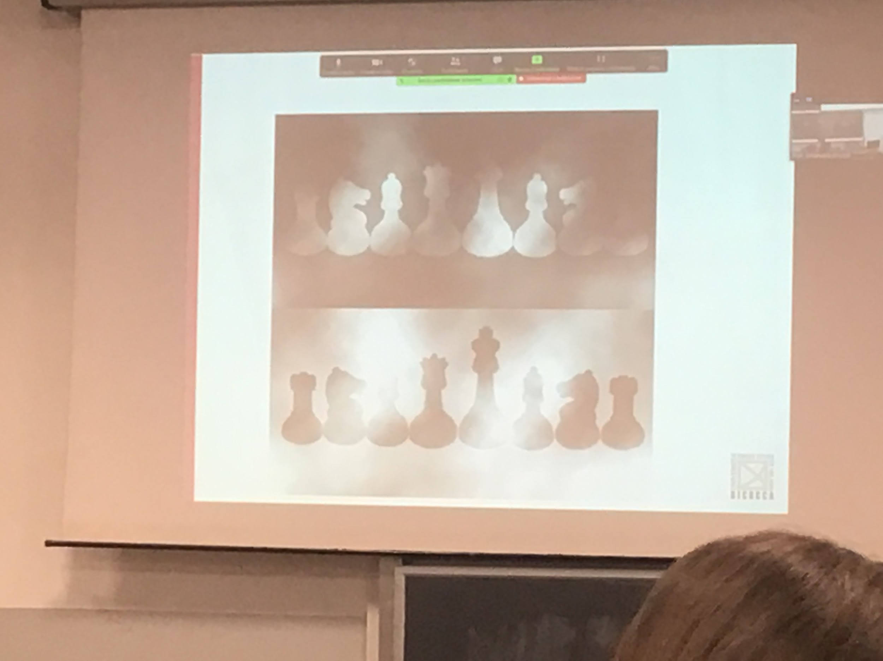

The colour of the pieces are the same but the perception is completely different

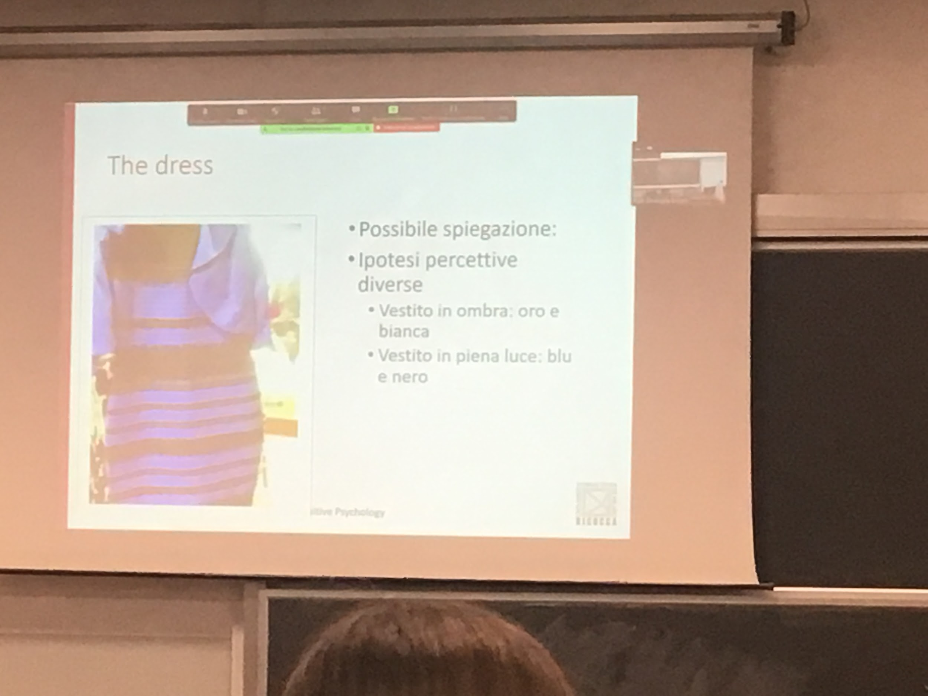

One of the example whew colour constancy doesn’t work

colours is interpretation